Table of Contents

**I.** **EXECUTIVE SUMMARY** 4

**I.** **INTRODUCTION** 5

**System Overview** 5

Booking Module 5

Account Management 6

Tracking Module 6

Payment Module 6

Business Module 7

Admin Module 7

System Goals and Objectives 8

Business Model 10

**Scope and Limitations** 25

Scope 25

Limitations 26

Assumptions 26

**II.** **ANALYSIS OF THE EXISTING SYSTEM** 31

**Use Case Diagram** 31

**Use Case Narratives and Activity Diagrams** 32

**Problems and Recommendations** 45

III. DESIGN OF THE PROPOSED SYSTEM 48

**System Features and Functionalities** 48

**System Security Features and Functionalities** 53

**Booking Module** 56

**Business Module** 77

**Tracking Module** 100

**Admin Module** 127

**Account Management Module** 155

**Site Map / Program Hierarchy** 162

**Data Dictionary** 171

**IV.** **IT INFRASTRUCTURE** 197

**Network Diagram** 197

Software Requirements 198

Hardware Requirements 201

Software and Hardware Justification 203

System Costing / Cost-Benefit Analysis 210

V. IMPLEMENTATION PLAN 214

Project Development Timetable 214

**VI.** **REFERENCE** 217

**VII.** **APPENDICES** 251

# **EXECUTIVE SUMMARY**

Suyo is a mobile booking application for labor jobs like plumbing, electrical and wiring, house cleaning, air-condition cleaning, appliances repair, and carpentry. Suyo is based on the tradition process of looking service providers through posters/flyers, and by asking family members and or friends.

The traditional way of looking for service providers is inconvenient and poses a couple of concerns for the customers. Some of the concerns that they encounter is if they will get a quality service, does the service provider have the right skill set, will the whole process be secure, and will the pricing will be fair and reasonable.

This is where Suyo comes in; it modernizes the traditional process of looking for service providers. Suyo will provide a safe platform for both customers and partner service providers. Suyo addresses the concerns of the customers by having a business profile for service providers where it will contain his/her proof of skill set (TESDA certification, proof of previous work, experience as a helper), government ids (barangay clearance, police clearance, NBI clearance, birth certificate, SSS, Philhealth). The profile will also contain the feedbacks and comments from previous customer to serve as an assurance that they provide good and quality services. The project will take 88 days in total to be finished and will cost 145,235.14 for development and business registration and a monthly cost amounting to 93,970.00

# **INTRODUCTION**

# **System Overview**

The team has proposed the SUYO system for android mobile application that focuses on booking of home services. The system is mainly designed for customers (people that finds home repair services) and service providers (clients that find more customers and work) who are only in vicinity of Metro Manila. The features of the application will only cover a registration and login feature, a map feature, a booking feature, a service requirement feature, a service quotation feature, a tracking feature, rating and comment feature, an E-receipt, a business profile, and a booking management.

#### Booking Module

The system will provide registration and login feature for the users. The registration provides verification, validation, and encryption to protect the users account. Also, login provides validations to know whether the users are typing the correct email or password. The registration and login are provided differently depending on what kind of user. The main feature of the application is the find service. Find service feature allows the customer to find a service provider by just book service or broadcast booking. In broadcast booking a customer can input a specific type of service and then waits for someone to accept the booking. While in the book service, the system shows the service providers name after the customer had input the service needed, then the customer has the free will to choose which of the service provider is the most appropriate. The team made the system easier for the users to use. It includes the functionality for customers to post comments and then upload pictures while booking. This allows the customers to give the service providers the problem in more detailed way, before accepting the booking. It also enables both users to manage bookings, while the service is in-progress. This allows both users to see on-going work. It also allows users to update and cancel their bookings. A chat feature is given in the application to enable users to have a conversation about the problem.

#### Account Management

SUYO application enables the users to have a password reset. Customer or service providers may request a password reset by clicking the forget password label when login in. The users may just type-in their email address and the system will just send an email for change request. User may also change their password through settings, if the users want to change password regularly.

#### Tracking Module

The system comes up with a map feature. It uses the Google API for map of the application, as it allows showing the customers the nearest service providers in vicinity of Metro Manila. Not only customers have the map feature, but also the service provider can use this feature. In the service providers side, the service provider can track the customer after both parties have accepted the bookings. In this way the map will show the shortest path to the customer’s location.

#### Payment Module

The SUYO application is proposed to have a more formal way of transaction between customers and service providers. The system generates an E-receipt to show proof that a customer made a contract to a service provider. The users can use the online pay by just going to the settings and then adding a PayMaya account. The application enables customers to rate the service providers and provide feedback after the payment is done. This allows customers, which service provider is trustworthy.

#### Business Module

The SUYO application allows the service provider to make an account for themselves. They may also use Google accounts to login. The system proposed, that service providers can add information such as: Educational attainment, certifications, services offered, and clearances inside the business page. The ratings and comments are also showed in the business profile. The system will also provide the service provider to accept bookings. May it be main request or side request. Not only can the customer manage the booking, but also the service provider.

#### Admin Module

The team had proposed a system not only for the users but also for the admins to use the system, and to view the information provided by the users. Admins also has the ability approve accounts, view complaints, view and download reports, and view the transaction between customers and service providers, and blacklist a service provider. While viewing the transaction, the system will show a well design dashboard for the admins.

#### System Goals and Objectives

|  |  |
| --- | --- |
| Goals | Objectives |
| To ensure our customers that they’ll only be receiving quality service | * To require every freelancer to send information, certifications, and education attained * To produce a system that will give customers an ability to send ratings and feedbacks about the service provider in-order * To build a system that allows the service provider to input their description to allow more information about them. |
| To protect our customer’s money | * To provide payment of contract to both parties for a more formal way of paying services * To provide validation for security on online payment |
| To provide a sense of security to our customers | * To require every freelancer to submit government clearances (NBI, police clearance, barangay clearance) * To build a feature that will allow customers to report a service provider, so actions will be provided. |
| To provide freelancers more connections and exposure to customers | * To create a profile for them containing their skill sets, clearances, certifications, and feedbacks and ratings * To provide a way to communicate in the system. * To make a feature that allows both parties to manage or cancel the booking. |
| To attain the nearest service provider | To provide a feature in the system that will allow the customer to see the nearest service provider.  To allow the service provider to see the location of the customer. |

### 

### Business Model

Customer’s Demography

Our target group is consisted of four (4) age groups; 18 - 28 years old, 29 - 38 years old, 39 - 48 years old, and 49 years old and above. These groups are located in Manila City, Makati City, Quezon City, and Pasay City wherein Manila City has the most number of residents. These different age groups live on condominiums, townhouses, apartments, and or the typical Filipino house. 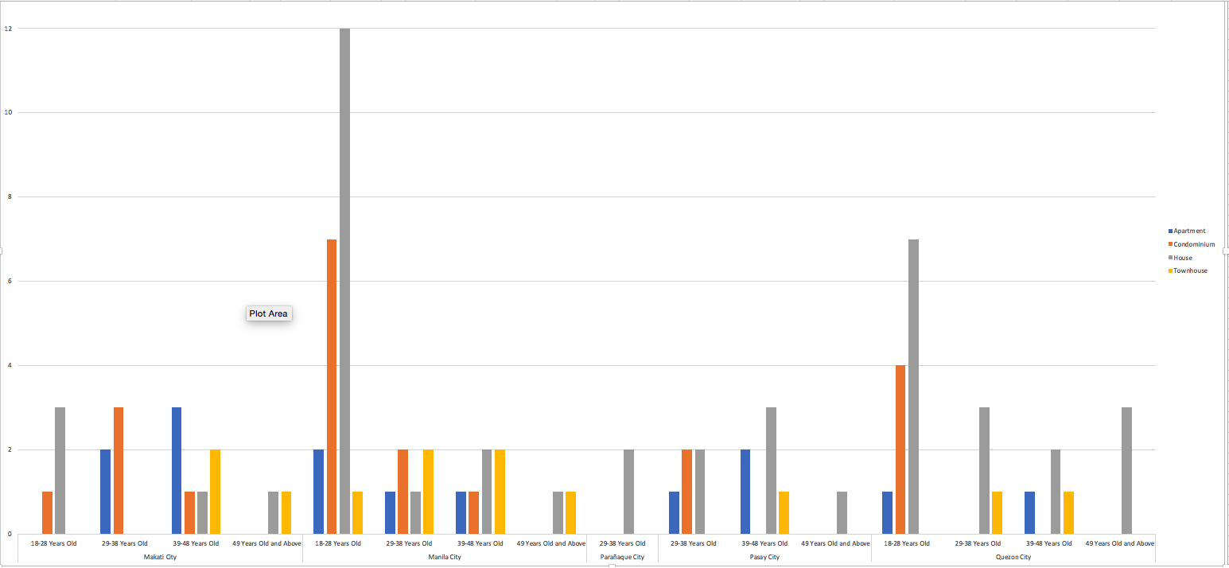

The group’s survey identified the employment status and the salary of each different age group. The age group of from 28 - to 39 years old has a salary ranging from 20,000 pesos to more than 30,000 pesos. Identifying the salary / allowances helps the researchers know the capabilities of the each different age group in using the application.

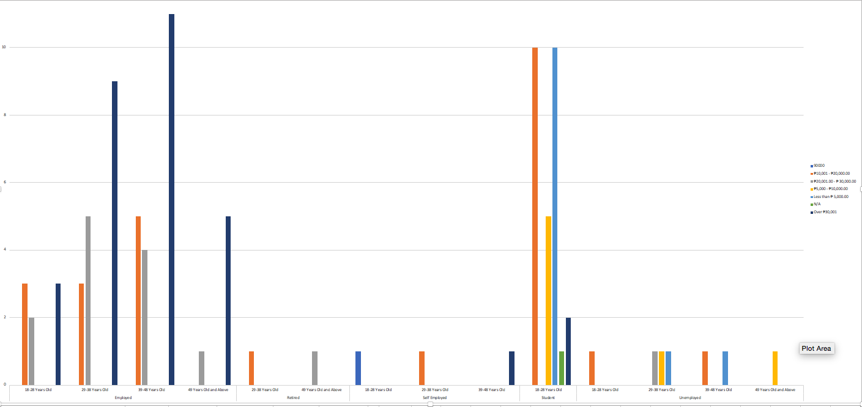

Researchers also identified the most common services being availed by these different age groups. The following are the most common services being availed:

Air Condition Cleaning

There are a total of 72 respondents out of 91 who are availing air condition cleaning services. Some of these respondents are also availing other services besides air condition cleaning. The survey also covered how frequent this service is being availed, majority of the age group says they often avail air condition cleaning

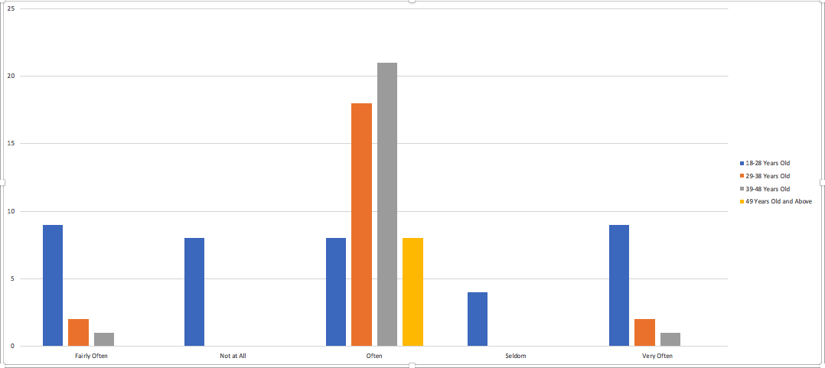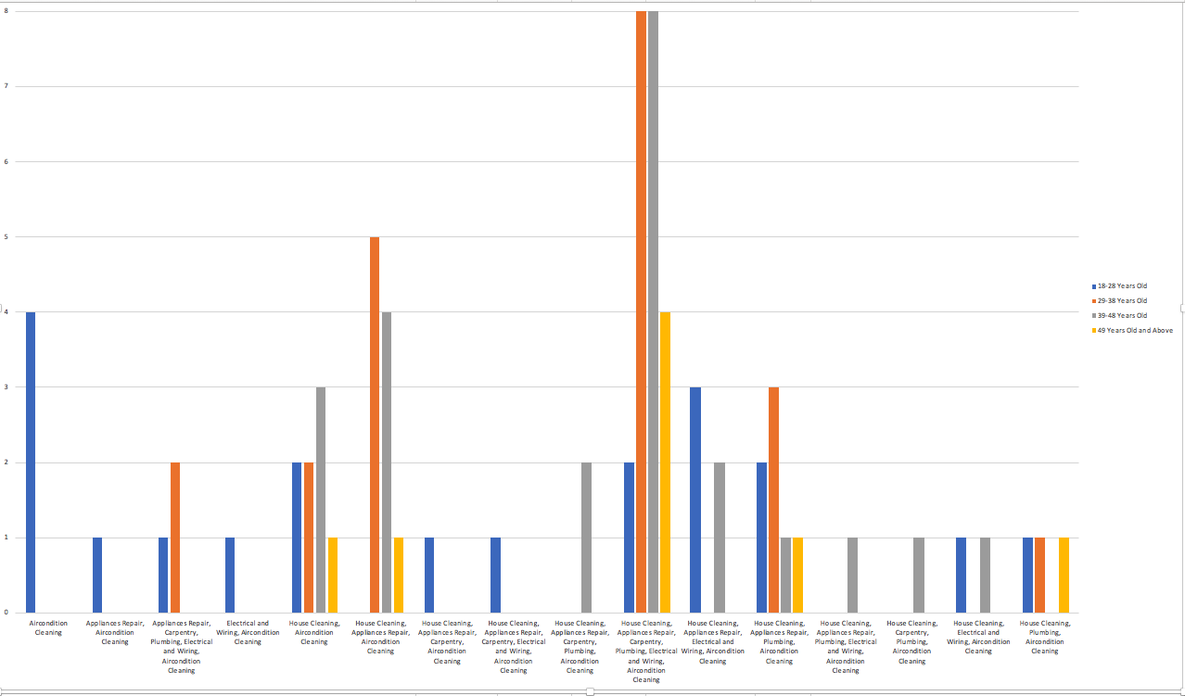

Appliances Repair

There are a total of 61 respondents out of 91 who are availing appliances repair services. Some of these respondents are also availing other services besides air condition cleaning. The survey also covered how frequent this service is being availed; age group from 29 - 48 years old says they often avail the service while some from the age group of 18 - 28 said they avail the service fairly often or seldom.

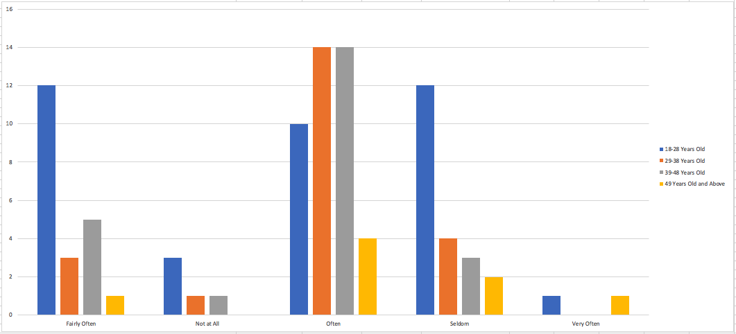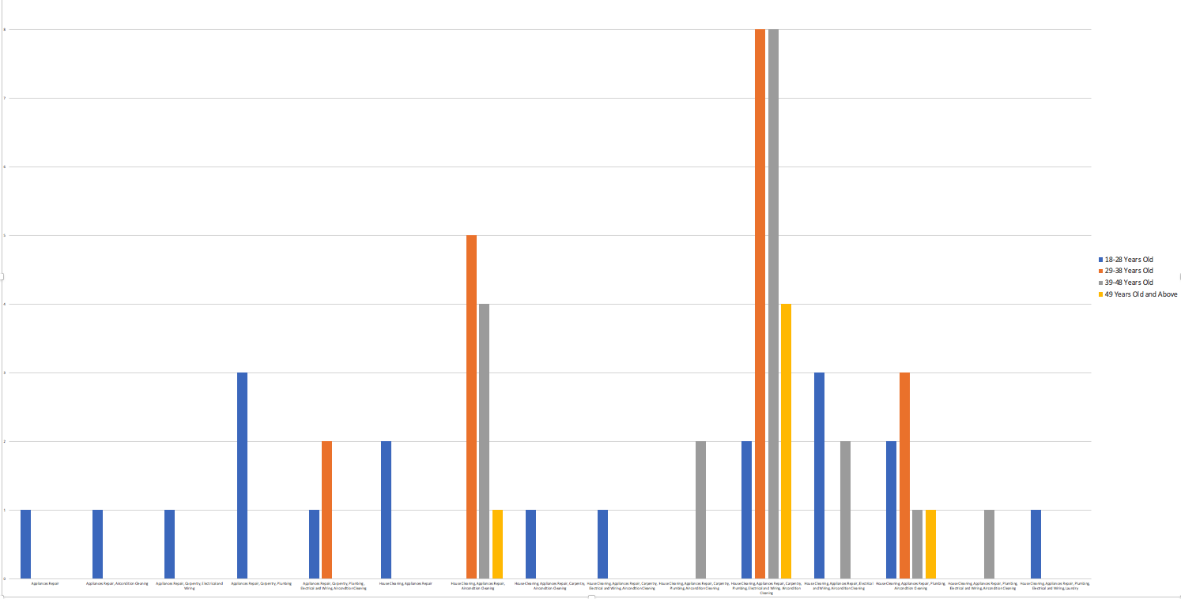

Carpentry

There are a total of 37 respondents out of 91 who are availing carpentry services. Some of these respondents are also availing other services besides air condition cleaning. The survey also covered how frequent this service is being availed, majority of the respondents said the seldom avail carpentry while some avail carpentry fairly often.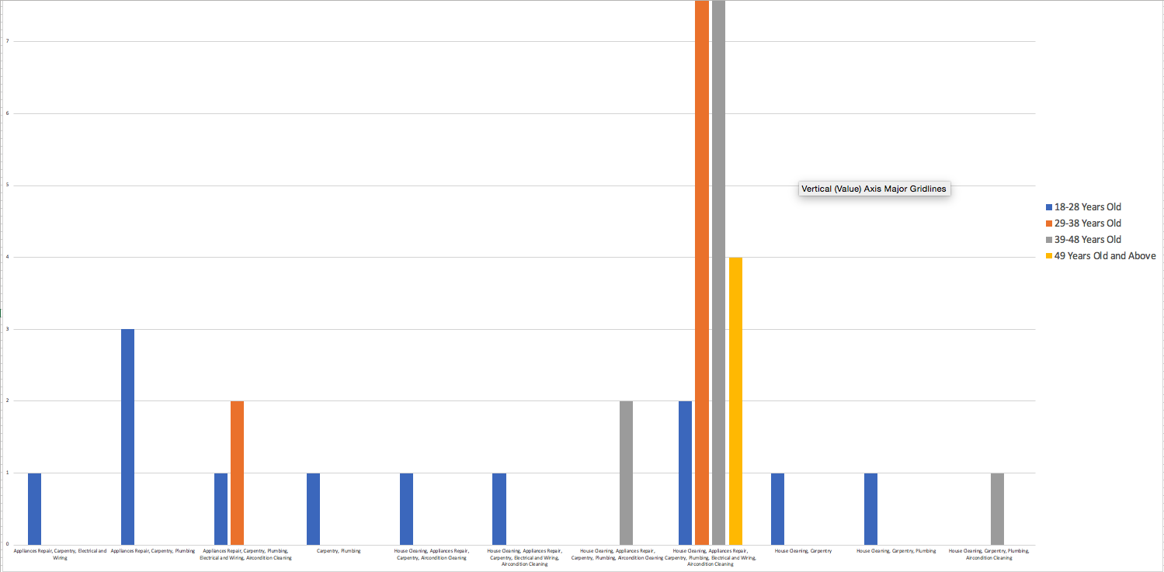

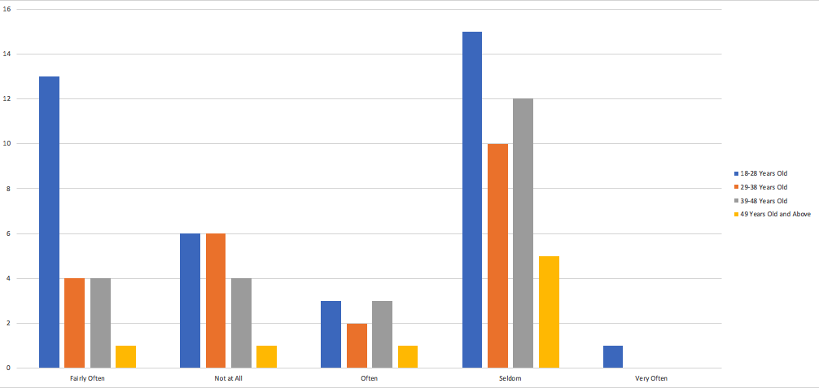

Electrical and Wiring

There are a total of 38 respondents out of 91 who are availing electrical and wiring services. Some of these respondents are also availing other services besides air condition cleaning. The survey also covered how frequent this service is being availed, the age groups are divided from availing the service seldom and often.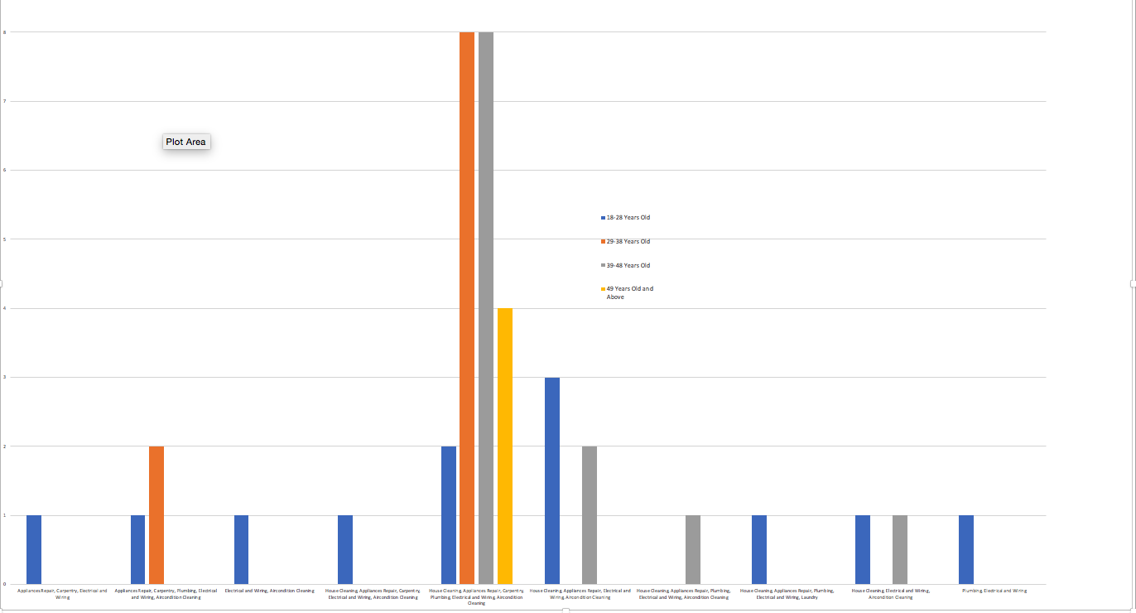

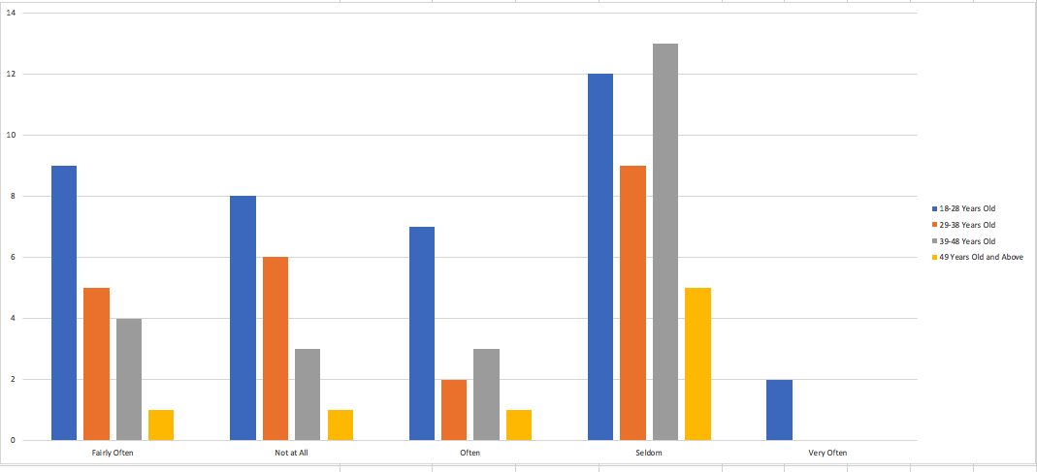

House Cleaning

There are total of 75 respondents out of 91 who are availing house cleaning services. Some of these respondents are also availing other services besides air condition cleaning. The survey also covered how frequent this service is being availed, majority of the respondents said they often avail house cleaning services.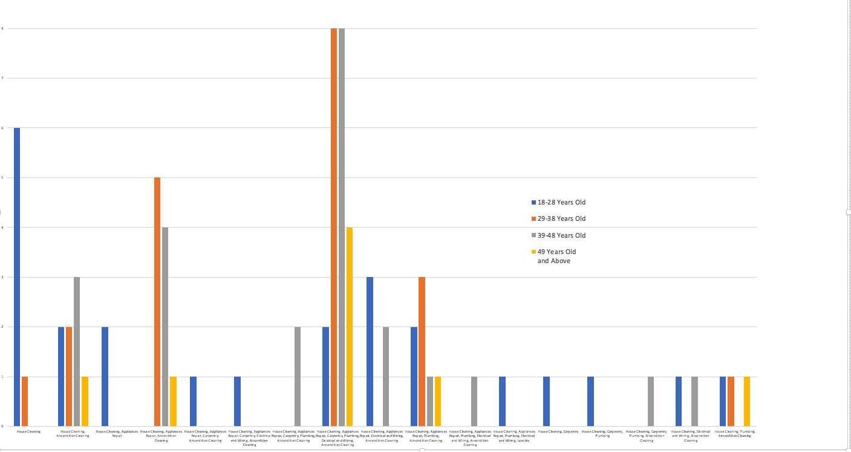

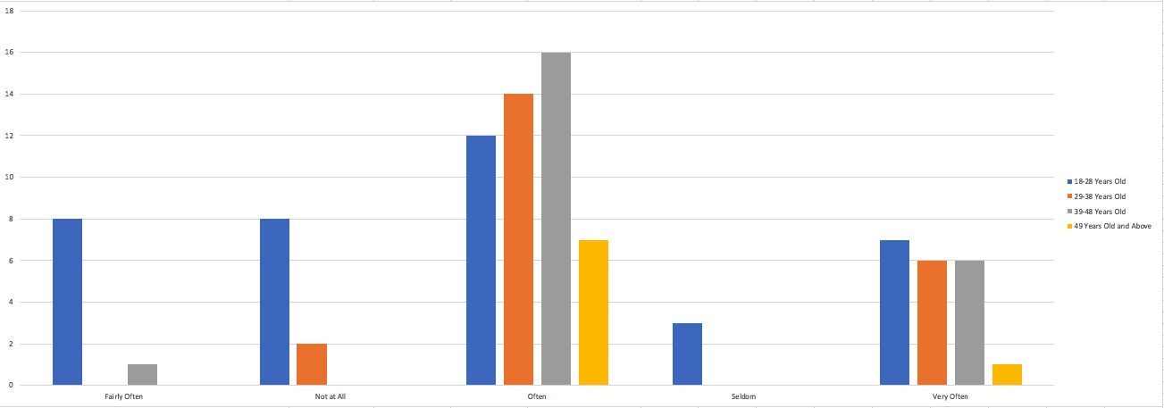

Plumbing

There are total of 75 respondents out of 91 who are availing house cleaning services. Some of these respondents are also availing other services besides plumbing. The survey also covered how frequent this service is being availed, majority from the age group of 18 - 28 years avails the service fairly often while the rest of the age group are availing it often and some seldom.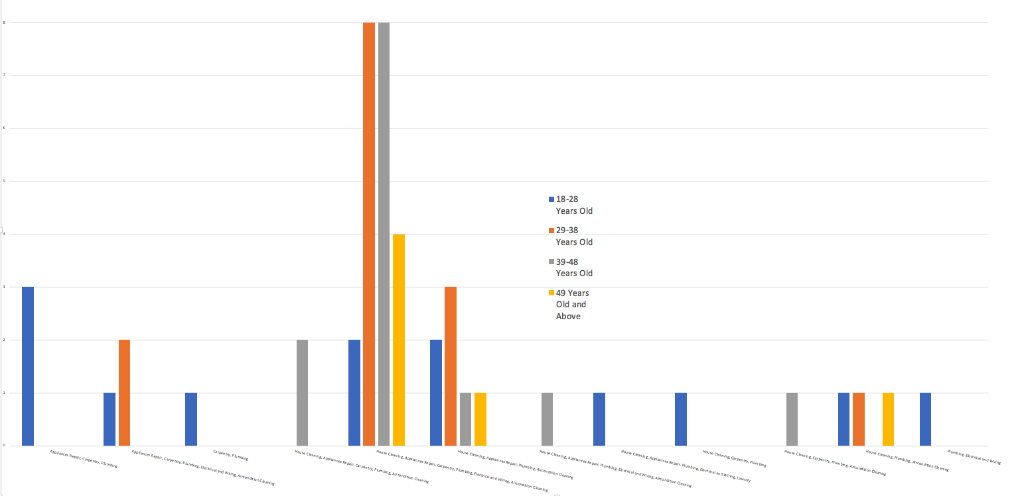

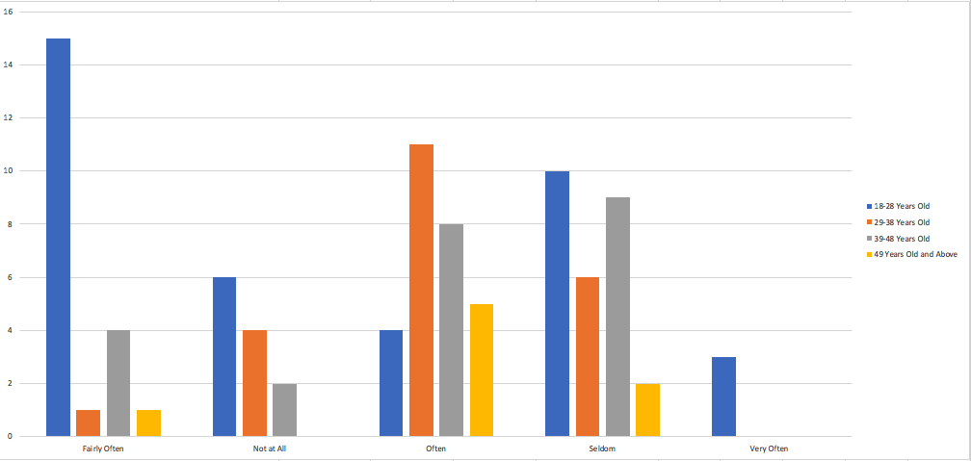

Customer Concerns

The researcher's identified the different concerns that the respondents encounters when availing services. Majority of the different age groups encounters the following; Skill set needed for the job, security, the quality of work, and the pricing of the services.

Skill set needed for the Job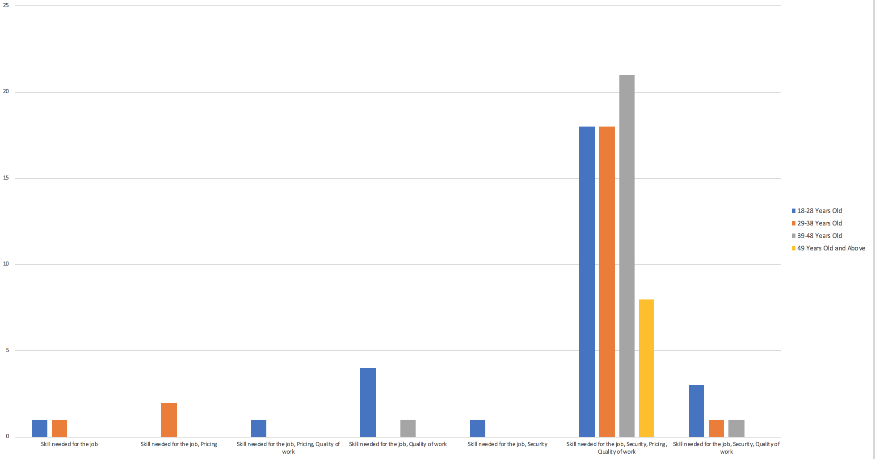

Security

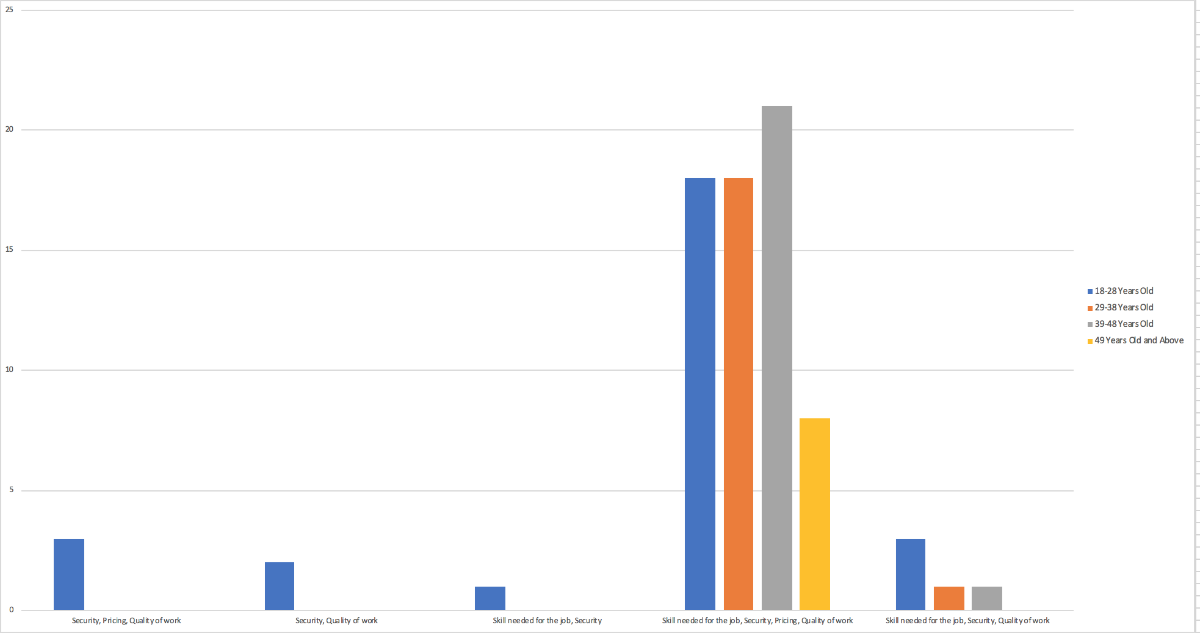

Quality of Work

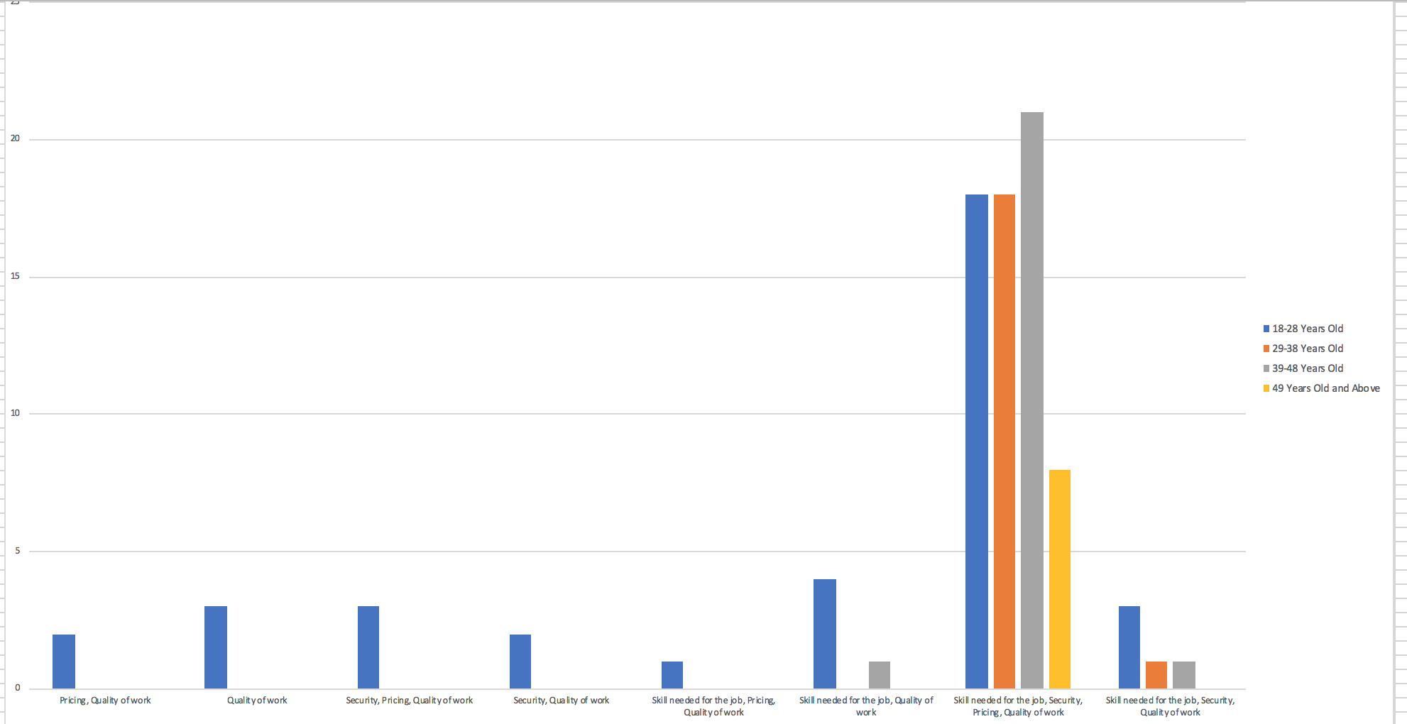

Pricing of the Services

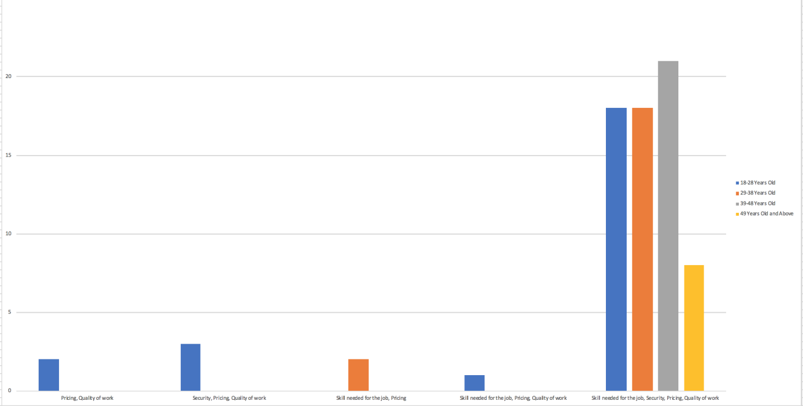

To know more about the capabilities of our target market to use our application, we’ve asked them how they pay for each service they avail and how likely/willing they are in using an online mode of payment. The majority of each different age groups pays via cash for each services they avail. 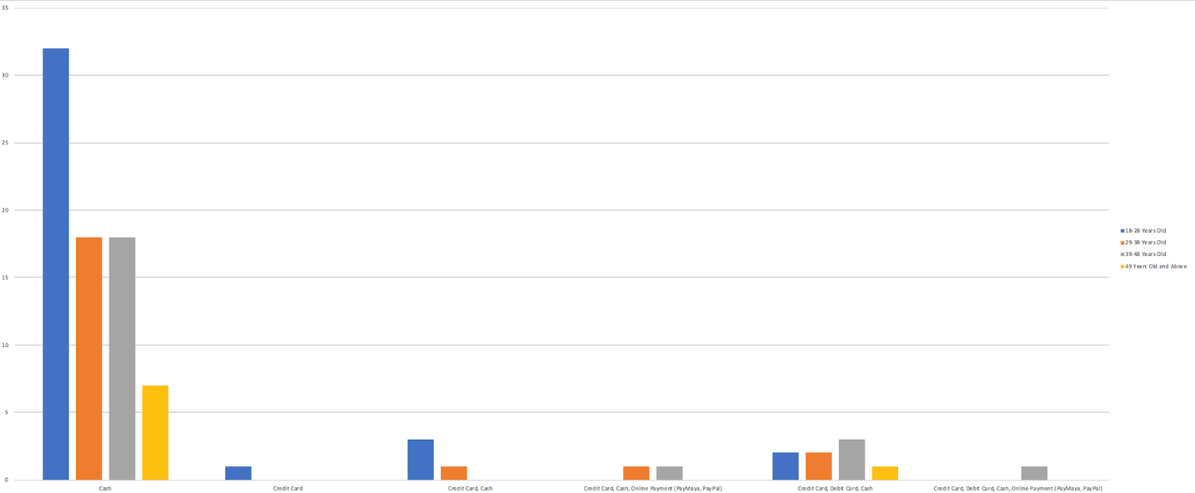

The researcher asked the respondents if they’ve used an online platform called PayMaya before. They’ve asked if they are willing to pay using it for the services that they are availing. Majority of each age group said that they are likely to use paymaya to pay for transactions. 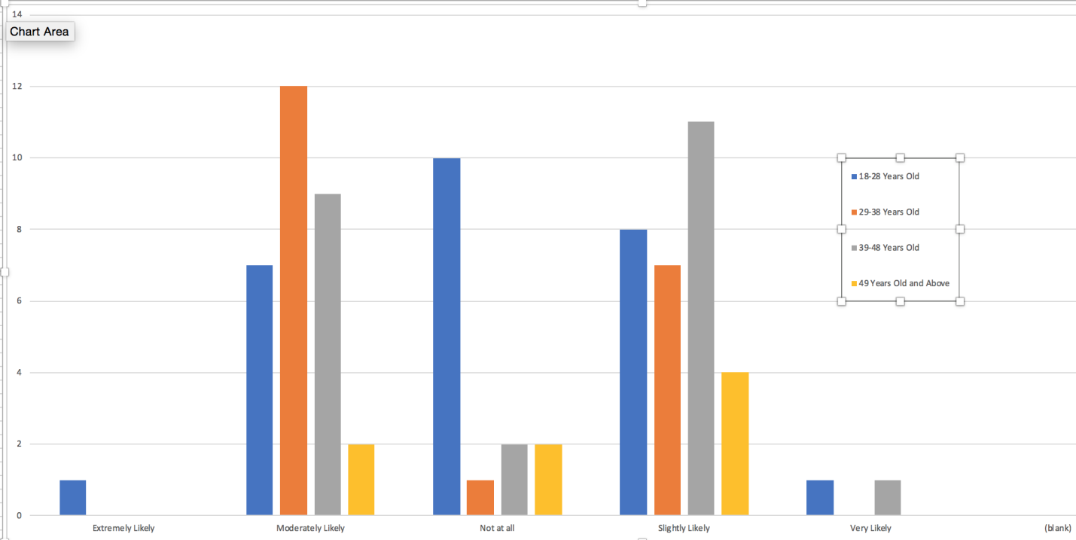

Lastly, the researcher asked the respondents are willing to pay a commission fee for each service that they’re going to avail. Majority of each age group answered that they are moderately willing to pay the commission fee. 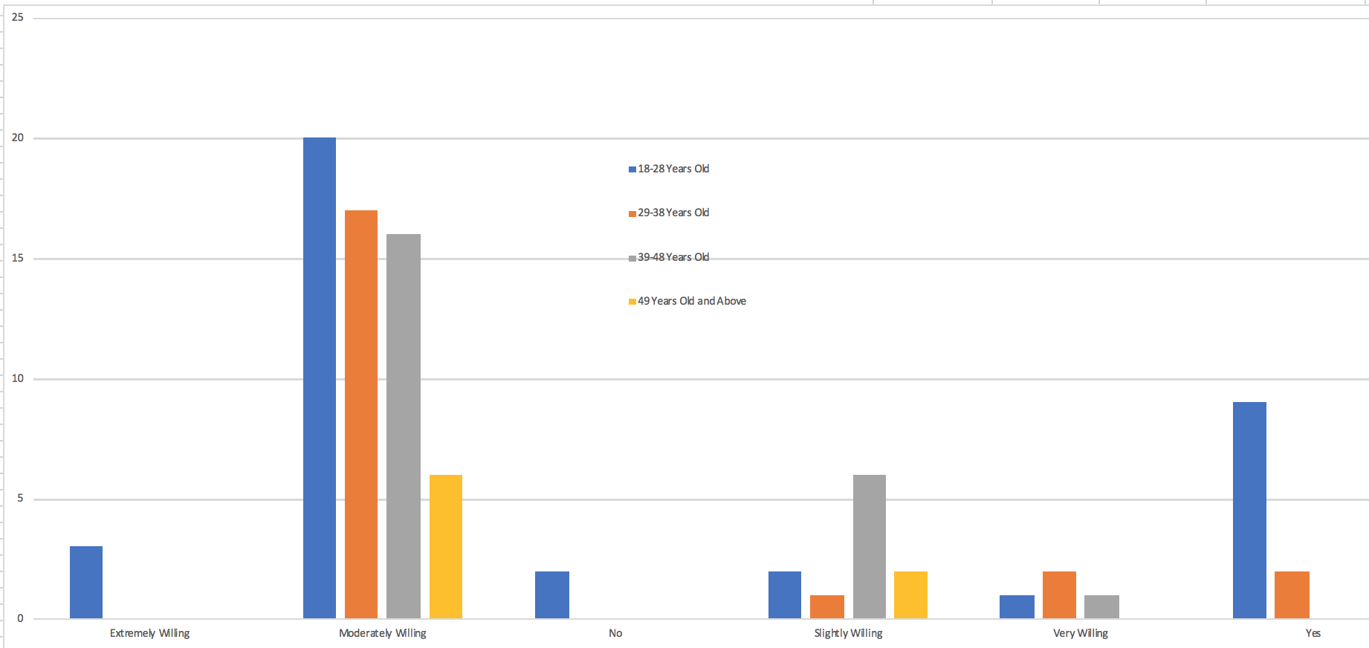

## **Scope and Limitations**

### Scope

The application will be covering six(6) service for now, namely; Air Conditioner Cleaning, Appliances repair, Carpentry, Electrical and Wiring, House Cleaning, and Plumbing. The Suyo application will be launched in Manila, Makati, and Quezon City.

The system will cover home repair services; these are the following scope of the system:

* A Register and Login page for both Customer and service provider.
* Show nearby services within customer’s vicinity in which they can change the preferences of far and what services to show.
* Customer can book by direct booking to the service provider shown in the map or they can use the broadcast booking.
* Within the booking, customer can pick the date and time of when they would like to have the service. After this they can have the option to add remarks and picture of the problem then send.
* Customer and Service provider can manage their bookings, in which they can also view past transactions.
* As an extended feature for the service provider. Transactions can show or view their earnings for the month.
* For our online payment, PayPal will be involved and will be part of the feature that supports transactions online.
* A quotation feature allows the service provider to send a second quotation
* Service providers can make a business profile this contains their information, might contain a profile picture, full name of both the service provider and business, contact number, email, and business permits. This will also show ratings and comments of the customers.
* Service providers needs to upload a picture of themselves and upload business permits or others like a diploma this allows us to verify them
* The customer can rate the service provider by giving a star as percentage. This will allow the customers to know what service has a good rating compared to the ones that have low ratings.

### Limitations

The system’s limitations are the following:

* The system will not be covering any call and chat features regarding the communication between the customer and the repair service providers.
* The system will only cover one particular place, that being Metro Manila which will be the coverage area of the project.
* The system is only accessible from a smartphone.

## Assumptions

* All service providers have their own tools
* All service providers and customers have smartphones capable of running our application
* File size and types; all sizes of files and png, jpeg, jpg files for image formats as long as it will not exceed 25 MB
* Price rates will be based on the agreed price of customer and service provider
* Payment options will be through cash and online payment assume they, customer and service provider have the PayMaya card to accept and receive payments. PayMaya card is also needed to pay commission fee.
* Assume PayMaya card has load balance to pay our services if customer prefer online payment and for service provider commission fee
* Radius map will be within 1000 meters or 1 km. this is the radius of all services that the app will load within customer. This will be able to use advanced search the radius up to 5000 meters or 5 km.
* There will be a fixed price based on the survey conducted before. The fixed price can still be change after the assessment of the problem. Suyo system will allow price override after the assessment only if the customer agrees.
* Based price will be based on the survey conducted therefore price will be fixed and will base on the description of services though this might change if the service provider have found a larger problem during the service and will override the price of the service, this of course if the customer agree to change.
* Requirements for Acceptance

1. Birth certificate
2. Transcript of Records/Diploma
3. NBI clearances
4. SSS
5. PAG-IBIG
6. Phil Health
7. BIR forms

* Scheduling Policy

The purpose of the scheduling policy is to provide a guideline for the service providers when registering their time schedule to SUYO. This would aid in the confusion of inputting their preferred/available dates.

1. It is the responsibility of the service provider to input their appropriate time schedule upon registering to SUYO.
2. The schedule submitted by the service provider will be verified by the admin of SUYO to avoid complications in scheduling work.
3. The service provider will be informed if there Is a change in their schedule to avoid overlapping.
4. The availability of the schedule will be in a first come first served basis.

* Cancellation Policy

This is to inform the service providers that there will be penalties if the service provider cancels a scheduled task. This would help the service providers in a way that they will be given a certain allowance for cancellation.

1. Service provider will be given an allowance of 5 cancellations per month.
2. Exceeding the allowance of 5 cancellations would result to the suspension of your account to a maximum of 2 days.
3. Service providers may cancel tasks without being charged with a cancellation fee
4. Cancelled tasks will be monitored by the admin, the system will warn the service provider after a third cancellation.
5. Customers are charged with a cancellation fee of 50 pesos if they cancel a booked task a day before without a valid reason.

* Blacklisting Guideline:

1.) Three (3) minor incidents is equal to a major offense leading to suspension of the users account

2.) Minor offenses:

- Service provider accepted but did not arrive

- Service provider is late

- Service provider mistreated the customer (rudeness, use of profane language)

- Service provider slacking on the job

- Service provider is asking more than what is needed to pay.

3.) Major offenses:

- Theft

- Injuring the customer

- Intentionally destroying customer’s property

- Identity theft (service provider sent a worker not included in the details of suyo)

- Service provider does not complete the job

- Foul Words

- Profanities

# **ANALYSIS OF THE EXISTING SYSTEM**

## **Use Case Diagram**

|  |  |
| --- | --- |
| Use case Diagram | Reference Number: ES-UCD-1 |
| Version Number: v1.3 |
| Existing System | |
| https://lh6.googleusercontent.com/u2JfcSVf5WdtGu5BlcweO-5wbCQzybIHPM5JTD9sgeQim6lWOKLUnnPZJYiD_u2RnQmtlaEcXdHiafEFIunsyeWOHz8HdJ_Jnieporg1ujkxUxGYQKKhx0vHqgZgxmdUn2xx7C2u | |

## **Use Case Narratives and Activity Diagrams**

Title: Find service provider

Summary: Process in finding a service provider.

Actors

1. Customer

Creation Date: October 23, 2018                 Update Date: November 7, 2018

Version: v1.3                                                   Person/s Responsible: Bryan Yabut

Flow of Events

Preconditions:

1. The customer must have problems in their home.

Main Success Scenario:

1. The customer asks for recommendation from a friend.
2. The customer asks the friend about the quality of work of the service provider.
3. The customer asks the home address of the customer.
4. The customer goes to the address of the service provider.
5. The customer nocks on the house of the service provider.
6. The service provider asks the customer.
7. The customer tells the service provider for a need of service.
8. The service provider responds to the customer.
9. The service provider asks for the problem.
10. The customer tells the problem.
11. The service provider accepts the request of the customer
12. The service provider gives the number to the customer.
13. The customer receives the number.

Alternative Sequence:

A1a. Finds ads from street poles

1. The customer reads the poster.

1a. The customer saves the number of the service provider.

1. The customer calls the service provider.

A1b. The customer asks around the neighborhood.

Error Sequence:

EA1. The customer ignores the tampered poster.

E11. The service provider did not accept the request.

Postconditions:

1. The customer successfully found a service provider

|  |  |
| --- | --- |
| Activity Diagram | Reference Number: AD-ES-1 |
| Version Number: v1.3 |
| Existing System | |
| Subject: Find System | |
| Description: https://lh5.googleusercontent.com/CCQ3qLeYsryxXt36-RiE9l_dqSy0Cpclj4s1NN9tpfp40T42oNlZveLc4xjJ_n54Skn_pjGFZNuwEJTlre4Wvjez3BWaMA0Eiky3mJY2dK-e0xz5-nd_1j9dN46Rc7Y69BYxF-zO | |

Title: Call service

Summary: Process of calling a service provider

Actors

1. Customer
2. Service provider

Creation Date: October 23, 2018                 Update Date: October 23, 2018

Version: V1.3                                                  Person/s Responsible: Bryan Yabut

Flow of Events

Preconditions:

1. The customer must have found a service provider.
2. The service provider must agreed to do the service.

Main Success Scenario:

1. Customer dials the number of the service provider.
2. The service provider’s phone rings.
3. The service provider answers the call.
4. The service provider asks the caller’s name.
5. The customer reminds the service provider.
6. The service provider remembers the caller.

Error Sequence:

E2. The customer dialed an invalid number.

E3. The customer hung up because of wrong number.

Postconditions:

1. The customer successfully called the service provider.

|  |  |
| --- | --- |
| Activity Diagram | Reference Number: AD-ES-2 |
| Version Number: v1.3 |
| Existing System | |
| Subject: Call Service | |
| Description: https://lh4.googleusercontent.com/2Vfj2wg9x8CxrS1ky4yE3kvDJ1JuvyOXs-J-ivtU-a-mU1XeET94LTtSxYX-rIwHegjg45kaCqR2jbJ1elZ_CBSaVOxrp1nmzRlJiMfMmkEq6o8ilDDsA5Ogaswrevyn-IJ_GJ1V | |

Title: Ask description

Summary: Process in asking description about the service.

Actors

1. Customer
2. Service provider

Creation Date: October 23, 2018                 Update Date: October 23, 2018

Version: v1.3                                           Person/s Responsible: Bryan Yabut

Flow of Events

Preconditions:

1. The customer must have called the service provider.
2. The customer must have seen the service provider.

Main Success Scenario:

1. Customer asks how long would it take for the service to be done.
2. Service provider tells how long it would take him to finish the work.
3. The customer asks for the price of the service.
4. The service provider tells the price.
5. The customer accepts the price.
6. The customer asks when will the service provider starts the work.
7. Service provider tells when.
8. The customer agrees the date.

Alternative Sequence:

A5. The service provider asks for the budget of the customer, because the customer did not accept the price.

1. Customer tells the budget.

1a. The service provider adjusts the price.

A8. The customer did agree on the date

1. The service provider re-schedules the date.

Error Sequence:

EA5. The service provider did not adjust the price.

Postconditions:

1. The customer successfully asked the description of the work.
2. The service provider successfully asks the customer for the right price and date.

|  |  |
| --- | --- |
| Activity Diagram | Reference Number: AD-ES-3 |
| Version Number: v1.3 |
| Existing System | |
| Subject: Ask Description | |
| Description: https://lh5.googleusercontent.com/LoTlTZxt60rm-IFFjER3UcCiv5sbImH9LIFQ4glWZPdOj2gFsTpetCM29aNq9DTHL4RzdqeYpI-3VYD1G3D1xXIHOvXU7jTGPBejdtkIy7XfUarmZCctAGyCt4KKvFdyjrK0jjiZ | |

Title: Do Service

Summary: Process of doing the service.

Actors

1. Customer
2. Service provider

Creation Date: October 23, 2018                 Update Date: November 7, 2018

Version: v1.3                                          Person/s Responsible: Bryan Yabut

Flow of Events

Preconditions:

1. The customer must have called the service provider.
2. The customer and the service provider must have agreed upon the description.

Main Success Scenario:

1. The customer explains the problem.
2. The service provider checks the problem.
3. The service provider buys the materials.
4. The service provider uses the materials.
5. The service provider starts the work.

Alternative Sequence:

A3. The customer buys the materials.

1. The customer gives the materials to the service provider.

Error Sequence:

E5. The customer cancels the work.

E5. The customer delays the service.

1. The customer tells the service provider to start the next day.

1a. The service provider accepts the offer.

Postconditions:

1. The service provider successfully starts the job.
2. The customer successfully tells the service provider to do the work.

|  |  |
| --- | --- |
| Activity Diagram | Reference Number: AD-ES-4 |
| Version Number: v1.3 |
| Existing System | |
| Subject: | |
| Description: https://lh5.googleusercontent.com/mo7zRmPtOS3duqrezt5qM0JXdkrwKDWUKc5lODw9fIJsCTGgU29R_DOd4mmVXWJS-NIiPkxrXY4JM5Jnk7KwNYshvImjFZf_kToxqnq7TaJJN1gME0-x4Svr5GeHagBbvOEZ8ACd | |

## 

Title: Pay Service

Summary: Process in paying the service provider.

Actors

1. Customer
2. Service provider

Creation Date: October 23, 2018                 Update Date: October 23, 2018

Version: v1.3                                                Person/s Responsible:

Flow of Events

Preconditions:

1. The service provider must have done the work.
2. The customer must have accepted the service.

Main Success Scenario:

1. The customer asks if the service provider is done on his work.
2. The service provider tells the customer that the job is done.
3. The customer checks if the work is okay.
4. The customer pays the service provider.
5. The service provider receives the payment

Error Sequence:

E2. The service provider tells the customer that the work is still ongoing.

E4. The service provider redo the service because of defects.

Postconditions:

1. The customer successfully pays the service provider.

|  |  |
| --- | --- |
| Activity Diagram | Reference Number: AD-ES-5 |
| Version Number: v1.3 |
| Existing System | |
| Subject: | |
| Description: https://lh3.googleusercontent.com/s0945VmhBeHkYQOkpKo5sLA1X5nNcDApDVfBWTqTJHc6KevkiHfPy7It7eNrArJvD0Cwx9pfb7sBPRX8mA7fcdfLSkvr4mBSe-Anmg_vDb5m0jUdV5qrBvMGydDflVwtwZXxSRYE | |

## **Problems and Recommendations**

|  |  |
| --- | --- |
| PROBLEMS | RECOMMENDATIONS |
| Quality of work – Customers availing services from blue-collar workers, needs to know whether the workers are giving their realistic information about their profession. | * All service providers must provide to us: certifications, trainings attended, educational attainment, and letter of recommendation from previous customers before they can partner with Suyo. * Provide a customer’s feedback about the services rendered by a blue-collar worker to know whether the output of the service is in the approval eyes of the customers. Feedbacks will be show in the profile of the service providers. * Provide ratings to the service provider. Rating will be shown in the profile of the service provider |
| Skill needed for the job – Customers ask questions personally to the service provider to know whether or not they are qualified to do the job. | * Create a business page where service providers may insert descriptions about their skills. * All service providers must provide certifications, trainings attended, educational attainment, and letter of recommendation from previous customers before they can partner with Suyo. |
| Pricing – Price are still not fixed from the beginning of the service to the end of the service in the manual process. Most of the customer and service provider are negotiating about price even after the service is done. | * A Chat feature for thorough assessment and for better price and quotation in which both customer and service provider can agree and disagree. |
| Security – Most of the customer does not give any assurance of their property being safe with a service provider. | * All service provider must provide government clearances (barangay, police, NBI) and valid ID before partnering with Suyo * Provides blacklisting features to the system. Any service provider that committed any crimes or are not honest about their work will be banned of the application. |

# DESIGN OF THE PROPOSED SYSTEM

## **System Features and Functionalities**

|  |  |
| --- | --- |
| Features | Functions |
| Registration and Login Feature | * Allow user to sign up for an account * Allow user to login using his/her account * Allow user (customer) to book service * Allow user (service provider) to create business page |
| Map Feature | * Allows user (customer) to see nearby services through the use of Google Map API for viewing all registered service providers * Allows user to adjust vicinity radius, add filter (price and service), and to search service |
| Booking Feature | * Allow user (customer) to choose a service * Allow user (customer) to book chosen service |
| Service Requirements Feature | * Allow the user (service provider) to provide information about himself and set an interview appointment through the app |
| Service Quotation | * First Quotation: will depend on the price in the Description * Second Quotation: Depends on the estimated some basic service or major service or service that service provider has a limit and might require additional price which will be added to the price. Once it was Accepted price can't be changed but dates can be changed and concerns can be added. |
| Tracking Feature | * Allow the user (service provider) to track customer’s location * Gives direction and shortest path |
| Ratings and Comments Features | * Allow user (customer) to give feedbacks to a service provider |
| Email Notifications | * Provides an e-receipt for both customer and service provider that would copy the transaction a service has been completely paid * Provides an account activation for both customer and service provider * Provides email notifications for password reset |
| Business Profile Feature | * Allows user to (service provider) to create a business page that contains his/her educational attainment, certifications, services offered, clearances, ratings, and comments |
| Booking Management | * Allows user both users (customer and service provider) to manage their bookings * Allows both users (customer and service provider) to see their ongoing booking |
| Chat Feature | * Allows the customer and service provider to communicate with the applications through the use of Firebase Cloud Messaging (FCM) API that will handle all chat capabilities |
| Online Payment | * This allows customer pay service provider online and service provider to pay or remit the commission fee online with the use of Paymaya api. |
| Report provider | * As a part of the feature for comments and ratings. Customers can report a service if the provider made a violation. |
| Admin reports | * Allows admin to view all of the reports of customer and service provider through a dashboard. * Types of reports: * Financial report * Complaints * User log reports * Account reports |
| Reports Download(Admin) | * Allows admin to download data as a Portable Document Format (PDF) * The available data that the admin can download are the following: * Complaints * Financial Reports * Account Reports * Log audits |

## **System Security Features and Functionalities**

|  |  |
| --- | --- |
| 1. Broken authentication protection | * Implementing the use of proper HTTP methods when making a request. * Limiting failed login attempts for each user. * Implementing a password complexity requirement during registration. It must not be less than eight characters, it must also contain one or more of the following: * Uppercase letters * Lowercase letters * Number * Special characters |
| 2 Password Encryption | * For storing passwords, the system will be using Advanced encryption standard using a 256 algorithm. |
| 3. Cross-Site Scripting (XSS) protection | * The system must implement a functionality or input validation that disregards inappropriate inputs. * The functionality must have a server-side validation instead of using the default validations (e,g, required). |
| 4. SQL injection protection | * The system must have a protection for malicious SQL commands that can be passed in the query allowing the attacker to make unintended commands within the system’s database. * Implementation of parameterized query, or if possible, a stored procedure. * Same as XSS protection, an input validation and input filtering |
| 5. Access levels and permission | * The system will be having a level of access for each user, depending on the type user. |
| 6. Log auditing | * When storing data, the system audits who and when it was stored and modified. The system will also audit and track a user of what they do within the system. |
| 7. Captcha | * Implementation of Captcha or reCaptcha api for both web app and android app‘s registration and login. Preventing the risk of spamming and creation of spam accounts. |
| 8. PCI DSS compliance | * The system will be using a the payment feature of Paymaya for transactions on the app. Payamaya undergoes the compliance of PCI-DSS certification[1]. |

## **Booking Module**

|  |  |
| --- | --- |
| Use Case Diagram | Reference Number: BKM-UCD-1 |
| Version Number: v1.1 |
| System Name: Suyo | |
| https://lh6.googleusercontent.com/qMTdD7DefgEn4KkXb-7qcRQSIetSsBC2EkBb_BCRySQLxX0bQ7NnNobGX49GyCmqzc8fmM_MmWxkyUThHeVVU4HPKRu9cWNhjb7fam7zBC9Z33gjPRaWRG_6KcIWxrvdy9YrHrE6 | |

Title: Sign up

Summary: Process in signing up

Actors:

1. Customer
2. System Suyo

Creation Date: October 23, 2018 Update Date: October 23, 2018

Version: v1.2 Person/s Responsible: Bryan Yabut, Cyruss Corpuz

Flow of Events

Preconditions:

1. The customer must have email address.
2. Customer must have an internet to access the application.

Main Success Scenario:

1. Customer opens the application.
2. The customer taps sign up.
3. The customer inputs the credentials.
4. The customer taps submit.
5. The system validates the inputs and validates the email address of the customer.
6. The system sends email confirmation.
7. The customer confirms email address.
8. The system validates the email of the customer.
9. The system saves the credentials to database.

Alternative Sequence:

A1. The customer has an account.

1. The customer clicks login.

1a. The customer logs in using google account.

2a. The customer logs in using email account.

Error Sequence:

E6. The credentials are invalid

1. The process returns to 3rd process of the main success scenario.

E9. The customer’s email was invalid and then sends the email.

1. The process returns to 6th process of the main success scenario.

Post conditions:

1. The customer successfully signed up.
2. User information is created and system audits the time and date of signup
3. The customer may now login and use the application.

Non-functional:

1. The system must use regex for email validations and verify if the email already exist.
2. The system must allow captcha before the user reaches the conclusion of registering.
3. The system must validate and verify if password contains a minimum of eight characters and have at least one or more uppercase and lowercase letters, numbers, and special characters.
4. The system must encrypt password.
5. All inputs must have corresponding server-side validations from the rest api.

|  |  |
| --- | --- |
| Activity Diagram | Reference Number: BKM-SU-1 |
| Version Number: v1.2 |
| System Name: Suyo Service Booking Application | |
| Subject: Customer Sign Up | |
| https://lh4.googleusercontent.com/K907KIlZghhPj8H2khjDloOwPb7DCypn8GDAEHIdRMmNlkdJOkeflDF1d6CvHyygZfuwqQzMU8nHWjunHr8XLqzbwVYkH7FV2btNAX7zLg_fXs44eWskGJZKq-A8A0aYgsUUe7pw | |

Title: Log in

Summary: Process in logging in

Actors:

1. Customer
2. System Suyo

Creation Date: October 23, 2018 Update Date: October 23, 2018

Version: v1.2 Person/s Responsible: Bryan Yabut, Cyruss Corpuz

Flow of Events

Preconditions:

1. The customer must have an account.

Main Success Scenario:

1. The customer opens the application.
2. The system checks the validity if the customer is logged in or not.
3. The system directs the customer to the home page of the application.
4. The customer taps log in.
5. The customer enters credentials.
6. The customer submits the credentials.
7. The system validates the inputs.
8. The system directs to the main page of the application.

Alternative Sequence:

A3. The customer is already logged inside the application.

1. The system directs to the main page.

A4. The customer logs in using google account.

1. The system validates the google account.

Error Sequence:

E4. The customer doesn’t have account.

Postconditions:

1. The customer successfully logged in the applications.
2. Customer login time and date is audited.
3. The customer may now use the application.

Non-functional Requirement:

1. The system must perform a limit of 5 failed login attempts will block the use account from the device temporarily and system will recommend to use another and a valid account to continue.
2. All inputs must have corresponding server-side validations and error response from the server.

|  |  |
| --- | --- |
| Activity Diagram | Reference Number: BKM-SU-2 |
| Version Number: v1.2 |
| System Name: Suyo Service Booking Application | |
| Subject: Customer Login | |
| https://lh3.googleusercontent.com/HTweKMr1jRFr7amVAb4CdHOeKfov00jJYYeTbxd0cS8k-fY3Jfj1ze5mR-_1tAhy6kgY0_E5qQfQGxWMJRJWHm_pZ6jg2UpF9XZ-Q-bXO--0jNahksR0ZU9j1bqUMO3zBvP7emLr | |

Title: Find Service

Summary: Process in finding service.

Actors

1. Customer
2. System Suyo

Creation Date: October 23, 2018 Update Date: October 23, 2018

Version: v1.2 Person/s Responsible: Bryan Yabut, Cyrus Corpuz

Flow of Events

Preconditions:

1. The customer must have an account.
2. The customer must be logged in.
3. The customer must have a house problem.

Main Success Scenario:

1. The system gets the customer location.
2. The system loads the businesses nearby the customer vicinity.
3. The customer taps search bar.
4. The customer inputs in the search bar.
5. The customer submits.
6. The system updates the service in the map.
7. The customer selects a business.
8. The system retrieves business details.

Alternative Sequence:

A3. The customer changes the filters.

Error Sequence:

E7. The search details do not exist.

Post conditions:

1. The customer found a business.
2. The system successfully loaded the details.

|  |  |
| --- | --- |
| Activity Diagram | Reference Number: BKM-SU-3 |
| Version Number: v1.2 |
| System Name: Suyo Service Booking Application | |
| Subject: Find Services | |
| https://lh3.googleusercontent.com/OIDzhQFqasA1enNfRz2wek1YZvPK3zbcLDLNS0TMy6jDv1hFs6a46PGv5tKJiXQVZQ6hTQ0czEq6LK4mAChuCn7WIzlj1dFikCRGBwICq9LtPiRgrEpJNave87VrOuEA_1-kP5Ca | |

Title: Inquire

Summary: Process in inquiring.

Actors

1. Customer
2. System Suyo

Creation Date: October 23, 2018 Update Date: October 23,2018

Version: v1.2 Person/s Responsible: Bryan Yabut, Cyruss Corpuz

Flow of Events

Preconditions:

1. The customer must have an account.
2. The customer must be logged in.
3. The customer must have found a business.

Main Success Scenario:

1. The customer taps chat.
2. The customer inputs message.
3. The customer submits the message.
4. The system saves the message.
5. The system notifies the receiver.
6. Customer waits for a reply.
7. The customer receives the reply of the service provider.
8. The customer did not reply.

Alternative Sequence:

A1. The customer taps book now

A8a. The customer replied to the service provider.

A8b. The customer taps book now.

Error Sequence:

E4. The message was not sent.

1. The customer re-inputs the message.

Post conditions:

1. The customer successfully inquired to a service provider.

|  |  |
| --- | --- |
| Activity Diagram | Reference Number: BKM-SU-4 |
| Version Number: v1.2 |
| System Name: Suyo Service Booking Application | |
| Subject: Inquire | |
| https://lh6.googleusercontent.com/AKut86lhq_1UsJ5OlTCEt-Pkx60xIKzATk5-lEXHqo07Vxp4b-RQV_Sc7UMCGT7NxBewM5Db0geQrtOVJ5FFeS5egk9MD1KxSsNOYHCqe3tKv0-LPKE1mYWCGqE4U9kvg_Y4gHg- | |

Title: Book Service

Summary: Process in booking a service

Actors

1. Customer
2. System Suyo

Creation Date: October 23, 2018 Update Date: October 23, 2018

Version: v1.2 Person/s Responsible: Cyruss Corpuz

Flow of Events

Preconditions:

1. The customer must have an account.
2. The customer must be logged in.

Main Success Scenario:

1. The customer taps book a service.
2. The customer selects a type of service.
3. The customer selects a date and time.
4. The customer inputs the problem remarks.
5. The customer uploads pictures of the problem.
6. The customer submits booking.
7. The system validates the uploads.
8. The system shows the summary.
9. The system saves to customer’s booking, sends notification to the service provider, and then saves to the service provider’s booking.

Alternative Sequence:

A1. The customer taps chat to inquire to the service provider.

A9. The customer returns to edit the booking.

Error Sequence:

E8. The uploaded files are invalid and then returns to the 5th process of the main success scenario.

E9. The customer taps cancel.

Post conditions:

1. The customer successfully booked a service.

|  |  |
| --- | --- |
| Activity Diagram | Reference Number: BKM-SU-5 |
| Version Number: v1.2 |
| System Name: Suyo Service Booking Application | |
| Subject: Book Services | |
| https://lh6.googleusercontent.com/nf-EH4Azz93chFO4yAO7nPe4VgzfuEBPN_ymCEeLC1mSYqrEnzFlpzZycLl6Cr24iUK038TYZI3s6k1ysVbKx9L3yWrCgIsh-NXFYI7xiXI-L9NXcKHv5LS-Q1WP_xtWwGx_R88G | |

Title: Broadcast booking

Summary: Process in broadcasting a booking

Actors:

1. Customer
2. System Suyo

Creation Date: October 23, 2018 Update Date: October 23, 2018

Version: v1.2 Person/s Responsible: Bryan Yabut, Cyruss Corpuz

Flow of Events

Preconditions:

1. The customer must have an account.
2. The customer must be logged in.

Main Success Scenario:

1. The customer taps settings.
2. The customer selects calls out.
3. The customer chooses what type of service.
4. The customer selects a date and time of when service is needed.
5. The customer inputs the problem.
6. The customer uploads pictures of the problem.
7. The customer submits booking.
8. The system validates uploads.
9. The system shows the summary.
10. The system saves to customer’s bookings and then broadcasts to service providers.

Alternative Sequence:

A10. The customer decided to edit the booking.

Error Sequence:

E9. The customer cancels the booking

E10. The uploads are invalid.

1. The process returns to 6th process of the main success scenario.

Post conditions:

1. The customer successfully broadcast a booking
2. The booking is time and date is audited in the database.

|  |  |
| --- | --- |
| Activity Diagram | Reference Number: BKM-SU-6 |
| Version Number: v1.2 |
| System Name: Suyo Service Booking Application | |
| Subject: Broadcast Services | |
| https://lh5.googleusercontent.com/XEytpFYnnq1NzIaUmx0Pquw6okPDBAaB8SIZgj7pLlwrMnlVVYCYDiURfuaYopFvz4s-dbIh9-zGIxYnCtbmOuex4IEmideNn3M0tKqysXyG68fgI-O1ErZ2yiz4cdxsmoDjEGyO | |

Title: Hire service provider

Summary: Process in hiring a service provider.

Actors:

1. Customer
2. System suyo

Creation Date: October 23, 2018 Update Date:October 23, 2018

Version: v1.2 Person/s Responsible: Bryan Yabut Cyruss Corpuz

Flow of Events

Preconditions:

1. The customer must have an account.
2. The customer must be logged in.
3. The customer must have found a service provider.

Main Success Scenario:

1. Customer taps settings.
2. The customer taps call out.
3. The customer taps call out respondents.
4. The system shows the lists of response.
5. The customer views service provider’s response.
6. The system shows the providers response.
7. The customer hires the service provider.
8. The system notifies a service provider.

Alternative Sequence:

A7. The customer taps chat.

Error Sequence:

E8. The system failed to notify the service provider.

Post conditions:

1. The customer successfully hired a service provider.

|  |  |
| --- | --- |
| Activity Diagram | Reference Number: BKM-SU-7 |
| Version Number: v1.2 |
| System Name: Suyo Service Booking Application | |
| Subject: Hire Service Provider | |
| https://lh3.googleusercontent.com/SxHGPBoBJxV0_1fBOl5YMN9XNM88JMPkz0Wq5JQhojHHa8auZCiyBi_iWTaKWEzljUAHMQuT4NFPTFwDb_SYW5ESoR1OuZTFwItQHggj_sb47uyPTMoyR7HvcDqEwskwQjXpFqfj | |

Title: Manage Booking

Summary: Process in managing a booking.

Actors

1. Customer
2. System Suyo

Creation Date: October 23, 2018 Update Date: February 6, 2019

Version: v1.2 Person/s Responsible: Bryan Yabut, Cyruss Corpuz

Flow of Events

Preconditions:

1. The customer must be logged in
2. The customer must have found a service.
3. The customer must have hired a service provider.

Main Success Scenario:

1. The customer taps settings.
2. The customer taps ongoing.
3. The system shows ongoing bookings.
4. The customer taps booking summary.
5. The customer decides to edit the booking.
6. The system send notification to the service provider.
7. The service provider views edits.
8. The system saves the changes.

Alternative Sequence:

A4. The customer taps the chat.

A5. The customer decided not to edit the changes and then goes back to the main page.

A8. The service provider re-edits the booking.

1. The system notifies the customer.

1a. the customer views the profile.

1. The customer agrees to the changes
2. The customer re-edits the booking.

1aa. The process repeats process to 6th process of the main success scenario.

Postconditions:

1. The customer and service provider successfully managed the booking.
2. The Modified booking of time and date is audited

|  |  |
| --- | --- |
| Activity Diagram | Reference Number: BKM-SU-8 |
| Version Number: v1.2 |
| System Name: Suyo Service Booking Application | |
| Subject: Manage Booking | |
| https://lh6.googleusercontent.com/XNlgAquvWyEswCSDru7e-fSt9f7x4TYfhpDkYHXJHmZx61q1Eq41mYld2qpaR27aZFgL7jPExFnFHOIxpA2YAwoibj3oezJLhdx_-cPEfUqcBf2NINXJL3KAi5t8-BRIYkm85ztw | |

Title: Log out

Summary: Process in logging out

Actors:

1. Customer
2. System Suyo

Creation Date: October 23, 2018 Update Date: February 6, 2019

Version: v1.2 Person/s Responsible: Bryan Yabut, Cyrus Corpuz

Flow of Events

Preconditions:

1. The customer must be logged in

Main Success Scenario:

1. The customer opens the settings.
2. The system shows the settings.
3. The customer taps logout.
4. The system ends the session.
5. The system clears the cache data.
6. The system redirects the customer to login page.

Post conditions:

1. The customer successfully logs out.
2. User Session is removed and log time and date is audited

|  |  |
| --- | --- |
| Activity Diagram | Reference Number: BKM-SU-9 |
| Version Number: v1.2 |
| System Name: Suyo Service Booking Application | |
| Subject: Logout | |
| https://lh6.googleusercontent.com/yXn21tDk-lTBiA3izRMPfU4fWQLGhCbx5iRPS_lVvipHqJ9PtJps1KDTz3wIGk_Q6H5jbpJNjIq944d8eYW_S7dYRv62xrHheK8Sd34bWvzsoo68SwiRlfuVpy2AdRUsFupczFsY | |

## 

## **Business Module**

|  |  |
| --- | --- |
| Use Case Diagram | Reference Number: BM-UCD-2 |
| Version Number: v1.1 |
| System Name: Suyo | |
|  | |

Title: Sign Up

Summary: Process of signing up of the service provider.

Actors

1. Service provider
2. System Suyo

Creation Date: October 23, 2018 Update Date: February 6, 2019

Version: v1.1 Person/s Responsible: Bryan Yabut

Flow of Events

Preconditions:

1. The service provider must have downloaded the SUYO application.

Main Success Scenario:

1. The service provider opens the application.
2. The service provider taps sign in.
3. The service provider inputs credentials.
4. The service provider taps submit.
5. The system validates the input and validates the email.
6. The system sends email confirmation.
7. The service provider confirms the email.
8. The system validates the email confirmation.
9. The system saves the account and redirects to account requirements.

Alternative Sequence:

A2. The service provider clicks login.

1. The service provider logs in using google account.
2. The service provider logs in using email.

Error Sequence:

E6. The system detected an invalid email address and credentials of the service provider.

1. The process returns to the 3rd process of the main success scenario.

E9. The system detected an invalid email address.

1. The service provider re-sends the email.

1a. The process returns to the 6th process of the main success scenario.

Post conditions:

1. The service provider successfully signed up in the application.

Non-Functional requirements:

1. The system must encrypt the password of the user.
2. The system must allow captcha before the user reaches the conclusion of registering.
3. The system must use regex for email validations and verify if the email already exist
4. The system must validate and verify if password contains a minimum of eight characters and have at least one or more uppercase and lowercase letters, numbers, and special characters.
5. All inputs must have corresponding server-side validations from the rest api.

|  |  |
| --- | --- |
| Activity Diagram of the Sign Up use case | Reference Number: BM-SPSU-1 |
| Version Number: v1.1 |
| System Name: Suyo Service Booking Application | |
| Subject: Service Provider Sign Up | |
| https://lh5.googleusercontent.com/84nYHQ64z7GKm-pOmD3IkuU_K9hUsLJ9EzLhlViRCK6xA_3XZ4faJ5jCQPe53a7E2r6RBU9OavUSu_4taTh116_x9xhl_EAtno283E2wGNXO9GO9-P8nMGeztQYp_bUl3yRGDjXb | |

Title: Account requirement

Summary: Process in uploading account requirements

Actors

1. Service provider
2. System Suyo

Creation Date: October 23, 2018 Update Date: February 6, 2019

Version: v1.1 Person/s Responsible: Bryan Yabut

Flow of Events

Preconditions:

1. The service provider must have an account.
2. The service provider must be logged in.

Main Success Scenario:

1. The service provider uploads profile picture.
2. The system checks the files uploaded.
3. The system enables next button.
4. The service provider taps next.
5. The system shows the summary.
6. The service provider taps next.
7. The system shows the appointment page.
8. The service provider selects appointment.
9. The service provider taps submit.
10. The system emails the details and saves to the database.
11. The service provider signs in Paymaya account.
12. The system redirects to the main business profile.

Alternative Sequence:

A4. The service provider taps go back.

1. The service provider re-uploads a profile picture.

A6. The service provider taps go back.

1. The service provider re-uploads a profile picture.

Error Sequence:

E3. The system detected invalid uploads.

1. The process returns to the 1st process of the main success scenario.

E12. The system detects invalid paymaya account

1. The process returns to 10th process of the main success scenario.

Post conditions:

1. The service provider successfully uploads account requirements.
2. System audits the date and time of user’s upload.

|  |  |
| --- | --- |
| Activity Diagram of the Sign Up use case | Reference Number: BM-AR-1 |
| Version Number: v1.1 |
| System Name: Suyo Service Booking Application | |
| Subject: Account Requirements | |
| https://lh4.googleusercontent.com/pU2P0dUvx2rVyecUC0cp8acRRf2aCXr-ySOW0sKl8ORyI2eNFAubDsUcYyi09MzKrUrPnACKGa8Xl8ewEVCA4AydjBgybZmP7YG15gONcldBPl8QH8j7hZOoApeFF2ic3dN9u5u4 | |

Title: Log in

Summary: Process in logging in by the service provider in the application SUYO.

Actors

1. Service provider
2. System Suyo

Creation Date: October 23, 2018 Update Date: February 6, 2019

Version: v1.1 Person/s Responsible: Samuel Landoy

Flow of Events

Preconditions:

1. The service provider must have an account

Main Success Scenario:

1. The service provider opens the application.
2. The system checks the validity.
3. The system directs the service provider to the homepage of the application.
4. The service provider taps log in.
5. The service provider enters the credentials or the email and password.
6. The service provider submits the credentials.
7. The system validates the inputs of the service provider.
8. The system directs the service provider to the main page of the application.

Alternative Sequence:

A3. The system detected the account of the service provider is logged in in the device.

A4. The service provider logs in using google account.

Error Sequence:

E4. The service provider doesn’t have an account.

1. The service provider taps sign in.

Postconditions:

1. The service provider successfully logs in in the application.

Non-Functional requirements:

1. The system must perform a limit of 5 failed login attempts will block the use account from the device temporarily and system will recommend to use another and a valid account to continue.
2. All inputs must have corresponding server-side validations and error response from the server.

|  |  |
| --- | --- |
| Activity Diagram of the Sign Up use case | Reference Number: BM-SPLI-1 |
| Version Number: v1.1 |
| System Name: Suyo Service Booking Application | |
| Subject: Service Provider Log in | |
| https://lh5.googleusercontent.com/07iSvubnwiwAjZla_5oDJCyh7ZH8tvRbwHjxCVhtuZYnhdmj044s-XCmzqGbHR9Zlm6Yh_U2V5KxdC7097Yw0Hwt9oEcbi8oTb3oASlHGghYZIb9699J1EopfE6tlbPXR_p_5K39 | |

Title: Create Business Profile

Summary: Process in creating business page.

Actors

1. Service provider
2. System Suyo

Creation Date: October 23, 2018 Update Date: February 6, 2019

Version: v1.1 Person/s Responsible: Bryan Yabut

Flow of Events

Preconditions:

1. The service provider must have an account.
2. The service provider must be logged in.
3. The service provider must have uploaded the account requirements.

Main Success Scenario:

1. The service provider inputs business name.
2. The service provider inputs business address.
3. The service provider inputs bio.
4. The service provider submits the inputs.
5. The system saves all changes.
6. The system shows profile.
7. The system accepts changes.
8. The System prompts to add services
9. The Service Provider Add Services

Alternative Sequence:

A1. The service provider taps edit.

1. The service provider re-inputs the business name.
2. The service provider re-inputs the business address.
3. The service provider re-inputs the profile bio.

Postconditions:

1. The service provider successfully created and audited business page time and date of creation.

|  |  |
| --- | --- |
| Activity Diagram of the Sign Up use case | Reference Number: BM-CBP-1 |
| Version Number: v1.1 |
| System Name: Suyo Service Booking Application | |
| Subject: Create Business Profile | |
|  | |

Title: Add Services

Summary: Process in adding a service

Actors

1. Service provider
2. System Suyo

Creation Date: February 25, 2019 Update Date: February 25, 2019

Version: v1.1 Person/s Responsible: Bryan Yabut, Cyrus Corpuz  
Flow of Events:

Preconditions:

1. The service provider must have uploaded the account requirements.
2. The service provider must have created the business profile.

Main Success Scenario:

1. The service provider taps the setting.
2. The service provider taps offered service.
3. The service provider taps adds service.
4. The service provider inputs the name of the service.
5. The service provider inputs service description.
6. The service provider selects service type.
7. The service provider submits the new service.
8. The system saves the details of the service added by the service provider to the database.

Alternative sequence:

A3. The system prompts the service provider to add a service

A3. The service provider taps the edit service icon

1. The service provider edits service.

1a. The service provider submits the changes

Error Sequence:

Post-Conditions:

1. The service provider successfully added a new service.
2. The service provider successfully modified a service.
3. The creation and modification is audited.

|  |  |
| --- | --- |
| Activity Diagram of the Adding Service use case | Reference Number: BM-AS-1 |
| Version Number: v1.1 |
| System Name: Suyo Service Booking Application | |
| Subject: Add Services | |
|  | |

Title: Accept Main Request

Summary: Process in accepting the main request.

Actors

1. Service provider
2. System Suyo

Creation Date: October 23, 2018 Update Date: February 6, 2019

Version: v1.1 Person/s Responsible: Bryan Yabut

Flow of Events

Preconditions:

1. The service provider must have uploaded the account requirements.
2. The service provider must have created the business profile.

Main Success Scenario:

1. The service provider taps request icon.
2. The system shows requests.
3. The service provider taps main requests.
4. The service provider taps a service request.
5. The system loads details.
6. The service provider views the details.
7. The service provider accepts request.
8. The service provider provides the service.

Alternative Sequence:

A3. The service provider taps side request.

A7. The service provider visits the address of the customer.

1. The service provider estimates the service

Error Sequence:

E4. The service provider has no request.

Postconditions:

1. The service provider successfully accepted a main request.
2. System audits the date and time of the action performed.

|  |  |
| --- | --- |
| Activity Diagram of the Sign Up use case | Reference Number: BM-AMR-1 |
| Version Number: v1.1 |
| System Name: Suyo Service Booking Application | |
| Subject: Accepts Main Request | |
|  | |

Title: Accept Side Request

Summary: Process in accepting side request.

Actors

1. Service provider
2. System Suyo

Creation Date: October 23, 2018 Update Date: February 6, 2019

Version: v1.1 Person/s Responsible: Bryan Yabut

Flow of Events

Preconditions:

1. The service provider must have uploaded the account requirements.
2. The service provider must have created the business profile.

Main Success Scenario:

1. The service provider taps request icon
2. The system shows request.
3. The service provider taps side requests
4. The service provider taps a service requests.
5. The system loads details.
6. The service provider inputs message and offer.
7. The service provider submits message.
8. The system notifies customer.

Alternative Sequence:

A3. The service provider taps side request.

Error Sequence:

E4. The service provider has no requests

Postconditions:

1. The service provider successfully accepted side requests.
2. System audits the date and time of the action performed.

|  |  |
| --- | --- |
| Activity Diagram of the Sign Up use case | Reference Number: BM-ASR-1 |
| Version Number: v1.1 |
| System Name: Suyo Service Booking Application | |
| Subject: Accept Side Requests | |
| https://lh5.googleusercontent.com/hLM88pkIqxYxgytHjht7CmQmW_Kmoi__yGKRtPtHWSxKWvC7mGuLr2f0SHODb5LPJ8LEJ0ZeBj4Xw8ksxQlgvI0urXTuD0aNz6dq_I0yhwKJnT6gTn1teWabtP6h1pFiwSMQ5NwL | |

Title: Manage Booking

Summary: Process in managing a booking.

Actors

1. Service provider
2. Customer
3. System Suyo

Creation Date: October 23, 2018 Update Date: February 6, 2019

Version: v1.2 Person/s Responsible: Bryan Yabut, Cj Corpuz

Flow of Events

Preconditions:

1. The service provider must be logged in
2. The service provider must have found a service.
3. The service provider must have hired a service provider.

Main Success Scenario:

1. The service provider taps settings.
2. The service provider taps ongoing.
3. The system shows ongoing bookings.
4. The service provider taps booking summary.
5. The service provider edits the booking.
6. The system sends notification to the customer.
7. The customer views edits.
8. The system saves the changes.

Alternative Sequence:

A4. The service provider taps the chat.

A5. The service provider decided not to edit the changes and then goes back to the main page.

A8. The customer re-edits the booking.

1. The system notifies the service provider.

1a. the service provider views the profile.

1. The service provider agrees to the changes
2. The service provider re-edits the booking.

1aa. The process repeats process to 6th process of the main success scenario.

Post conditions:

1. The customer and service provider successfully managed the booking.
2. System audits the date and time of the action performed.

|  |  |
| --- | --- |
| Activity Diagram of the Sign Up use case | Reference Number: BM-SPMB-1 |
| Version Number: v1.1 |
| System Name: Suyo Service Booking Application | |
| Subject: Service Provider Manage Booking | |
| https://lh5.googleusercontent.com/Ok2NO45PLs7--osy05BTycRDbzDRewqEmwC2IuZgKivDFp67pu9Zb3bfpRZpJFyaBgWLp3WNLFrgmhw9gMXAOPh-_wtEJp8KhePnpxyN4_mXw_gAJmxhbbBCqtonZ0CqbPFw1pBr | |

Title: Log out

Summary: Process in logging out

Actors:

1. Service provider
2. System Suyo

Creation Date: October 23, 2018 Update Date: February 6, 2019

Version: v1.2 Person/s Responsible: Bryan Yabut, Cyruss Corpuz

Flow of Events

Preconditions:

1. The service provider must be logged in

Main Success Scenario:

1. The service provider opens the settings.
2. The system shows the settings.
3. The service provider taps logout.
4. The system ends the session.
5. The system clears the cache data.
6. The system redirects the customer to login page.

Post conditions:

1. User Session is removed and log time and date is audited.
2. The user successfully logs out.

|  |  |
| --- | --- |
| Activity Diagram of the Sign Up use case | Reference Number: BM-SPL-1 |
| Version Number: v1.1 |
| System Name: Suyo Service Booking Application | |
| Subject: Service Provider Logout | |
| https://lh4.googleusercontent.com/KLyKmVUnh-oqSF9MHhaOwIoYC0FieWqAfeFgd5eFGsHpEJ3j5kUAqiB5ZIelC5kwquE-QCf__6ynEmAWBoTVGwAEyu23Y-TWSGiO9B88RdNIfzm63OU_SOkk1AtwcRxXgBKO7HDn | |

## **Tracking Module**

|  |  |
| --- | --- |
| Use Case Diagram | Reference Number: TM-UCD-3 |
| Version Number: v1.0 |
| System Name: Suyo | |
| https://lh3.googleusercontent.com/YcQc3nAuNeEsbQRyTjFKkmdT2sbcEZLcSl4Fnl7ME78W-u-j8k0cYqgAD2gmhaKdQzJ4kgvt8c3965xBVEddeN5uR_egYYsm_uNI-TsuSGkyTng5SdUFxjB3pxcYmwWZai_iC-Fj | |

Title: Accept Booking

Summary: Process in accepting booking

Actors:

1. Customer
2. Service provider
3. System Suyo

Creation Date: October 23, 2018 Update Date: February 6, 2019

Version: v1.1 Person/s Responsible: Bryan Yabut, Cyrus Corpuz

Flow of Events

Preconditions:

1. The customer must have the location on.
2. The service provider must have the location of the smart phone on.

Main Success Scenario:

1. The customer finds services by direct booking.
2. The customer sets the time and date of the appointment.
3. The customer inputs the description of the problem.
4. The customer uploads a picture of the problem.
5. Customer submits the form.
6. The system sends the inputs of the customer to the service provider.
7. The service provider opens the main request of the application.
8. The service provider opens the service request sent by the customer.
9. The service provider accepts the request.
10. The system notifies the customer.
11. The customer opens notification.
12. The system shows the details.
13. The customer taps hire button after accepting the quotation.
14. The system notifies the service provider and marks the booking as ongoing.
15. The service provider opens the ongoing bookings.
16. The service provider tracks the customer’s location.

Alternative Sequence:

A1. The customer finds a service provider by selecting broadcast booking

1. The customer sets the time and date of the appointment.

1a. The customer inputs the description of the problem.

1. The customer uploads a picture of the problem.

1aa. The customer adds budget for the description of finding a service provider.

1. Customer submits the form.

A6. The system submits the form sent by the customer to all the service provider in the vicinity.

1. The service provider opens side request to see any bookings of a customer.

A9. The service provider conducts visitation/

1. The service provider saw that the problem is worse than the description given and then makes an estimation to make another price for the problem.

A12. The system shows the service providers a second quotation.

Error Sequence:

EA12. The customer did not accept the second quotation.

1. The process repeats to process 11 of the main success scenario.

Post conditions:

1. The customer successfully found a service provider.
2. The system successfully found a service provider for the customer.
3. The service provider may now continue to track the customer.

|  |  |
| --- | --- |
| Activity Diagram | Reference Number: TM-AB-1 |
| Version Number: v1.0 |
| System Name: Suyo Service Booking Application | |
| Subject: Accept Booking | |
|  | |

Title: Track Customer

Summary: Process in tracking the customer

Actors:

1. Customer
2. Service provider
3. System Suyo

Creation Date: October 23, 2018 Update Date: February 6, 2019

Version: v1.1 Person/s Responsible: Bryan Yabut, Cyrus Corpuz

Flow of Events

Preconditions:

1. The service provider must accepted the request of the customer.
2. The customer must have booked a service.

Main Success Scenario:

1. The customer completes the booking.
2. The system notifies the service provider.
3. The service provider receives the notification.
4. The service provider messages the customer.
5. The system notifies customer.
6. The customer receives notification.
7. The customer taps okay.
8. The service provider starts tracking the customer.

Alternative Sequence:

A3a. The service provider manages the booking.

A3b. The service provider accepts the booking.

Error Sequence;

Post conditions:

1. The service provider successfully tracked the customer.
2. The customer successfully change the date and time of the appointment.
3. The service provider may now proceed to the service.

|  |  |
| --- | --- |
| Activity Diagram | Reference Number: TM-AB-2 |
| Version Number: v1.0 |
| System Name: Suyo Service Booking Application | |
| Subject: Track customer | |
| https://lh5.googleusercontent.com/Ks0o3AGSO648wr8zOWcS5E6ltvcNA4QsxNx8Rb7Tgr44_DAurRtLtPbyHIoh6u-ZZnxpRtaYFmz0yFhEAl6vbZnuUjnkWAm1N8dECisunnIkVB8TpLz-J4mvEv88Fk-AD25AlaC3 | |

**Payment Module**

|  |  |
| --- | --- |
| Use Case Diagram | Reference Number: PM-UCD-4 |
| Version Number: v1.1 |
| System Name: Suyo | |
| https://lh3.googleusercontent.com/tPli3srzke3SjIc2fETJlqV9EE8YQtNEJnK_3KQwM00NDEXy2tWlApcnbNFPP-BcFyE3J_aCURYHBkvzRpiYyJS2twERX0CXD2zizQs0W05efwB-NDIIUz7eosTC-Ki90IResYp4 | |

Title: End service

Summary: Process of ending a service by the system and both parties of users

Actors:

1. Service provider
2. Customer
3. System Suyo

Creation Date: October 23, 2018 Update Date: October 23, 2018

Version: v1.1 Person/s Responsible: Bryan Yabut, Cyrus Corpuz

Flow of Events

Preconditions:

1. The service provider must have finished the work

Main Success Scenario:

1. Service provider taps on the setting button of the application.
2. The service provider taps the option “on going” to see the bookings that is still in progress.
3. Service provider selects ongoing booking.
4. The service provider taps button end service.
5. System sends notification to the customer.
6. The customer receives the notification.
7. The customer opens the notification sent by the system.
8. The system shows the details of the work to the customer.
9. The system shows the payment method to the customer.

Alternative Sequence:

A9. The customer denied the end of the service.

1. The system notifies the service provider.

1a. the service provider continues the service.

Error Sequence:

E5. The system failed to notify the customer about the cancelation of the service provider.

E7. The customer did not open the notification.

Postconditions:

1. The service was successfully ended.
2. The system successfully shows the payment method.
3. The customer successfully saw the payment methods.

|  |  |
| --- | --- |
| Activity Diagram | Reference Number: PM-ES-1 |
| Version Number: v1.1 |
| System Name: Suyo Service Booking Application | |
| Subject: End Service | |
| https://lh3.googleusercontent.com/ChlC1QZw2479Qh5lwP_IzrnX-BgMFJNmQTNBv2N1WXuoWvPtxEIrT8h2NnLYK5Z_0iBLXftm6Q-ApIZ1OkzkYJqFyZ0YjiY21bAQsnQEkdQW4u2n45xQk64aQEAvWQ3cRwBPyIyY | |

Title: Add Paymaya

Summary: Process on adding paymaya account in the application.

Actors:

1. Customer
2. System Suyo
3. Service provider

Creation Date: October 23,2018 Updated Date: October 23, 2018

Version: v1.1 Person/s Responsible: Bryan Yabut, Cyrus Corpuz

Flow of Events

Preconditions:

1. The customer must have an account on Paymaya
2. The service provider must have an account on Paymaya

Main Success Scenario:

1. The customer and service provider taps “setting” of the application.
2. The customer and service provider selects “Paymaya” icon.
3. The customer and service provider adds their Paymaya account.
4. Paymaya verifies account validity of the users account.

Alternative Sequence:

A4. Paymaya detected the account as invalid.

1. The process returns-back to 3rd process of the main success scenario until the account’s validity is valid.

Error Sequence:

A4. The account was detected non-existing.

Postconditions:

1. The customer and the service provider added a Paymaya account in the application.
2. The Paymaya account were valid.

|  |  |
| --- | --- |
| Activity Diagram | Reference Number: PM-AP-2 |
| Version Number: v1.1 |
| System Name: Suyo Service Booking Application | |
| Subject: Add Paymaya | |
| https://lh5.googleusercontent.com/uCE1wBBwSGckn9YNCWaEvmJkE9rzUKqNQvY5lZQ_GwwXEu8pgykDpURP8JAku611bovIAwYpLjD7f0yKVOXiTdQ2ML8wtjmunCqiS6w4o4fG5vmMsPZSe3lCiHjF_PQMWoTuIwN9 | |

Title: Process Payment

Summary: This uses case shows the task of processing payment.

Actor:

1. Customer
2. System Suyo

Creation Date: October 23, 2018 Update Date: October 23, 2018

Version: v1.1 Person/s Responsible: Bryan Yabut, Cyrus Corpuz

Flow of Events

Preconditions:

1. The customer taps “continue” after seeing the service progress.
2. The system shows the payment methods of the application.
3. The customer selects cash or Paymaya as method of payment.
4. The customer selects cash on hand then taps “continue”.
5. The system shows the summary of the transaction to the customer.
6. The customer taps “okay” after reading the transaction summary.
7. The system sends a copy of the transaction to email.
8. The system shows the feedback and rating form to the customer, to rate the service providers’ performance.

Alternative Sequence:

A4. The customer selects Paymaya as a form of payment.

1. The system checks the paymaya account validity of the customer.

1a. The process continues to 5th process of the main success scenario, because the Paymaya account is valid.

Error Sequence:

E4. The customer selects Paymaya as a form of payment

1. The Paymaya account is not valid.

1a. the process returns to the 3rd process of the main success scenario.

Post conditions:

1. The customer successfully paid the service provider.
2. The system successfully showed the feedback and rating form.
3. The customer may now continue to give the service provider some feedback and ratings.

|  |  |
| --- | --- |
| Activity Diagram | Reference Number: PM-PP-3 |
| Version Number: v1.1 |
| System Name: Suyo Service Booking Application | |
| Subject: Process Payment | |
| https://lh4.googleusercontent.com/5LQrcFB4DvZq5qcrc2HXPjbWPk65O6S5TA6cEOKO6BVQ0zLhtF-1k-qVGD6qalxItosiDzC80_47M80DuhbeIwlx3bZFNk1YV41Hvuc-ZFZGtn06a0w43UjJP5U7RFVrQLzfEgJm | |

Title: Provide Feedback

Summary: Process in providing feedback to the service provider

Actors

1. Customer
2. System Suyo

Creation Date: October 23, 2018 Update Date: October 23, 2018

Version: v1.1 Person/s Responsible: Bryan Yabut, Cyrus Corpuz

Flow of Events

Preconditions:

1. The customer must have paid the service provider.
2. The system must have shown the form to the customer.

Main Success Scenario:

1. The system shows feedback and rating to the customer.
2. The customer rates the service provider’s work and performance.
3. The customer provides feedback about the service.
4. The customer submits the rating and the feedback.

Alternative Sequence:

A1. The customer skips the form.

Postconditions:

1. The customer successfully provided a rating, feedback and or report.

|  |  |
| --- | --- |
| Activity Diagram | Reference Number: PM-PF-4 |
| Version Number: v1.1 |
| System Name: Suyo Service Booking Application | |
| Subject: Provide Feedbacks | |
| https://lh5.googleusercontent.com/rWqHOihLrF0S89hmuxvkkv-2yTlfoGfxNvgfnpmrRzkT0TI7D-eL5xudTnUiA_LiOXz91HUi52MAze_rJuwTIytVdyKLspHwWEdeRu2o8puc1p6hins7xbG0r6yU9ZhjuwJco2Pm | |

Title: Send complaints

Summary: Process of sending complaints to Suyo

Actors:

1. Customer
2. Service provider
3. System Suyo

Creation Date: January 10, 2019 Update Date: January 10, 2019

Version: v1.1 Person/s responsible: Bryan Yabut, Cyrus Corpuz

Flow of Events

Preconditions:

1. The account should be registered to Suyo
2. The account must have a complaint

Main Success Scenario:

1. The customer and service provider opens settings.

2. The customer and service provider opens transaction receipts

3. Customer selects the service provider he/she wishes to send a complaint about

4. Customer taps on report

5. Customer selects complaint type

6. Customer inputs his/her complaint.

7. Customer submits report.

8. Service provider Selects customer he/she wishes to send a complaint about

9. Service provider taps on report

10. Service provider selects complaint type

11. Service provider inputs report details

12. Service provider submits report

13. Suyo saves the complaint of both the service provider and customer

14. The system will send a report ticket to the compliance

Alternative sequence:

A1. Service Provider wants to request his commission report

1. The process continues to the main success scenario

Error Sequence:

E2. The System did not save the complaint made by the customer nor the service provider.

E4. The System did not email a report ticket.

Post condition:

1. The customer has successfully sent a complaint to Suyo.

2. The service provider has successfully sent a complaint to Suyo.

3. The service provider has successfully his/her commission report to Suyo.

|  |  |
| --- | --- |
| Activity Diagram | Reference Number: PM-SC-6 |
| Version Number: v1.1 |
| System Name: Suyo Service Booking Application | |
| Subject: Send Complaint | |
|  | |

Title: Remittance

Summary: Process in remitting payment

Actors:

1. Service Provider
2. System Suyo
3. Customer

Creation Date: October 23, 2018 Update Date: October 23, 2018

Version: v1.1 Person/s Responsible: Bryan Yabut, Cyrus Corpuz

Flow of Events

Preconditions:

1. The service must be done.
2. Both the service provider and the customer must have clicked the done service button.
3. The customer must have paid the service provider’s service.

Main Success Scenario:

1. Customer pays through online
2. The service provider receives the payment from the customer.
3. The system checks the service providers transaction.
4. The system computes the commission for the service.
5. The service provide pays the computed amount of commission fee.
6. The system emails an e-receipt to the service provider.
7. The system receives the right amount of payment from the service provider.

Alternative Sequence:

A1. Pays through cash

A5. The system detected a payment that did not reached the quota.

A6. The service provider fails to pay the commission fee.

1. The system pays send a notification to the service provider.

1a. The service provider pays through cash to the main office of the owner of the application.

1b. The service provider reloads the paymaya account.

Error Sequence:

E4a. The service provider failed to pay the commission fee.

1. The system provides suspends the account of the service provider.

Post conditions:

1. The service provider successfully paid the commission fee.
2. The system successfully receives the payment, via Paymaya, of the commission fee.

|  |  |
| --- | --- |
| Activity Diagram | Reference Number: PM-R-5 |
| Version Number: v1.1 |
| System Name: Suyo Service Booking Application | |
| Subject: Remittance | |
| https://lh3.googleusercontent.com/HBaQIyBtKlF4a1RsZgJdRM-4dqvi4DMYr5-Jd9Lg8fIECk57r_J_2ZkJFAP1ggDUMDGFELHSBBQBxrNu_P0dFWrsH0P5De6kwT28HAMffOpqw-_F3j6tD8lsbRnPSuO4um1-j6ta | |

## **Admin Module**

|  |  |
| --- | --- |
| Use Case Diagram | Reference Number: AM-UCD-5 |
| Version Number: v1.1 |
| System Name: Suyo | |
|  | |

Title: Validating Application form  
Summary: Process in accepting a service provider with Tesda certifications and non tesda certifications  
Actors:

1. Admin
2. System Suyo
3. Service Provider

Creation Date: February 27, 2019 Update Date: February 28,2019   
Version: v1.1 Person/s Responsible: Juan Rafael Vargas  
Flow of Events  
Preconditions:  
The service provider must have submitted an application form.  
The service provider must have submitted his/her Tesda certificates  
Main Success Scenario:

1. Admin opens TESDA’s website
2. Admin enters service provider’s tesda certificate reference no.
3. Admin emails service provider for an interview.
4. System sends email to service provider.

Alternative Sequence:

A1. The service provider submits non-tesda certificates

1. Admin contacts service provider’s references that were written in his/her application form.

A2. The admin emails the service provider that the application form is invalid.

A3. Admin will partially accept the service provider and would be fully accepted if his/her first 5 jobs receives positive feedbacks.

1. Admin Checks service provider feedback from customer.

1a. Admin sees the good feedback from the customer and approves the account of the service provider.

1. The admin emails service provider.

2a. Admin sees a bad feedback from the customer and disapproves the account of the service provider

1. The admin emails service provider.

Post conditions:

1. The service provider is successfully accepted.
2. The TESDA certification is successfully verified.
3. The service provider is partially accepted.

|  |  |
| --- | --- |
| Activity Diagram | Reference Number: AM-VA-1 |
| Version Number: v1.1 |
| System Name: Suyo Service Booking Application | |
| Subject: View Accounts | |
|  | |

Title: Approve account

Summary: Process of approving accounts.

Actors:

1. Admin
2. System SUYO

Creation Dates: October 23, 2018 Update Date: October 23, 2018

Version: v1.1 Person/s responsible: Bryan Yabut, Cyrus Corpuz

Flow of Events

Preconditions:

1. Admin must have viewed and seen the unapproved accounts.
2. System must have shown the unapproved accounts.
3. Admin must have access to the accounts.

Main Success Scenario:

1. Admin clicks approve accounts button.
2. System retrieves or loads the account details.
3. The admin views the account details of the service provider that is unapproved.
4. Admin emails service provider.
5. Admin interview the service provider for some questions.
6. The admin approves the account of the service provider.
7. System changes the status of the account into approved.
8. The system notifies the service provider about the acceptance to be a service provider.

Alternative Sequence:

A4. The admin calls the service provider.

1. The process continues to the 5th process of the main success scenario.

Error Sequence:

E6. The admin disapproves the service provider’s account.

Post conditions:

1. The account of the service provider was successfully approved by the admin.
2. The service provider successfully receives a notification for confirmation of the approval.

Non-functional requirements:

1. The system must give the admin the only specified privilege to be accessed.
2. System will use proper HTTP methods for session management and passing request around the admin site.

|  |  |
| --- | --- |
| Activity Diagram | Reference Number: AM-AA-2 |
| Version Number: v1.1 |
| System Name: Suyo Service Booking Application | |
| Subject: Approve Accounts | |
| **https://lh4.googleusercontent.com/koTR4zNrvlGfYkMpzkrdF4UUo7p0BXZtEXK6Oxr8gnQDYQVbmQlQ81axqWGP7asW7UimCfaEsSCeqoTZGtbeQNSL8Oegf6t8d2Tq2ef5cVeS5ANMvs7uxocPCEbe29maWxVF85SC** | |

Title: Blacklist

Summary: Process of blacklisting a service provider.

Actors:

1. Admin
2. System Suyo

Creation Date: October 23, 2018 Update Date: October 23, 2018

Version: v1.1 Person/s Responsible: Bryan Yabut, Cyrus Corpuz

Flow of Events

Preconditions:

1. The admin must have seen a service provider with complaint.

Main success Scenario:

1. System show the complaint to the admin.
2. The admin reads the complaint of a service provider’s account.
3. The admin decides what action to be done to the service provider’s account.
4. The admin contacts and emails the customer.
5. The admin contacts and emails service provider

Alternative Sequence:

A4. The admin checks other or similar complaints.

1. The admin contacts and emails service provider.

Post conditions:

1. The admin successfully blacklisted a service provider.

Non-functional requirements:

1. The system must give the admin the only specified privilege to be accessed.
2. System will use proper HTTP methods for session management and passing request around the admin site.

|  |  |
| --- | --- |
| Activity Diagram | Reference Number: AM-BA-3 |
| Version Number: v1.1 |
| System Name: Suyo Service Booking Application | |
| Subject: Blacklist accounts | |
| **https://lh6.googleusercontent.com/7QUVS6_tXmaUQjPUBkB5IRrQb0EwCnPYV_cl8OeJ7ekjAdSqWmdUgP9dhslKEXkq25H5YIK__RR1A5C5ut7sUl6ltqubXWYGkuEmjtgPJIkIqdp7Zg5mi7jh3gDmlSrI0jGfGjjq** | |

Title: Viewing Reports

Summary: Process in viewing a specific report.

Actors:

1. Admin
2. Suyo

Creation Date: March 1, 2019 Update Date: March 1, 2019

Version: v1.1 Person/s Responsible: Juan Rafael Vargas

Flow of Events

Preconditions:

1. The admin has access to view reports

Main Success Scenario:

1. Admin logs in with his account.
2. System checks if the admin has the privilege to access reports.
3. System loads the dashboard.
4. Admin clicks on a tab panel showing a specific report.
5. Admin clicks view logs.

Alternative Sequence:

A5. The admin selects complaints.

A5. The admin selects accounts.

A5. The admin selects transactions.

Error Sequence:

E2. The admin’s account is not verified/does not have access.

1. He will be brought back to the login page.

Post conditions:

1. The admin has successfully logged in.
2. The admin has access to view reports.
3. The admin is able to view a specific report on a service provider.

Non-functional requirements:

1. The system must give the admin the only specified privilege to be accessed.
2. System will use proper HTTP methods for session management and passing request around the admin site.

|  |  |
| --- | --- |
| Activity Diagram | Reference Number: AM-VR-4 |
| Version Number: v1.1 |
| System Name: Suyo Service Booking Application | |
| Subject: View Reports | |
|  | |

Title: Complaints

Summary: Process in viewing complaints of both the service provider and customer.

Actors:

1. Admin
2. Suyo

Creation Date: March 1, 2019 Update Date: March 1, 2019

Version: v1.1 Person/s Responsible: Juan Rafael Vargas, Cj Corpuz

Flow of Events

Preconditions:

1. The admin logs in with a valid account.

Main Success Scenario:

1. Admin chooses type of complaint
2. Admin clicks on service provider complaints.
3. Suyo shows list of complaints.
4. Admin views complaints.
5. Admin clicks complaint summary.
6. The system compiles complaints.
7. The system shows the summary.
8. The admin downloads details.

Alternative Sequence:

A1. The admin clicks customer complaints.

A5a. The admin chooses tags report.

1. The process repeats to process three (3) of the main success scenario.

A5b. The admin clicks a complaint.

1. The admin clicks a specific account.

1a. The admin takes an action to blacklist an account.

1b. The admin clicks all complaint.

Error Sequence:

E1. The admin’s account is not verified/does not have access.

1. He will be brought back to the login page.

Post conditions:

1. The admin is able to view a complaint.
2. The admin is able to tag a complaint.
3. The admin is able to blacklist an account.
4. The admin is able to compile and download the details of the complaints.

Non-functional requirements:

1. The system must give the admin the only specified privilege to be accessed.

2. System will use proper HTTP methods for session management and passing request around the admin site.

|  |  |
| --- | --- |
| Activity Diagram | Reference Number: AM-C-5 |
| Version Number: v1.2 |
| System Name: Suyo Service Booking Application | |
| Subject: Complaints | |
|  | |

Title: User Log Reports

Summary: Admin can view users log reports.

Actors:

1. Admin
2. Suyo

Creation Date: March 1, 2019 Update Date: March 1, 2019

Version: v1.1 Person/s Responsible: Juan Rafael Vargas

Flow of Events

Preconditions:

1. The admin logs in with a valid account.

Main Success Scenario:

1. Admin chooses from the button bar.
2. Admin clicks on customer logs.
3. Suyo shows details of the customer logs.
4. Admin views the details.
5. Admin downloads the details.

Alternative sequence:

A2a. Admin clicks logs summary.

1. The system calculates all logs.

1a. The system summarizes the logs.

A2b. Admin clicks admin logs

A2c. Admin clicks service provider logs.

A5. Admin views the wrong tab.

1. Process repeats to the first process of the main success scenario.

Error Sequence:

E1. The admin’s account is not verified/does not have access.

1. He will be brought back to the login page.

Postconditions:

1. The admin is able view specific logs of an account.
2. The admin is able to download the data that came from specific logs.

Non-functional requirements:

1. The system must give the admin the only specified privilege to be accessed.
2. System will use proper HTTP methods for session management and passing request around the admin site.

|  |  |
| --- | --- |
| Activity Diagram | Reference Number: AM-ULR-6 |
| Version Number: v1.2 |
| System Name: Suyo Service Booking Application | |
| Subject: User Log Report | |
|  | |

Title: Account Reports

Summary: Process of viewing account reports.

Actors:

1. Admin
2. System Suyo

Creation Date: March 1. 2019 Update Date: March 1, 2019

Version: v1.1 Person/s Responsible: Bryan Yabut, Cyrus Corpuz

Flow of Events

Preconditions:

1. The admin must have the privilege to access the data.

Main Success Scenario:

1. Admin chooses from the button bar of the application.
2. The admin clicks customers accounts.
3. The system shows the details of the accounts.
4. The admin views the details of the accounts.
5. The admin downloads the data of the customers into a pdf

Alternative Sequence:

A2a. The admin clicks the service provider account.

1. The system shows the details of the accounts in the service provider section.

1a. The admin views the accounts of the service providers.

1. The admin downloads the data of all the service providers.

A2b. The admin clicks accounts summary.

1. The system calculates all accounts.

1a. The system summarizes all accounts into the dashboard.

A2c. The admin clicks on unapproved accounts.

A5. The admin chooses another tab.

1. The process repeats back to process one (1) of the main success scenario.

Post condition:

1. The admin was able to view the accounts of the customers and the service provider.
2. The admin was able to download the data of the customer and the service provider.

Non-functional requirements:

1. The system must give the admin the only specified privilege to be accessed.
2. System will use proper HTTP methods for session management and passing request around the admin site.

|  |  |
| --- | --- |
| Activity Diagram | Reference Number: AM-AR-7 |
| Version Number: v1.2 |
| System Name: Suyo Service Booking Application | |
| Subject: Account Reports | |
|  | |

Title: Financial Report

Summary: Process of viewing financial reports.

Actors:

1. Admin
2. System Suyo

Creation Date: March 1, 2019 Update Date: March 1, 2019

Version: v1.1 Person/s Responsible: Bryan Yabut, Cyrus Corpuz

Flow of Events

Preconditions:

1. The admin must have the privilege to access the data.

Main Success Scenario:

1. The admin chooses from the button bar.
2. The admin clicks on the company’s earnings.
3. The system calculates all of the earnings of the company.
4. The system summarizes all of the earnings.
5. The system shows all the details of the company’s earnings.
6. The admin views the company’s earnings.
7. The admin downloads the earning’s data into pdf.

Alternative Sequence:

A2. The admin chooses clicks transactions.

1. The system shows the details of the transactions.

A7a. The admin changes the filter into month or year.

1. The process returns to process five (5) of the main success scenario.

A7b. The admin chose a wrong tab and then chooses another tab.

1. The process returns to process 1 of the main success scenario.

A7c. The admin clicks a specific transaction.

1. The process returns to process five (5) of the main success scenario.

Postcondition:

1. The admin was able to view company earnings.
2. The admin was able to view transactions.
3. The admin was able to download financial data.

Non-functional requirements:

1. The system must give the admin the only specified privilege to be accessed.
2. System will use proper HTTP methods for session management and passing request around the admin site.

|  |  |
| --- | --- |
| Activity Diagram | Reference Number: AM-FR-8 |
| Version Number: v1.2 |
| System Name: Suyo Service Booking Application | |
| Subject: Financial Reports | |
|  | |

Title: Financial Report

Summary: Process of viewing financial reports.

Actors:

1. Admin
2. System Suyo

Creation Date: March 1, 2019 Update Date: March 1, 2019

Version: v1.1 Person/s Responsible: Bryan Yabut, Cyrus Corpuz

Flow of Events

Preconditions:

1. The admin must have the privilege to access the data.

Main Success Scenario:

1. Admin logs in to account.
2. The admin opens a form (Transaction, Logs, Complaints, or Account reports).
3. The system shows the list of data.
4. The admin clicks print.
5. The system generates data into pdf file format.
6. The system begins to download the pdf file format.
7. The admin receives the file.

Alternative Sequence:

A1. The admin decides to choose a minimum row.

Post condition:

1. The admin successfully downloaded the information into pdf.

Non-functional requirements:

1. The system must give the admin the only specified privilege to be accessed.
2. System will use proper HTTP methods for session management and passing request around the admin site.

|  |  |
| --- | --- |
| Activity Diagram | Reference Number: AM-DR-9 |
| Version Number: v1.2 |
| System Name: Suyo Service Booking Application | |
| Subject: Download Reports | |
|  | |

## **Account Management Module**

|  |  |
| --- | --- |
| Use Case Diagram | Reference Number: AMGMT-UCD-6 |
| Version Number: v1.0 |
| System Name: Suyo | |
|  | |
| https://lh5.googleusercontent.com/jnHIgHXNcJ0ehhyxK94EVyooEdNeuE0sHugxakeQgibYN4SrpsrS6aZCGljbg4_O3NfnY1YfoSj-hlZb4Mg6Z5gZOqvrSyYx-K7AQuCERLDO_Lu8hkIkuBaCjJxZhUDRaYizNmzL | |

Title: Forgot Password

Summary: Process in forgot password

Actors:

1. Customer
2. Service provider
3. System Suyo

Creation Date: October 23, 2018 Update Date: October 23, 2018

Version: v1.1 Person/s Responsible: Bryan Yabut, Cyrus Corpuz

Flow of Events

Preconditions:

1. The customer must have an account in the Suyo application.
2. The service provider must have an account in the Suyo application.
3. The customer must have email.
4. The service provider must have an email.

Main Success Scenario:

1. The customer and service provide taps forgot password label.
2. The service provider and customer inputs their email inside the textbox.
3. The customer and service provider submits the email to the system.
4. The system sends email confirmation for password reset to the service provider and customer.
5. The customer and service provider confirms the email sent by the system.
6. The customer and service provider resets the password of the account.
7. The system updates the password of both users.

Postconditions:

1. The customer and service provider successfully changed their passwords.
2. The system successfully resets the password.

Non-functional requirements:

1. The system must use server side validation of regex for email validations.
2. The system must not allow the user to use greater than and less than sign.

|  |  |
| --- | --- |
| **Activity Diagram** | **Reference Number: AMGMT-FP-1** |
| **Version Number: v1.0** |
| **System Name: Suyo Service Booking Application** | |
| **Subject: Forgot Password** | |
| **https://lh3.googleusercontent.com/bcrV7ldUn5_LfmmBnhJHsRNHfB8i6ZYXZg0fexvFtnAXwxQirSRAWQdUPAcH3hxKgL7SsJ6YAnzzKfyXhh2LhERIIsTxNHjM_fGNjK0JM5JBlyuijaXNzn66B1oKqlcjKKa_MMem** | |

Title: Change Password

Summary: process in changing the password

Actors:

1. Customer
2. Service provider
3. System Suyo

Creation Date: October 23, 2018 Update Date: October 23, 2018

Version: 1.1 Person/s Responsible: Bryan Yabut, Cyrus Corpuz

Flow of Events

Preconditions:

1. The customer must have an account in the application.
2. The service provider must have an account in the application.
3. The service provider and the customer must be logged in inside the application.

Main Success Scenario:

1. The customer and service provider goes to the setting of the application.
2. The customer and service provider taps “change password”.
3. The system sends an email to the customer and service provider.
4. The customer and service provider confirms the email.
5. The customer and service provider changes password.
6. The system updates the password of the users.

Error Sequence:

E3. The system did not email the customer or the service provider.

E6. The system failed to change the password of the users who wants to change passwords.

Post conditions:

1. The customer and service provider successfully changed passwords.
2. The system successfully updated the passwords of the users.

Non-functional requirements:

1. The system will checks if the password have reached a minimum of into eight characters and to have at least one or more uppercase and lowercase letters, numbers, and special characters, including a special character blacklisting.
2. The system must not allow the user to use greater than and less than sign.

|  |  |
| --- | --- |
| **Activity Diagram** | **Reference Number: AMGMT-FP-1** |
| **Version Number: v1.0** |
| **System Name: Suyo Service Booking Application** | |
| **Subject: Change Password** | |
| **https://lh5.googleusercontent.com/QAhZiMZF5Qv_LkTpfOccWDH4_uPk3qb-RDIViCWEGceTPnwxsBGnjpSh-K_bJKfG_5HFRS_SDaS83frumc34FV8hjG0YWxceRKJDfIJyqFvg6wZMgKgDUeEhFi0ovF-syjwkc-UP** | |

## **Site Map / Program Hierarchy**

[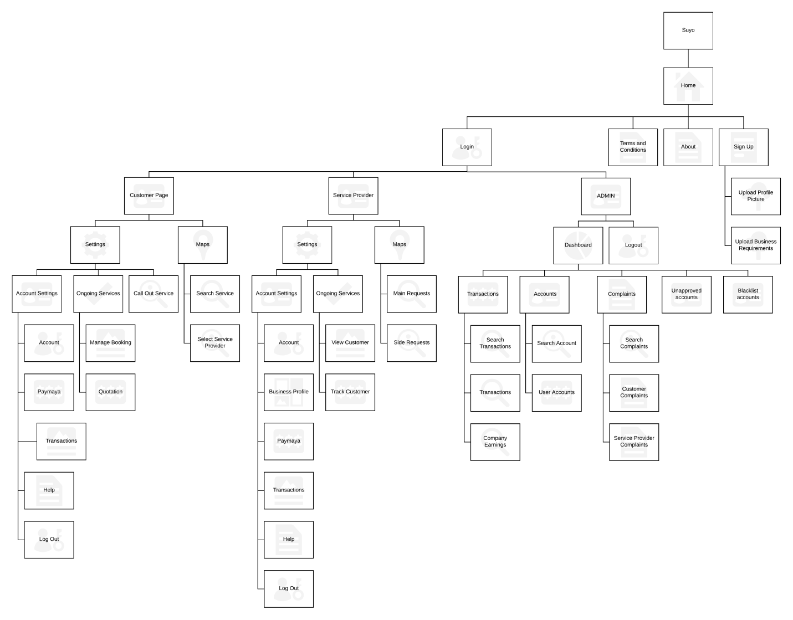](https://www.lucidchart.com/documents/edit/c05936a6-2bb6-4d3c-8dae-9d5d7f4183f7/0?callback=close&name=docs&callback_type=back&v=5207&s=816)

*Figure 1.0 whole site map*

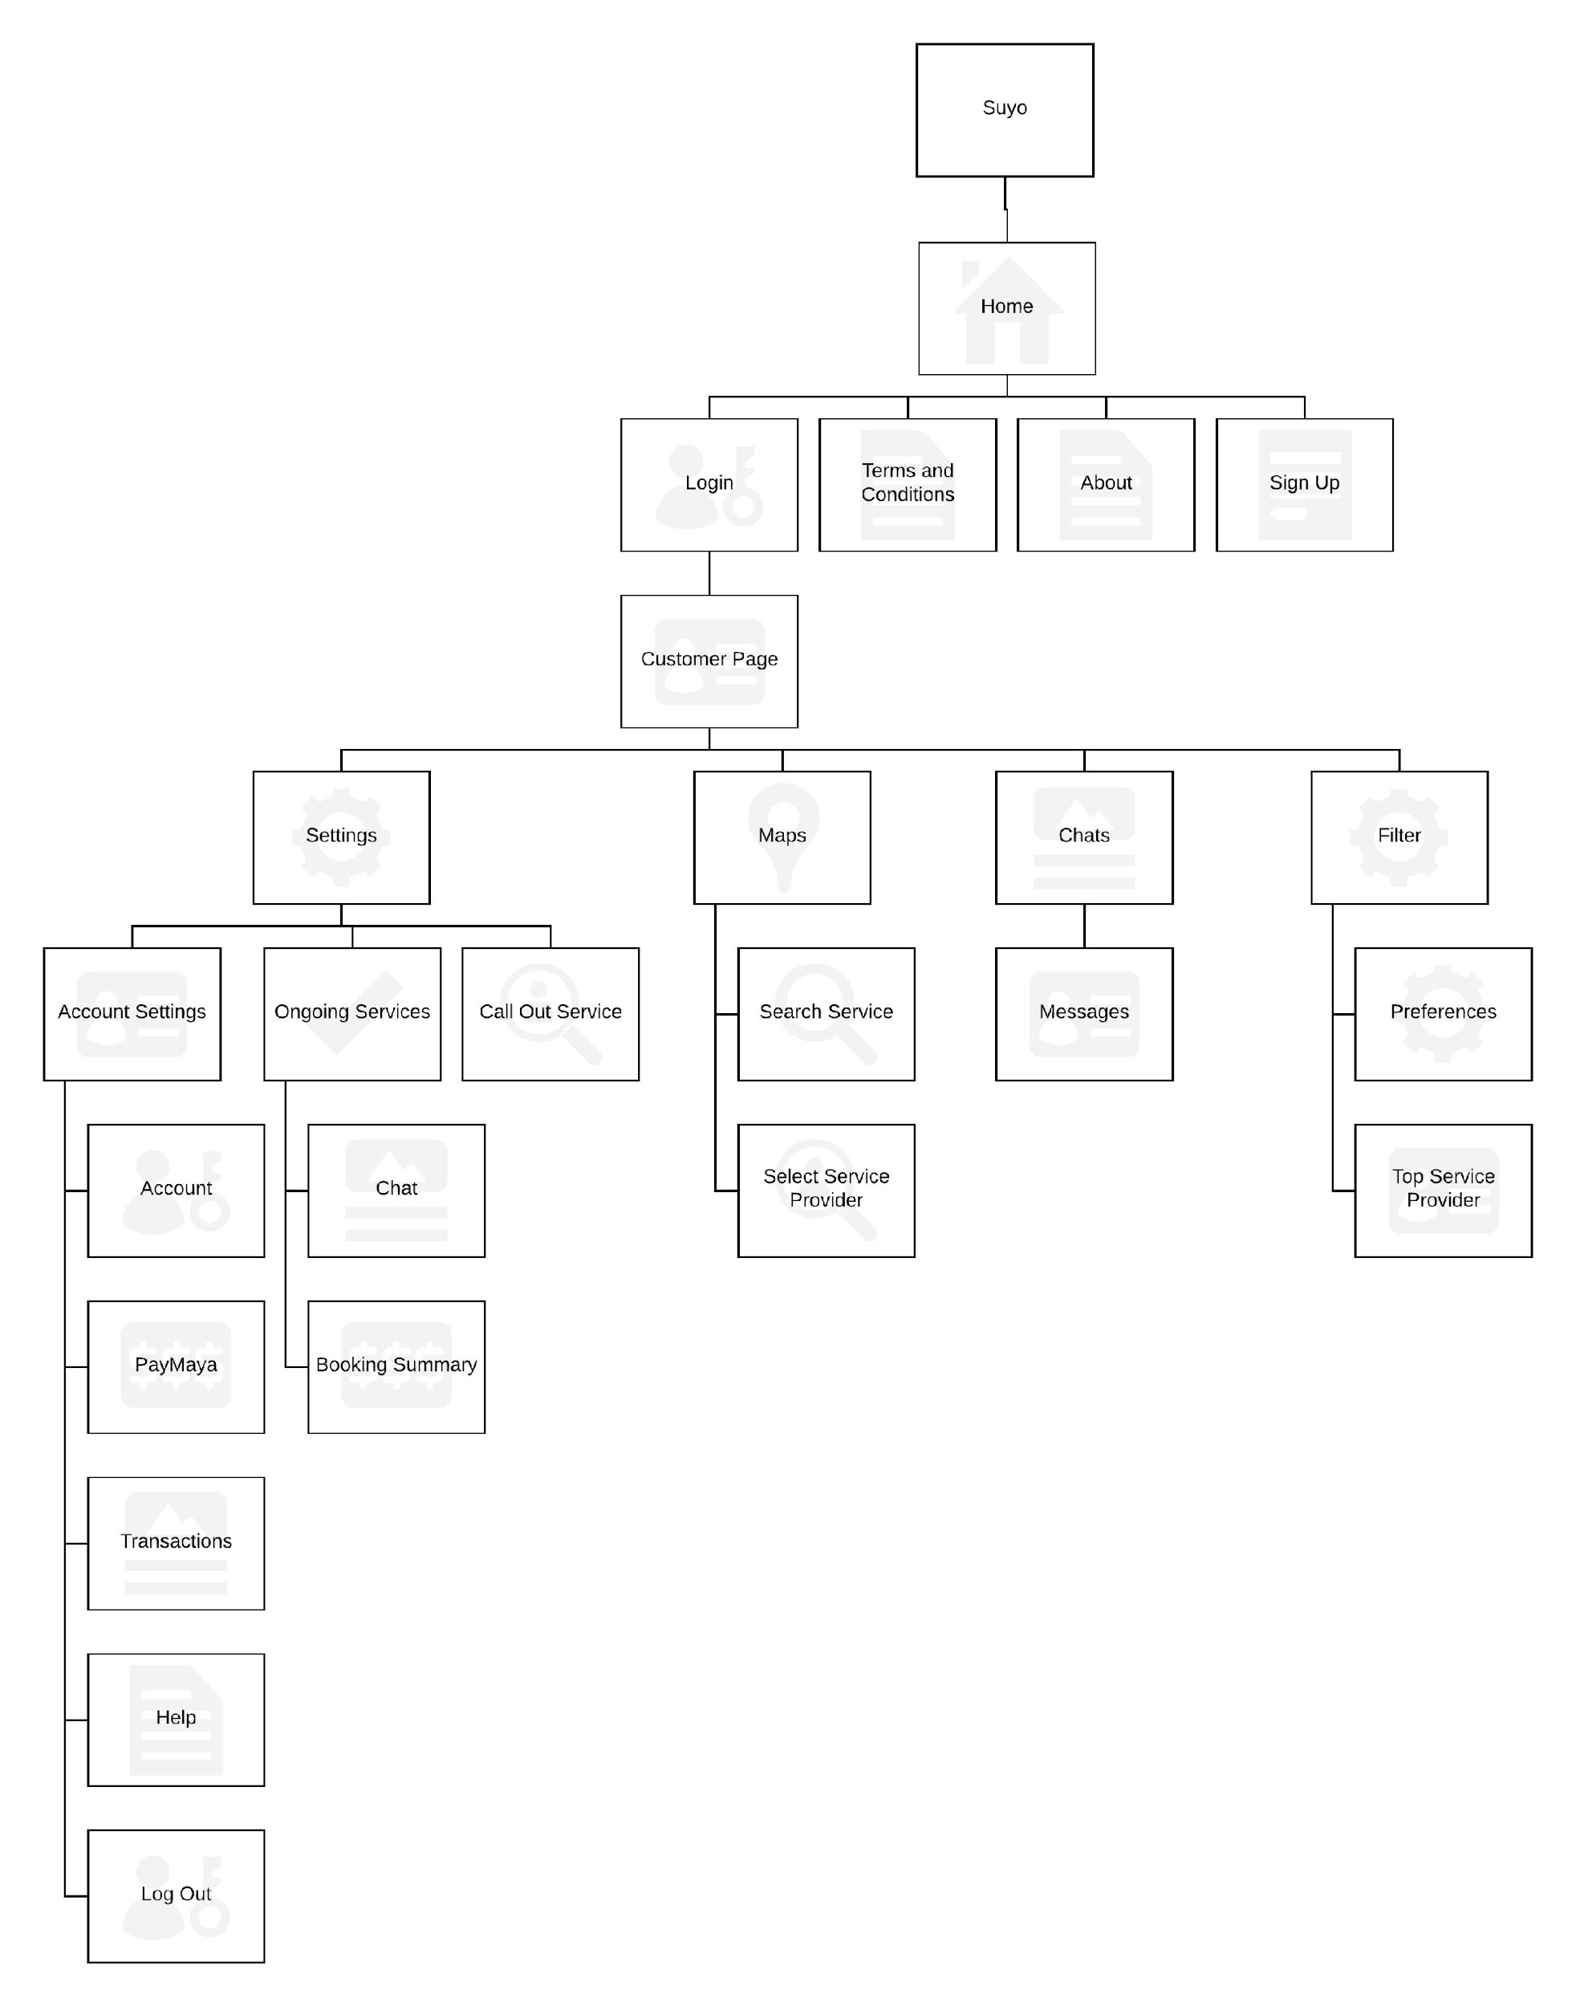

*Figure 1.1 Customer Site map*

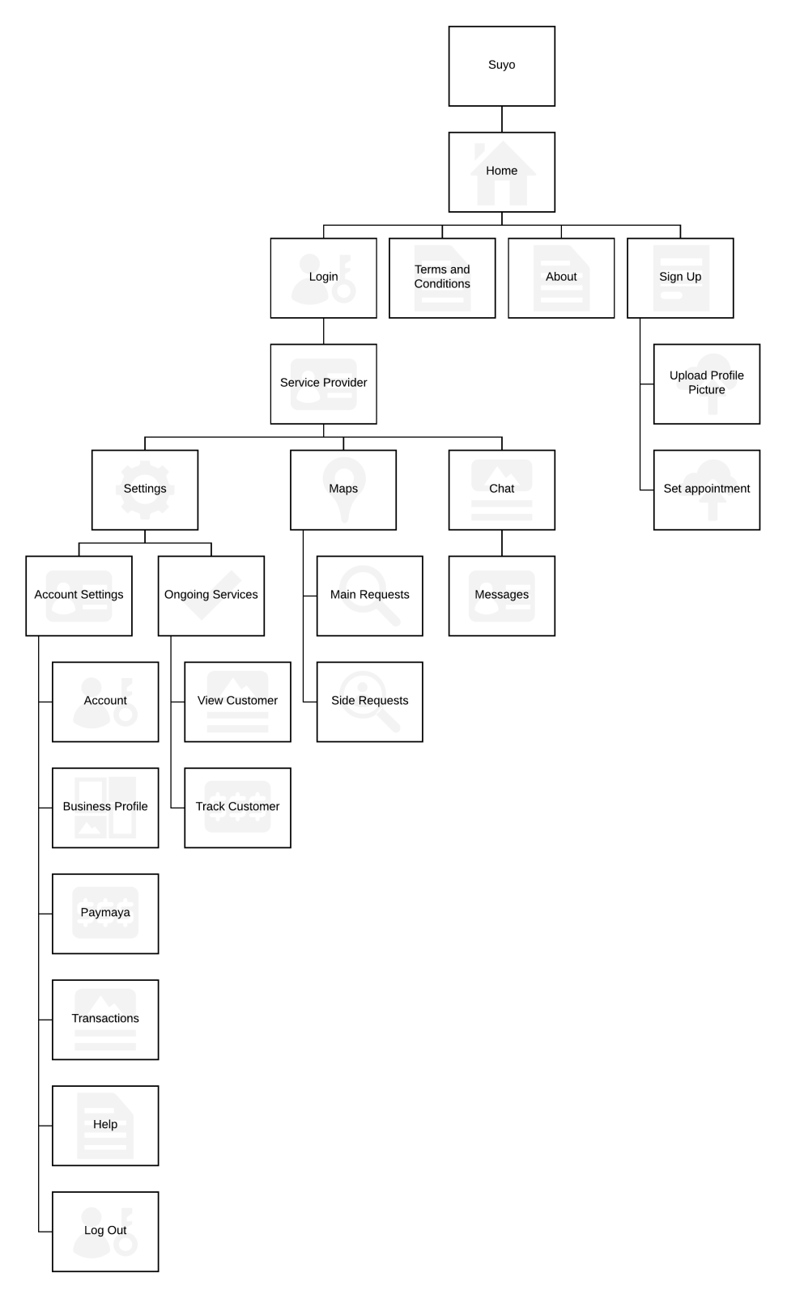

*Figure 1.2 Service Provider sitemap*

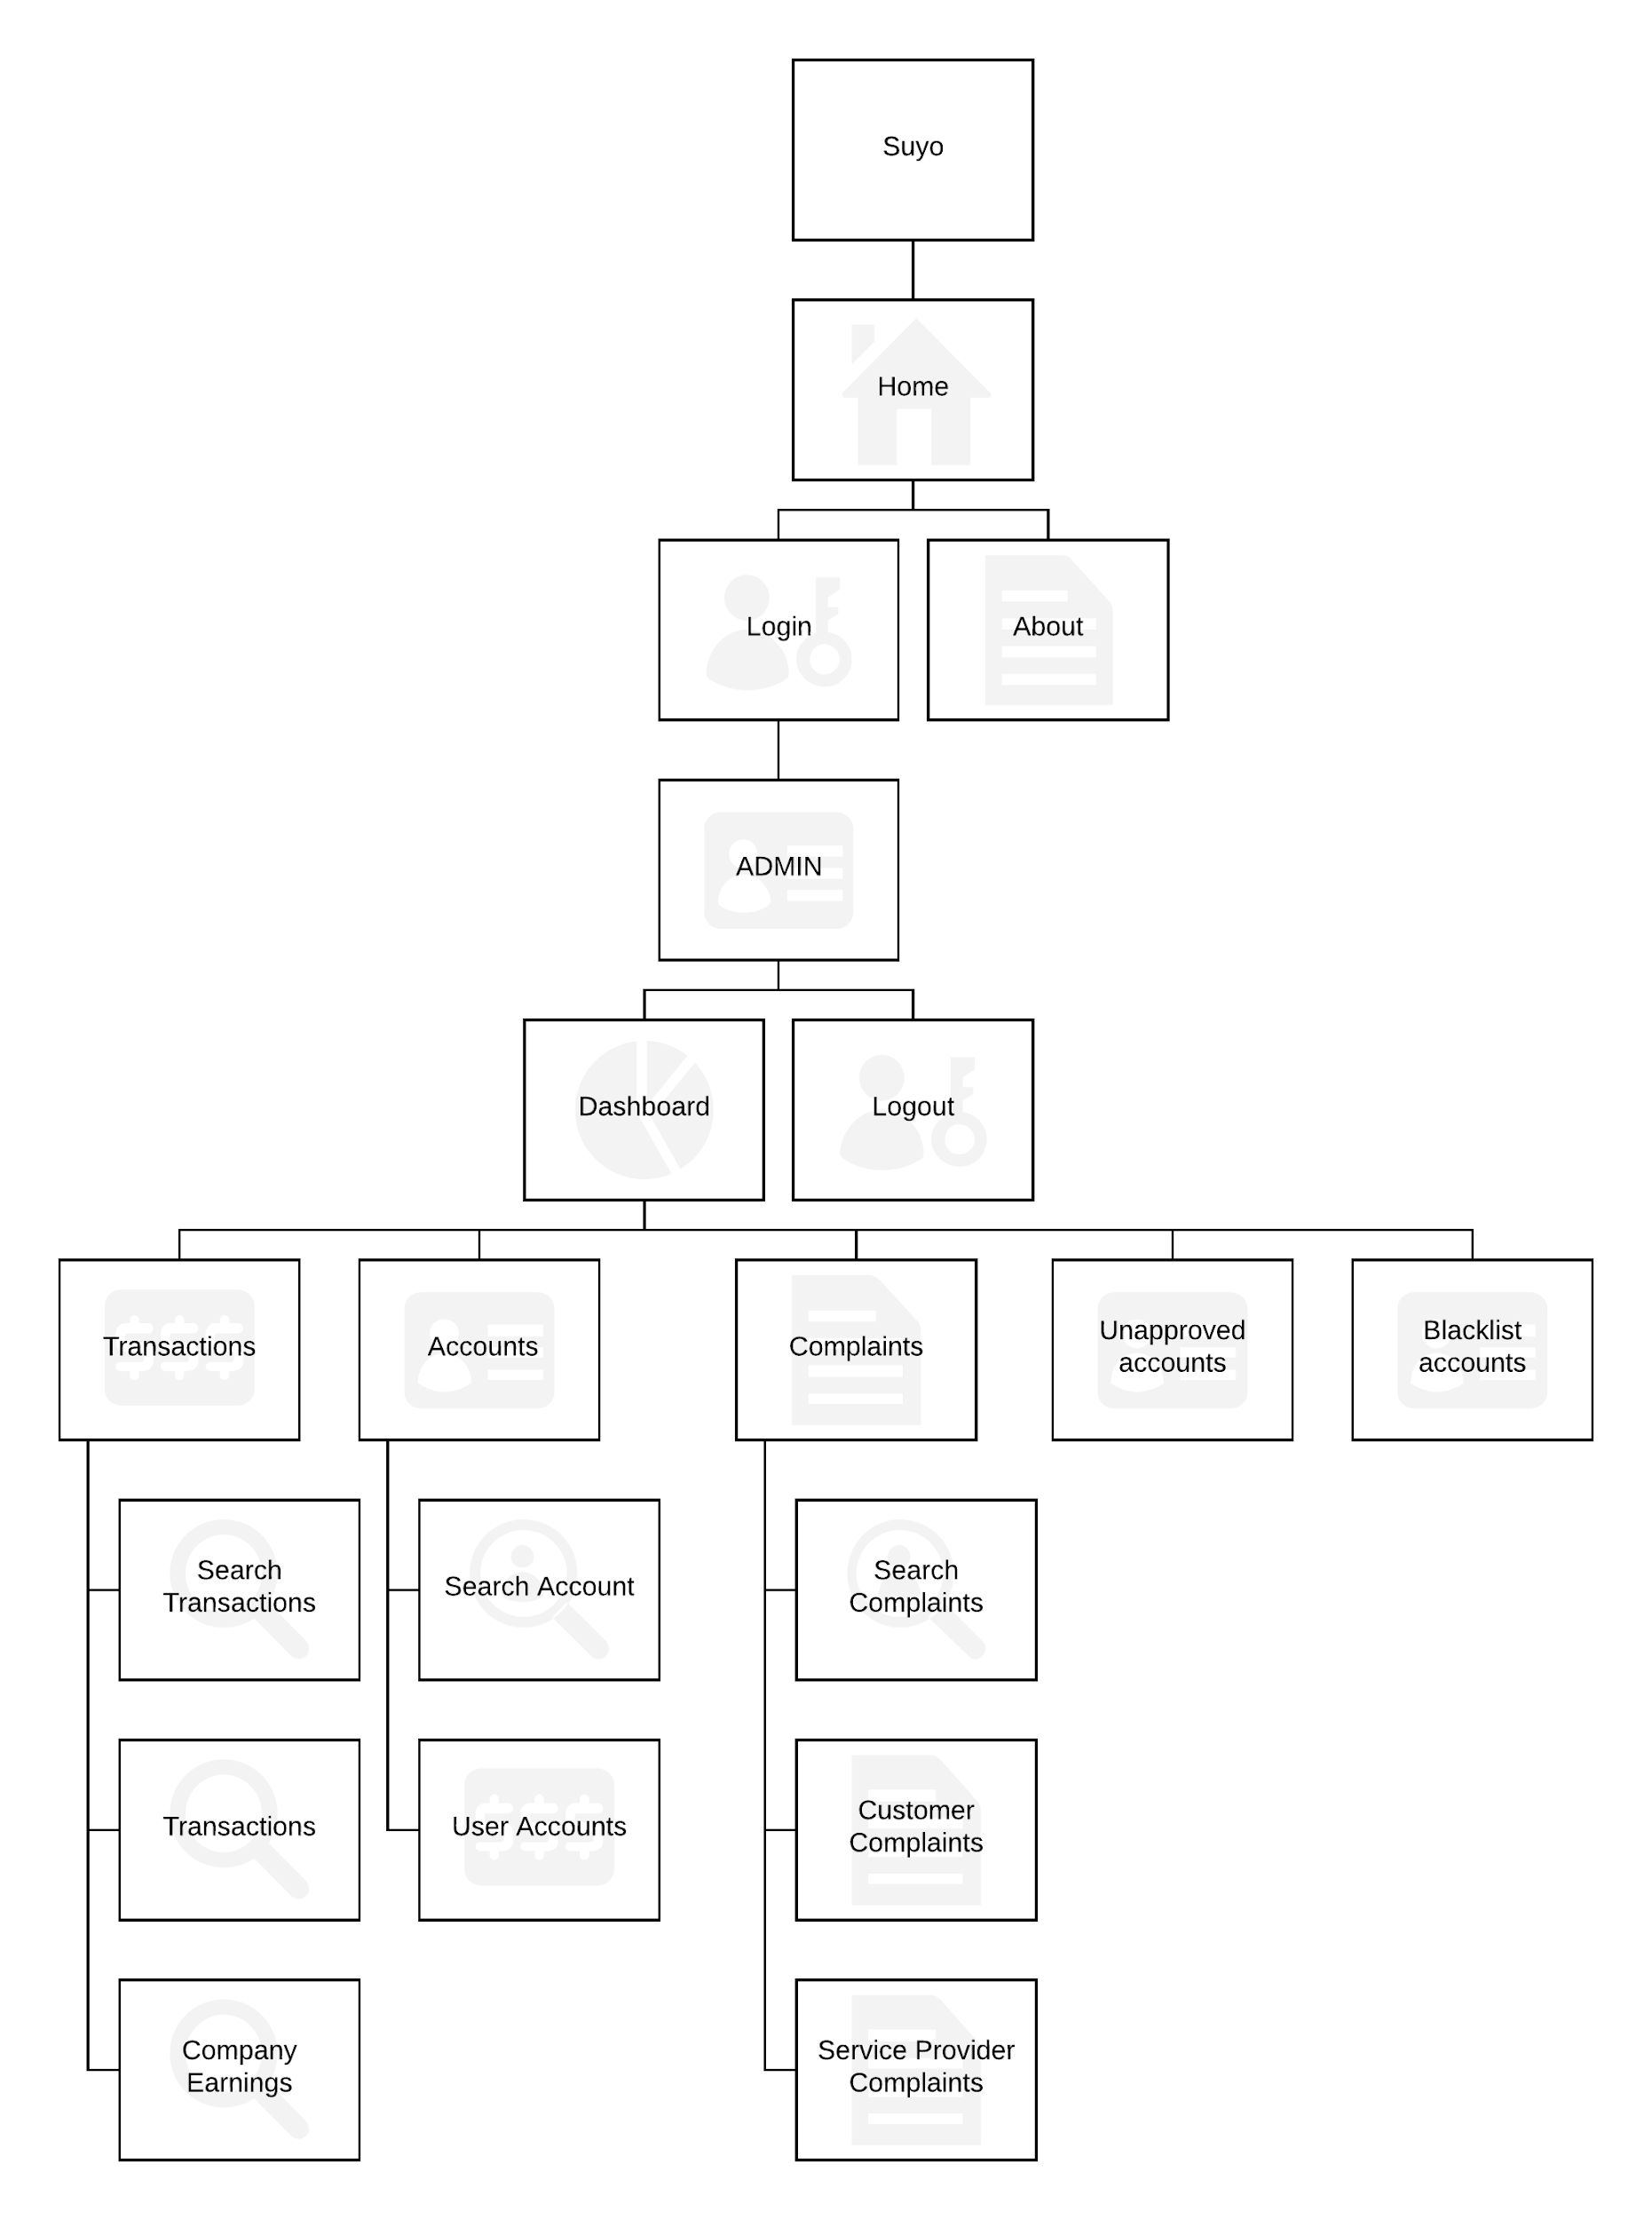

*Figure 1.3 Admin Sitemap*

**Database Schema Entity Relationship Diagram (ERD)**

|  |  |
| --- | --- |
| Database Schema | Reference Number: DS-WDB-0 |
| Version Number: v2.4 |
| System Name: Suyo | |
|  | |

|  |  |
| --- | --- |
| Database Schema | Reference Number: DS-DB-1 |
| Version Number: v2.4 |
| System Name: Suyo | |
|  | |

|  |  |
| --- | --- |
| Database Schema | Reference Number: DS-DB-2 |
| Version Number: v2.4 |
| System Name: Suyo | |
|  | |

|  |  |
| --- | --- |
| Database Schema | Reference Number: DS-DB-3 |
| Version Number: v2.4 |
| System Name: Suyo | |
|  | |

|  |  |
| --- | --- |
| Database Schema | Reference Number: DS-DB-4 |
| Version Number: v2.4 |
| System Name: Suyo | |
|  | |

## **Data Dictionary**

|  |  |
| --- | --- |
| Data Dictionary | Reference Number: DD-1 |
| Version Number: v2.4 |
| System Name: Suyo | |
| Subject: Users | |

|  |  |  |  |  |  |  |
| --- | --- | --- | --- | --- | --- | --- |
| PK | Field name | Data type | Length | Nullable | Default Type | Description |
| YES | UserId | INT | 11 | NO | NONE | Primary Key of this table |
| FK | UserTypeId | INT | 11 | NO | NONE | Foreign key from UserType table |
| FK | AccountRequirementsId | INT | 11 | NO | NONE | Foreign key from AccountRequirements table |
| FK | AddressId | INT | 11 | NO | NONE | Foreign key from Address table |
| NO | FirebaseRegistrationId | VARCHAR | 300 | NO | NONE | Contains the Firebase Cloud Messaging Id of the User |
| NO | FirstName | VARCHAR | 50 | NO | NONE | Stores the Firstname of user |
| NO | LastName | VARCHAR | 50 | NO | NONE | Stores the Lastname of user |
| NO | Email | VARCHAR | 50 | NO | NONE | Stores the email of user |
| NO | Password | VARCHAR | 255 | NO | NONE | Stores the password stored in AES form of user |
| NO | ProfilePicture | BLOB | --------------- | NO | NONE | Stores the ProfilePicture of user |
| NO | Mobile | BIGINT | 20 | NO | NONE | Stores the Mobile Number of user |
| NO | Status | INT | 11 | NO | NONE | 0-Unactivated  1 – Activated  2- Activated under probation  3-Suspended  4-terminated |
| NO | ActivationNo | VARCHAR | 200 | NO | NONE | Stores the Activation Number of the account |
| NO | DateAdded | TIMESTAMP | --------------- | NO |  | Date and time of when data is added |
| NO | DateActivated | TIMESTAMP | --------------- | YES | NONE | Date and time of when data is Activated |
| NO | DateModified | TIMESTAMP | --------------- | YES | NONE | Date and time of when data is Modified |

|  |  |
| --- | --- |
| Data Dictionary | Reference Number : DD-2 |
| Version Number v2.4 |
| System Name: Suyo | |
| Subject: ServiceProviderBusiness | |

|  |  |  |  |  |  |  |
| --- | --- | --- | --- | --- | --- | --- |
| PK | Field name | Data type | Length | Nullable | Default Type | Description |
| YES | BusinessAccountId | INT | 11 | NO | NONE | PrimaryKey for This table |
| FK | UserId | INT | 11 | NO | NONE | Foreign key from users table retrieves owner of the business |
| FK | SkillId | INT | 11 | NO | NONE | Foreign key from skills table; The skill / work type of the owner |
| NO | BusinessLocation | VARCHAR | 500 | NO | NONE | Stores The Lat and Long of the business to be shown in the map |
| NO | BusinessName | VARCHAR | 45 | NO | NONE | Stores the Unique Name of the Business |
| NO | BusinessAddress | VARCHAR | 200 | NO | NONE | Stores an added location of the business |
| NO | BusinessNumber | BIGINT | 20 | NO | NONE | Stores the mobile Number of the business |
| NO | Status | VARCHAR | 50 | NO | NONE | Stores the status of the business (Activated/suspended/terminated) |
| NO | DateAdded | TIMESTAMP | ------- | NO |  | Will store when the Business was added to the database |
| NO | DateModified | TIMESTAMP | ------- | NO | NONE | Will Store when it is last modified |

|  |  |
| --- | --- |
| Data Dictionary | Reference Number : DD-3 |
| Version Number v2.4 |
| System Name: Suyo | |
| Subject: Bookings | |

|  |  |  |  |  |  |  |
| --- | --- | --- | --- | --- | --- | --- |
| PK | Field name | Data type | Length | Nullable | Default Type | Description |
| YES | BookingId | INT | 11 | NO | NONE | PrimaryKey of this table |
| FK | UserId | INT | 11 | NO | NONE | Foreign Key of the Users Table; shows own this booking |
| FK | QuoteId | INT | 11 | YES | NONE | Foreign Key of the Quotations Table |
| FK | BusinessAccountId | INT | 11 | YES | NONE | Foreign Key of the Business Table |
| FK | PaymentsId | INT | 11 | YES | NONE | Foreign Key of the Payments Table |
| FK | FeedBackId | INT | 11 | YES | NONE | Foreign Key of the Feedbacks Table |
| FK | ProblemImagesId | INT | 11 | NO | NONE | Foreign Key of the ProblemImages Table |
| NO | Remarks | TEXT |  | NO | NONE | Stores the added Remarks of the Customer |
| NO | Status | VARCHAR | 45 | NO | NONE | Shows if this booking accepted/canceled/completed |
| NO | BookingType | VARCHAR | 45 | NO | NONE | Direct booking or Indirect Booking |
| NO | BookingDateTime | DATETIME |  | NO | NONE | Stores the chosen date and time of the booking |
| NO | DateAccepted | TIMESTAMP |  | NO |  | When did the service provider accepted the service |
| NO | DateCanceled | TIMESTAMP |  | YES | NONE | When did the service Provider canceled the booking |
| NO | DateModified | TIMESTAMP |  | YES | NONE | When did they modified the booking |
| NO | DateCompleted | TIMESTAMP |  | YES | NONE | When did the booking completed or ended |

|  |  |
| --- | --- |
| Data Dictionary | Reference Number: DD-4 |
| Version Number: v2.4 |
| System Name: Suyo | |
| Subject: Interview Schedules | |

|  |  |  |  |  |  |  |
| --- | --- | --- | --- | --- | --- | --- |
| PK | Field name | Data type | Length | Nullable | Default Type | Description |
| YES | InterviewId | INT | 11 | NO |  | Primary key for this table |
| FK | UserId | INT | 11 | NO |  | Foreign key from users table that will retrieve the service provider |
| FK | AdminId | INT | 11 | YES |  | Foreign key from admins table; retrieve the admin that approve the account or user |
| NO | InterviewStatus | VARCHAR | 10 | NO |  | Ongoing/approved/rejected/canceled/rescheduled |
| NO | DateSchedule | DATE |  | NO |  | Contains the date of the interview |
| NO | DateRescheduled | DATE |  | YES |  | Contains the rescheduled date of the interview |
| NO | DateTimeAdded | TIMESTAMP |  | NO |  | Date and time when the interview contents was added |
| NO | DateTimeModified | TIMESTAMP |  | YES |  | Date and time when the interview contents was modified |
| NO | DateApproved | TIMESTAMP |  | YES |  | Date and time when the interview contents was approved or completed |

|  |  |
| --- | --- |
| Data Dictionary | Reference Number: DD-5 |
| Version Number: v2.4 |
| System Name: Suyo | |
| Subject: Admins | |

|  |  |  |  |  |  |  |
| --- | --- | --- | --- | --- | --- | --- |
| PK | Field name | Data type | Length | Nullable | Default Type | Description |
| YES | AdminId | INT | 11 | NO | NONE | Primary key for this table |
| FK | UserId | INT | 11 | NO | NONE | Foreign key from Users Table;retrives other contents of the admin table |
| NO | Role | VARCHAR | 10 | NO | NONE | The Role of the admin |
| NO | AccountStatus | VARCHAR | 10 | NO | NONE | The status of the account |
| NO | DateAdded | TIMESTAMP |  | NO | NONE | Date and time when the account was added |
| NO | DateModified | TIMESTAMP |  | YES | NONE | Date and time when the account was Modified |

|  |  |
| --- | --- |
| Data Dictionary | Reference Number: DD-6 |
| Version Number: v2.4 |
| System Name: Suyo | |
| Subject: UserTypes | |

|  |  |  |  |  |  |  |
| --- | --- | --- | --- | --- | --- | --- |
| PK | Field name | Data type | Length | Nullable | Default Type | Description |
| YES | UserTypeId | INT | 11 | NO | NONE | Primary key for this table |
| NO | UserType | VARCHAR | 20 | NO | NONE | Admin/Customer/Service Provider |

|  |  |
| --- | --- |
| Data Dictionary | Reference Number: DD-7 |
| Version Number: v2.4 |
| System Name: Suyo | |
| Subject: DataLogs | |

|  |  |  |  |  |  |  |
| --- | --- | --- | --- | --- | --- | --- |
| PK | Field name | Data type | Length | Nullable | Default Type | Description |
| YES | DataLogId | INT | 11 | NO |  | Primary keys of This table |
| FK | UserId | INT | 11 | NO |  | Foreign Keys from the users table; contains the user id |
| NO | LogType | VARCHAR | 20 | NO |  | Log In/Log out |
| NO | LogInDateTime | TIMESTAMP |  | NO |  | Date and Time of Login |
| NO | LogOutDateTime | TIMESTAMP |  | YES |  | Date and Time of Logout |

|  |  |
| --- | --- |
| Data Dictionary | Reference Number: DD-8 |
| Version Number: v2.4 |
| System Name: Suyo | |
| Subject: Skill | |

|  |  |  |  |  |  |  |
| --- | --- | --- | --- | --- | --- | --- |
| PK | Field name | Data type | Length | Nullable | Default Type | Description |
| YES | SkillId | INT | 11 | NO | NONE | Primary keys for this table |
| NO | SkillName | VARCHAR | 50 | NO | NONE | Name of the skill |
| NO | Description | TEXT |  | NO | NONE | Description of the skill |
| NO | DateAdded | TIMESTAMP |  | NO | NONE | Date and time when skill is added |
| NO | DateModified | TIMESTAMP |  | YES | NONE | Date and Time when the skill is modified |

|  |  |
| --- | --- |
| Data Dictionary | Reference Number: DD-9 |
| Version Number: v2.4 |
| System Name: Suyo | |
| Subject: Services | |

|  |  |  |  |  |  |  |
| --- | --- | --- | --- | --- | --- | --- |
| PK | Field name | Data type | Length | Nullable | Default Type | Description |
| YES | ServiceId | INT | 11 | NO | NONE | Primary key for this Table |
| FK | BusinessAccountId | INT | 11 | NO | NONE | Foreign key of the ServiceProviderBusiness table |
| NO | ServiceName | VARCHAR | 50 | NO | NONE | Shows the name of the service |
| NO | ServiceDescription | TEXT |  | NO | NONE | Shows the description of the service |
| NO | ServiceTypeId | INT | 11 | NO | NONE | Foreign key of the ServiceTypes table |
| NO | DateAdded | TIMESTAMP |  | NO |  | Date and Time when the Service is added |
| NO | DateModified | TIMESTAMP |  | YES | NONE | Date and Time when the Service is modified |

|  |  |
| --- | --- |
| Data Dictionary | Reference Number: DD-10 |
| Version Number: v2.4 |
| System Name: Suyo | |
| Subject: Quotations | |

|  |  |  |  |  |  |  |
| --- | --- | --- | --- | --- | --- | --- |
| PK | Field name | Data type | Length | Nullable | Default Type | Description |
| YES | QuoteId | INT | 11 | NO | NONE | Primary key of the this table |
| NO | Description | TEXT |  | NO | NONE | Shows the description of the quote |
| NO | AgreedPrice | DECIMAL | 10,0 | NO | NONE | The Agreed price of the customer and Provider |
| NO | Status | VARCHAR | 45 | NO | NONE | The status of the quote (Completed/changed) |
| NO | DateAdded | TIMESTAMP |  | NO | NONE | Date and Time when the Quote is added |
| NO | DateModified | TIMESTAMP |  | YES | NONE | Date and Time when the Quote is modified |
| NO | DateProcessed | TIMESTAMP |  | YES | NONE | Date and Time when the Quote is Processed |

|  |  |
| --- | --- |
| Data Dictionary | Reference Number: DD-11 |
| Version Number: v2.4 |
| System Name: Suyo | |
| Subject: ProblemImages | |

|  |  |  |  |  |  |  |
| --- | --- | --- | --- | --- | --- | --- |
| PK | Field name | Data type | Length | Nullable | Default Type | Description |
| YES | ProblemImagesId | INT | 11 | NO | NONE | Primary key of this table |
| NO | FileLocation | VARCHAR | 200 | NO | NONE | Stores the location of the file (.png.jpg) |

|  |  |
| --- | --- |
| Data Dictionary | Reference Number: DD-12 |
| Version Number: v2.4 |
| System Name: Suyo | |
| Subject: Reports | |

|  |  |  |  |  |  |  |
| --- | --- | --- | --- | --- | --- | --- |
| PK | Field name | Data type | Length | Nullable | Default Type | Description |
| YES | ReportsId | INT | 11 | NO | NONE | Primary Key of the table Reports |
| NO | Subject | VARCHAR | 45 | NO | NONE | Contains the subject of the Report |
| NO | Details | TEXT |  | NO | NONE | Contains the details of the Report |
| NO | DateAdded | TIMESTAMP |  | NO | NONE | Date and Time when the Report is added |
| NO | DateProcessed | TIMESTAMP |  | YES | NONE | Date and Time when the Report is processed |

|  |  |
| --- | --- |
| Data Dictionary | Reference Number: DD-13 |
| Version Number: v2.4 |
| System Name: Suyo | |
| Subject: FeedBacks | |

|  |  |  |  |  |  |  |
| --- | --- | --- | --- | --- | --- | --- |
| PK | Field name | Data type | Length | Nullable | Default Type | Description |
| YES | FeedBackId | INT | 11 | NO | NONE | Primary key of this Table |
| NO | Rating | DECIMAL | 10,0 | NO | NONE | The Rating of the customer 1.0 -5.0 rating |
| NO | Remarks | TEXT |  | NO | NONE | The Comments of the customer |
| NO | DateTimeAdded | TIMESTAMP |  | NO | NONE | Date and Time when the Feedback is added |

|  |  |
| --- | --- |
| Data Dictionary | Reference Number: DD-14 |
| Version Number: v2.4 |
| System Name: Suyo | |
| Subject: Payments | |

|  |  |  |  |  |  |  |
| --- | --- | --- | --- | --- | --- | --- |
| PK | Field name | Data type | Length | Nullable | Default Type | Description |
| YES | PaymentsId | INT | 11 | NO | NONE | Primary key of this Table |
| NO | PaymentType | VARCHAR | 45 | NO | NONE | What type of payment (Cash on hand/ online) |
| NO | AmountPaid | DECIMAL | 10,0 | NO | NONE | The amount Paid |
| NO | ReferenceNo | BIGINT | 20 | NO | NONE | The Referencwe No of the Payment |
| NO | Status | VARCHAR | 45 | NO | NONE | The Status of the payment |
| NO | DateTimeProcessed | TIMESTAMP |  | YES | NONE | Date and Time when the Payment is processed |

|  |  |
| --- | --- |
| Data Dictionary | Reference Number: DD-15 |
| Version Number: v2.4 |
| System Name: Suyo | |
| Subject: Address | |

|  |  |  |  |  |  |  |
| --- | --- | --- | --- | --- | --- | --- |
| PK | Field name | Data type | Length | Nullable | Default Type | Description |
| YES | AddressId | INT | 11 | NO | NONE | Primary key of this Table |
| NO | RoomNo | INT | 11 | YES | NONE | Contains the room number of a unit |
| NO | BuildingName | VARCHAR | 50 | YES | NONE | Contains the name of the building |
| NO | LotNo | INT | INT | 11 | YES | Contains the lot number of a home or a unit |
| NO | BlockNo | INT | INT | 11 | YES | Contains the block number of a home or a unit |
| NO | PhaseNo | INT | 11 | YES | NONE | Contains the phase number of a home or a unit |
| NO | StreetName | VARCHAR | 50 | YES | NONE | Contains the name of the street |
| NO | Subdivision | VARCHAR | 50 | YES | NONE | Contains the name of the subdivision |
| NO | Barangay | VARCHAR | 50 | YES | NONE | Contains the name of the barangay |
| NO | City | VARCHAR | 50 | YES | NONE | Contains the name of the city |
| NO | Province | VARCHAR | 50 | YES | NONE | Contains the name of the province |
| NO | Zipcode | INT | 11 | YES | NONE |  |

|  |  |
| --- | --- |
| Data Dictionary | Reference Number: DD-16 |
| Version Number: v2.4 |
| System Name: Suyo | |
| Subject: AccountRequirements | |

|  |  |  |  |  |  |  |
| --- | --- | --- | --- | --- | --- | --- |
| PK | Field name | Data type | Length | Nullable | Default Type | Description |
| YES | AccountRequirementsId | INT | 11 | NO | NONE | Primary key of this Table |
| NO | Filepath | VARCHAR | 200 | NO |  | Contains the compiled accounte reuiremnents |

|  |  |
| --- | --- |
| Data Dictionary | Reference Number: DD-17 |
| Version Number: v2.4 |
| System Name: Suyo | |
| Subject: ServiceTypes | |

|  |  |  |  |  |  |  |
| --- | --- | --- | --- | --- | --- | --- |
| PK | Field name | Data type | Length | Nullable | Default Type | Description |
| YES | ServiceTypeId | INT | 11 | NO | NONE | Primary key of this Table |
| NO | ServiceType | VARCHAR | 50 | NO |  | Contains the compiled accounte reuiremnents |
| NO | MinPrice | DECIMAL | 10,0 | NO | NONE | Shows the minimum price of the service |
| NO | MaxPrice | DECIMAL | 10,0 | NO | NONE | Shows the maximum price of the service |
| NO | DateAdded | TIMESTAMP |  | NO |  | Date and Time when the Service is added |
| NO | DateModified | TIMESTAMP |  | YES | NONE | Date and Time when the Service is modified |

## 

# **IT INFRASTRUCTURE**

## **Network Diagram**

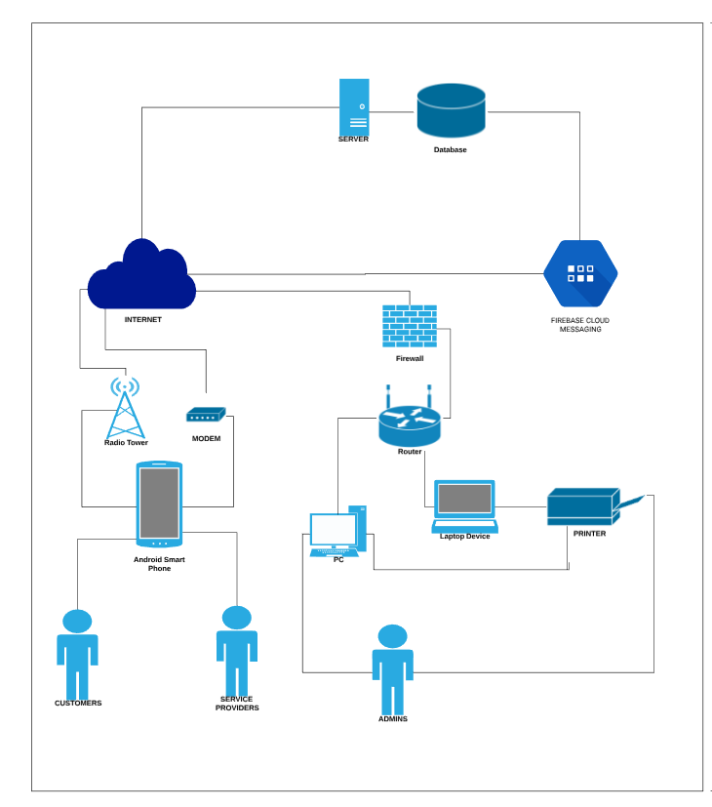

## Software Requirements

Development

|  |  |  |
| --- | --- | --- |
| SOFTWARE | SPECIFICS | DESCRIPTION |
| Integrated Development Environment | Android Studio (Java Development Kit: Java SE 8) | This software will be used in creating the android application. |
| Sublime  Notepad++  Atom | The Following are list of code editors that can be used to develop the PHP or the web application that will run the administrator page of the system |
| Programming Language | JAVA (via Android Studio) | JAVA will be used for coding the android application |
| PHP version 7.2.0  SQL  JSON | PHP will be used to connect to the database server  SQL will be used to perform CRUD  JSON will be used for adding, retrieving and updating data in the database |
| Production Database | Mysql 5.7 | Will be used as the database to handle all user data during development and for testing |
| Operating System | Android OS version Lollipop 5.1 and later versions | The application will be implemented in various version of android |
| Windows 8.1/10 | Windows 8.1/10 will be used for the software of each desktop or laptop used for development |
| Web Browser | Google Chrome Version  67.0.3396.99 | Google Chrome will be used run XAMPP |
| Maps | Google map API | The API will be used to for the map feature of the application |
| Web Server | XAMPP 7.2.0  Apache 2.4.29 | These will be used to run the PHP files and MYSQL |
| Payment | PayMaya SDK | PayMaya SDK will be used for the handling online payments feature of the application |
| Chat | Firebase or Firebase Cloud Messaging (FCM) | For handling chat features we will be using Firebase FCM for providing fast online chat |

DEPLOYMENT

|  |  |  |
| --- | --- | --- |
| Software | Specifics | Description |
| Operating System | Android OS version Lollipop 5.1 and later versions | The application will be implemented in various version of android |
| Windows 8.1/10 | Windows 8.1/10 will be used for the software of each desktop or laptop used for development |
| App Deployment Service | Google Play Store | Google play will be used to deploy and distribute the app to the users |
| Hosting | Fastcomet Cloud VPS server  (Cloud 2) | This will be used in hosting the web-app and database under the domain www.suyo.ph |
| Internet Service Provider | PLDTHome DSL Plan 1299 (3 Mbps ) | Provides Internet connection that enables administrator to access the admin website. |

## Hardware Requirements

Development

|  |  |  |
| --- | --- | --- |
| HARDWARE | SPECIFICS | DESCRIPTION |
| Smart phone | * Android phones capable of both wireless internet and 4G connection * Able to run android 5.1 (Lollipop) and above * LG G6 64GB any color | * This device needed to run the application for development and testing |
| RAM | 3GB RAM MINIMUM, | * Required RAM to run android studio * This stores temporary data used by software and programs that is being used by the user. |
| 8GB RAM RECOMMENDED,  + 1GB RAM FOR ANDROID EMULATOR |
| Processor | 2.6 GHz processor | * Responsible for executing programs that mainly has a sequence of instructions; taking an input and process this to return an output.[2] |
| Storage | Minimum of 2GB OF AVAILABLE DISK SPACE, | * Required Storage for android studio |
| 4GB FOR RECOMMENDED (500 MB for IDE + 1.5 GB for Android SDK and emulator system image) |
| 256 GB HDD Storage | * Used to store user files and various pre-installed and installed applications by user [3] |
| Monitor Display | * 1280 x 280 minimum screen resolution for android studio | * Used to view the  graphical data from the desktop |

Deployment

|  |  |  |
| --- | --- | --- |
| Hardware | Specifics | Description |
| Desktop | HP EliteDesk 600G1 SFF (Intel Core-i5 4570, 3.2 GHz, 16GB RAM DDR3, 2TB HDD, DVD ROM, HDMI , Windows 10 Pro) | * Desktop that can run Android studio for development of the app * Machine that will be used to access the data in web server. |
| Printer | Printer Brother DCP-T710W Multifunction Print Scan Copy | * Print confidential data this are personal accounts of service provider (Only prints when it is needed) government |

## Software and Hardware Justification

Development

Android Studio – Will be used in developing the mobile application. The use of Android studio is for the efficiency of the development and because of the nature of the android studio is open source, while other application development tools like Xamarin has features that needs to be paid before using it. It has an emulator itself and has an instant run to see the changes instantly without the hassle of building a new Android Application Package (APK). The android studio features a code editor that has code completion, improving internal structure without altering the external behavior, and has the feature to find a faulty code and fixing it. Another feature that android studio gives is the click and drag feature in the designing phase of the application.

Code Editor:

Atom - is a code editor and has the functionalities of an IDE, but the team will just use Atom as a code editor to program the admin site. The Atom can be used for web design and backend programming. It features teletype that allows developers to work together in real time.

Java – Java programming language is used by an android studio, mostly the core java. Most of the parts of the android studio like its API’s are written in Java. The team is intended to study and use Java as the primary source of programming language.

MySQL – is an open source relational database management system for the use of storing information about the users in the application. The create, read, update and delete (CRUD) will be used in altering the data and connecting the application to the database.

Android Version Lollipop 5.1 – this version of Android will be used as the minimum required an operating system for Android phones. The team’s decision to use Lollipop as the minimum specification required to download the application is because of the rate of distribution of Android Lollipop 5.1 is at 14.4% higher than Nougat’s 7.1% and Oreo’s 8.1%.

Windows 8/10 – will be used for development because it is the most used operating system and most of the team uses this kind of operating system.

PHP – Mostly used by developers in making a website. It is an open source scripting language designed to web development and a general-purpose programming language. PHP will be used by our team for the admin site of the system. It will also be used as the backend language for the database.

JSON- Is an alternative use of data interchange rather than using XML. Json is more readable while XML is more on machine-readable. Another advantage why the team will be using JSON is it uses less tags.

Web Browser:

Google Chrome – A web browser for accessing the world wide web. Will be used to run the pages in the admin site. The team have decided to chrome as the browser to display the admin site because it uses less ram than Mozilla Firefox.

Maps:

Google Map API – The API will be used for the map feature of the application.

Web Server:

XAMPP 7.2.0 – Will be used as a development tool for us to test our admin site without using the internet. The team will be using xampp for several reasons:

* XAMPP has a control panel to whether tell which software are running.
* It has a button to start or stop Apache or Mysql.
* Users can access the user interface of phpMyAdmin by clicking the admin button.
* It supports different operating systems.
* It features a Secure Socket Layer to manage server authentication between servers and clients.

Payment:

Paymaya SDK – As another mode of payment in our application. This will allow the users to pay online inside our application using the virtual prepaid card for a faster transaction. Our team decided to use Paymaya as another mode of payment because of its reliability. It allows the users to load the card via prepaid load to have virtual money. And it also allows users to own a paymaya without the actual card by just installing the mobile application.

Chat Feature:

Firebase – The has decided to use firebase cloud messaging to handle the chat feature of the application. It will make the development of the chat feature more efficient when using firebase.

Deployment

Lollipop – The SUYO application will be available in version Lollipop 5.1 and higher.

Windows Os – The admin will be using windows 8.1/10 operating system.

Google Play Store – This will be used as the deployment of the application itself. As it is widely used to download applications and games in Android operating system.

Fastcomet – The team will be using this as a hosting service for our website and database. Fastcomet offers a complete set of features which provides cloud vps. The price had given as the opportunity to use the hosting cloud service at a reasonable price.

These are some of the features:

* SSD servers
* Same price every renewal
* SSD storage capacity of 80GB
* Bandwidth of 4TB
* RAM of 4GB ECC
* Free daily and weekly backups
* Free backup Restore
* Network and web application firewall
* Exploit and malware protection
* 24/7 support
* Response time of 10 mins
* Free website setup and transfer
* Free Domain name setup

Internet Connection – A PLDT home DSL will cost us 1299 with a 3mbps speed.

Hardware

Smartphone - Android phones capable of running both wireless, 4G connection, and able to run 5.1 Lollipop or higher version of Android. The team will be using a specific phone, which is LG G6 64GB, as the phone originally owned by one of our members and will be used a subject on testing the application.

RAM - it stores data on a memory which enables the system to do tasks. The team will need to use a 3GB RAM as a minimum specification and a 8GB’s of RAM as the recommended specification to run other application especially an Android studio.

Processor - Responsible for executing programs that mainly has a sequence of instructions; taking input and process this to return an output. The team will use 2.6GHz of processor to handle the compilation of the code faster.

Storage - Hard Disk Drive is used to store an operating system and other files. It is usually the largest storage in a computer. The team will be using 256GB of HDD as a minimum specification. A 4GB of storage is recommended to install an IDE (500 MB) and Android SDK (1.5GB).

Monitor Display - Used to display information or graphical data processed by the graphics card. The team will be using 1280 x 280 for minimum screen resolution.

Deployment

Desktop - HP EliteDesk 600GI SFF can run Android studio and other application.

* Processor - Intel Core-i5 4570, 3.2 GHz.
* Memory - 16GB RAM DDR3.
* Storage - 2TB HDD.
* Operating System - Windows 10 Pro
* With DVD, ROM and HDMI

Printer - The team will be using Printer Brother DCP-T710W to print confidential information of the service provider. The printer can scan copy and print.

Monitor - 15.6” AOC LED Monitor will be used to view graphical data from the desktop.

* Full HD display (1920 x 1080p at 60 GHz)

## 

## System Costing / Cost-Benefit Analysis

Software Cost

|  |  |  |  |
| --- | --- | --- | --- |
| Software | Quantity | Amount (PHP) | Total Cost in First Year |
| Android Studio | 1 | ₱ 0.00 | ₱ 0.00 |
| XAMPP | 1 | ₱ 0.00 | ₱ 0.00 |
| Google map Api | 1 | ₱ 0.00 | ₱ 0.00 |
| Paymaya Api | 1 | ₱ 0.00 | ₱ 0.00 |
| Firebase Cloud Message | 1 | ₱ 0.00 | ₱ 0.00 |
| Google Play Store | 1 | $25.00(₱1334.44) | ₱1,334.44 |
| Fastomet  (Cloud 2) | 1 | ₱3,723.00/mo ($69.95) | ₱ 44, 676.00 |
|  |  |  | ₱ 46,010.44 |

Hardware Cost

|  |  |  |  |
| --- | --- | --- | --- |
| Hardware | Quantity | Amount(PHP) | Total Price |
| Smartphone | 1 | ₱ 22,999.00 x 1 | ₱ 22,999.00 |
| Desktop | 1 | ₱ 19,485.70 x 1 | ₱ 19,485.70 |
| Monitor | 1 | ₱ 2,999.00 x 1 | ₱ 2,999.00 |
|  |  |  | ₱ 45,483.70 |

Business Registration

|  |  |  |
| --- | --- | --- |
| Expense | Amount | Total |
| Business Name Registration Certificate | 1,000.00 (Regional) | 1,000.00 |
| Documentary Stamp Tax | 15.00 | 15.00 |
| SEC Registration Certificate | 360.00 | 360.00 |
| Business Permit | 26,000.00 | 26,000.00 |
| BIR Registration | 500.00 | 500.00 |
| DOLE | 25,000.00 | 25,000.00 |
| ECC | 1,226.00 | 1,226.00 |
|  |  | 53,741.00 |

Operational Expense (Monthly)

|  |  |  |
| --- | --- | --- |
| Expenses | Amount | Total |
| Office Rent | [18,870.00](https://www.lamudi.com.ph/metro-manila/commercial/rent/)[4] | 18,870.00 |
| Salaries | 15,000 x 4 | 60,000.00 |
| Facebook Marketing & Ads | 500.00 per day x 30 days | 15,000.00 |
|  |  | 93,970.00 |

Suyo will be renting a commercial workspace monthly. Regus offers a workspace that includes internet connection, utilities, office cleaning, and access to printer, scanner, and a photocopy machine. Regus also have meeting rooms which Suyo can reserve in case the employees need it. These inclusions makes Regus an ideal commercial space for startup companies since the company will only have to worry about the monthly rent.

In order to cover the monthly expense and earn income, Suyo will be collecting a commission fee worth of 88.00 pesos plus a 12% vat which will be a total of 99.00 pesos per service and will be added to the final bill.

The processes of collecting the commission fee are as follows:

1. If the customer opted to pay in cash, the service provider will collect the bill and then remit it to Suyo via Paymaya. Remittance of the said commission fee will be on a monthly basis.
2. If the customer opted to use Paymaya, the payment for the service will go directly to the service provider’s Paymaya account. The service provider will then remit the commission fees to Suyo on a monthly basis.

# IMPLEMENTATION PLAN

## Project Development Timetable

1st Half

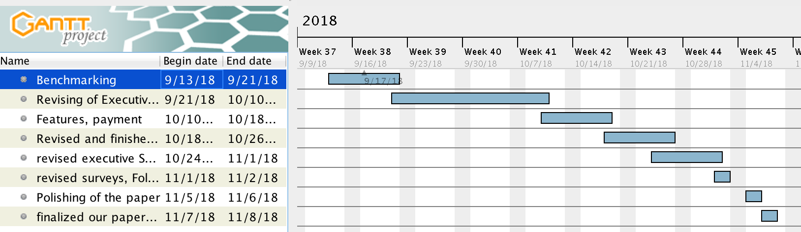

This gantt chart shows the time and schedule of finishing the first half of Suyo Documentation

* Benchmarking started on September 13 2018 and ended at September 21 2018
* Revising of Executive summary and conduction of interviews started and ended within September 21 2018 to October 10 2018
* Revised the Drafted the features and payment on October 10 2018 to October 18 2018
* Revised drafting and finished the Certifications, Categorizing, Pricing, Scope and Limitations, Features and Functionalities, And Problems and Recommendations within October 18 2018 to October 26 2018
* Revised the executive Summary, System overview, and checked designed the IT infrastructure, Database and UML on October 26 to November 1 2018
* Revised and checked our surveys, Followed up the UML’s and Database within November 1 to November 2 2018
* Polished our paper during the dates November 2 2018 to November 6 2018
* Finalized our paper and printed it during November 6 2018 to November 8 2018

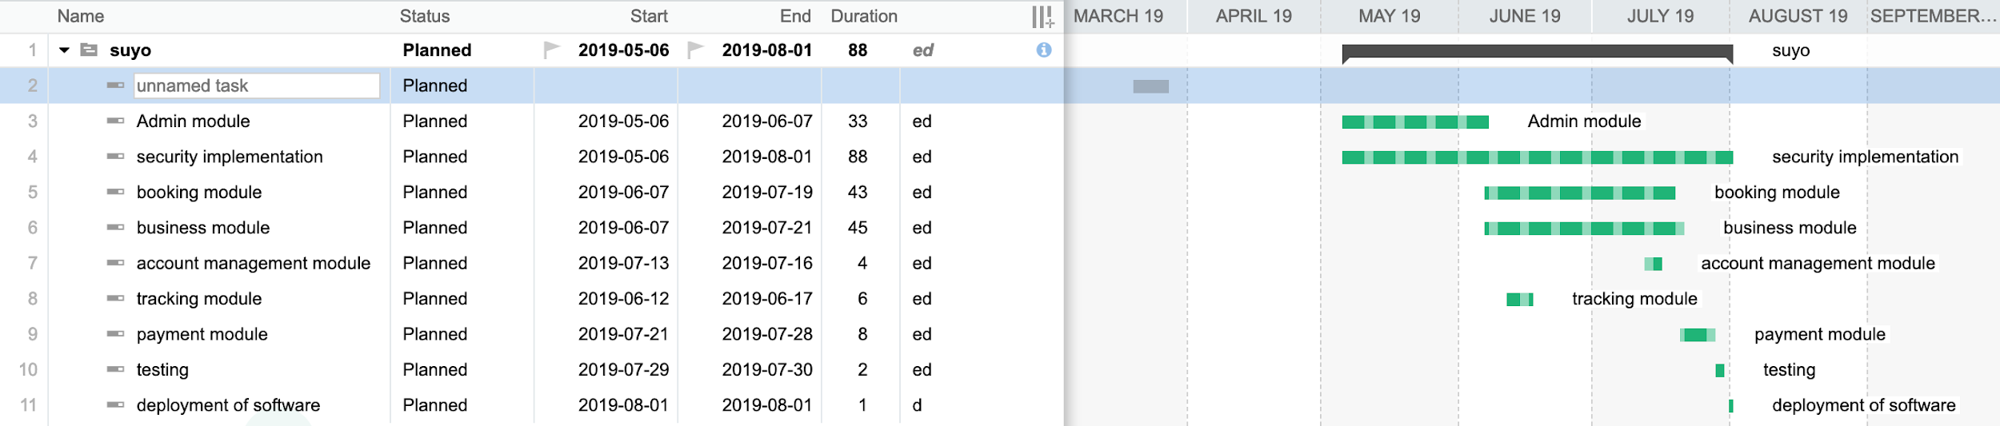

2nd half of Suyo, Development Timetable.

Timetable Narrative:

The project will take 88 days in total to be completed. The decided initialization of the project will start at May 6 2019 which is the Admin module followed by implementing security codes, implementation of security will be applied all throughout the development stage. The booking module will start on June 7 2019 along with the business module.We will be applying the security implementation all-throughout the project until August 2 2019. The Account management Module will start being developed on July 13 2019 while finishing the business and booking module. We will be developing the tracking module during June 12 2019 and finish it at June 17 2019; it will be done in between the business and booking module. The payment module will be done during July 21, 2019, we decided to squeeze it in since we only have limited time. It will be finished on July 28 2019. Testing of the application will be done on July 29 2019 to July 30 2019. And finally, the deployment of the application is projected to be on August 2 2019.

# **REFERENCE**

SOFTWARE REQUIREMENTS:

<https://developer.android.com/studio/>

<https://www.mysql.com/>

<https://www.android.com/>

<https://www.google.com/chrome/>

<https://developers.google.com/maps/documentation/>

<https://developers.google.com/maps/documentation/android-sdk/intro>

<https://www.apachefriends.org/>

<https://dev.mysql.com/doc/refman/5.7/en/>

<https://developer.paypal.com/docs/integration/mobile/android-integration-guide/>

<https://play.google.com/apps/publish/signup/>

<https://developer.paypal.com/docs/integration/mobile/mobile-sdk-overview/>

<https://www.fastcomet.com/compare-cloud-servers>

<https://pldthome.com/dsl>

<https://shop.pldthome.com/Home/SelectAddedService?q=LS93umLZ53Lt6lWPyM%2FEDXLIyI%2BmKZusOnwxYT%2BrDuJW1shNuO6Upv1Wtro6A6jDTYNHNTFe%2BSk%2B4k8VMv6pXgC3xz%2FLtCa9O8w%2BCI2e%2B6WsndfOdgW%2F9QkxGL2rjbb1VjPuSFOJoz3DUWeMHQ2t02PWQADzggQC%2FbYFag7Ixe3oIvk4kNnGVhSWWx1JxPkG0U6%2BaxRbg4iRTeS4OSpcKrTWS1ccvd7jHR7iX6phzsq06bnpEZDkoFN3AI8H4Sre80OkKis%2BvXJPhkw9lxkuFA2nnd%2BHhGBrZlkKNrHjvfEIpNWOHvcXhvXyXkY4yWFcRBxQP%2BdE8i8m9P4obT36s2uNuizCXXweAF14M7Z%2B6%2B%2BoyX5mVCzj%2B0kRTQXdnqRv&serviceId=2888>

HARDWARE REQUIREMENTS:

Smartphone:

https://www.lazada.com.ph/products/lg-g6-64gb-dual-lte-i123733893-s129023288.html?spm=a2o4l.searchlist.list.3.393b23cbtymCL9&search=1

Monitor:

https://www.cnet.com/products/hp-prodisplay-p221/

Desktop:

https://www.amazon.com/HP-ELITEDESK-800-G1-Refurbished/dp/B07CZR82CR?th=1

PRINTER:

https://www.lazada.com.ph/printer-brother-dcp-t710w-multi-function-print-scan-copy-82094336.html?spm=a2o4l.searchlistcategory.list.73.50f0290e3w3YVo

RAM  
https://www.lifewire.com/what-is-random-access-memory-ram-2618159  
Processor  
https://www.sqa.org.uk/e-learning/FirstLine01CD/page_05.htm  
Storage   
http://www.kierenreynolds.com/2015/12/14/internal-storage-devices

Reference about bootstrapping

Lahm, Robert J, Jr; Little, Harold T, Jr. Journal of Entrepreneurship Education; Arden Vol. 8, (2005). Retrieved from https://search.proquest.com/docview/235758183/408B21A3454F4115PQ/1?accountid=190479

https://www.jobstreet.com.ph/en/job-search/junior-java-developer-jobs/

Ebben, Jay J. (2009). Bootstrapping and the financial conditions of small firms. Retrieved from https://search.proquest.com/docview/212171848/fulltext/F9C116C2FD25495EPQ/1?accountid=190479

Perry, John T; Chandler, Gaylen N; Yao, Xin; Wolff, James A. (Spring 2011). Bootstrapping Techniques and New Venture Emergence. Retrieved from https://search.proquest.com/docview/862563157/EC1A988EE3C94161PQ/1?accountid=190479

Winborg, Joakim. Venture Capital: an International Journal of Entrepreneurial Finance (Jan 2009) Retrieved from https://search.proquest.com/docview/608635279/408B21A3454F4115PQ/5?accountid=190479

References about the topic android:

Rajput. M (2016, August 16) Why Should Startups Focus on android Development? Retrieved From https://www.mindinventory.com/blog/why-should-startups-focus-on-android-application-development/

Callaham, J (2015, September 29) Google says there are now 1.4 billion active android Devices worldwide. Retrieved From https://www.androidcentral.com/google-says-there-are-now-14-billion-active-android-devices-worldwide

Global market share held by leading smartphone operating systems in sales to end users from 1st quarter 2009 to 1st quarter 2018 (2018) Retrieved From https://www.statista.com/statistics/266136/global-market-share-held-by-smartphone-operating-systems/

Katariya. J (2017, March 1) Apple Vs. android – a comparative study 2017 retrieved from https://android.jlelse.eu/apple-vs-android-a-comparative-study-2017-c5799a0a1683

Muzunes. G (2016, August 15) a profile of smartphone users in the Philippines [Blog Post] Retrieved From http://blog.pawnhero.ph/a-profile-of-smartphone-users-in-the-philippines/

Epstein. Z (2018, January 9) it’s 2018 but the world’s most popular version of android is from 2015 Retrieved From https://bgr.com/2018/01/09/android-oreo-features-sorry-nope-enjoy-marshmallow/

Distribution Dashboards (2018, May 24) Retrieved From https://developer.android.com/about/dashboards/

References about the topic Secure Socket Layer ,Security and Encryption

Munipalla, B. (2003). *A methodology to increase the security and performance of applications that utilize the secure socket layer concept*(Order No. 1415547). Available from ProQuest Dissertations & Theses Global. (305238476). Retrieved from https://search.proquest.com/docview/305238476?accountid=190479

Paul, M (2013, August 27) *Official (ISC)2 Guide to the CSSLP CBK, Second Edition / Edition 2,* Boca Raton, Florida: Publisher: Taylor and Francis

What is SSL, TLS, and HTTPS? (n.d.) Retrieved From https://www.websecurity.symantec.com/security-topics/what-is-ssl-tls-https

Martins, F (2016, February 11)*Google takes another step to help encourage https everywhere.* Retrieved From https://www.digicert.com/blog/google-takes-another-step-to-help-encourage-https-everywhere/

Barnes, K (2018, January 11) Why HTTPS matters. Retrieved From https://developers.google.com/web/fundamentals/security/encrypt-in-transit/why-https

Secure your Site with HTTPS (n.d.) Retrieved From https://support.google.com/webmasters/answer/6073543?hl=en

Why SSL? The purpose of using SSL Certificates (n.d) Retrieved from https://www.sslshopper.com/why-ssl-the-purpose-of-using-ssl-certificates.html

Juraschka. R (n.d) Why SSL certificates are important on your website Retrieved From: https://hostpapa.blog/security/why-ssl-certificates-are-important-for-your-website/

Lazarte, M (2009, April 30) Preventing Theft and Unauthorized modification of electronic data with new ISO/IEC standard Retrieved From https://www.iso.org/news/2009/04/Ref1221.html

OWASP TOP 10 Application Security Risks -2017 (2017) Retrieved From https://www.owasp.org/index.php/Top_10-2017_Top_10

References About Paypal:

Introducing Adaptive Payments (n.d) Retrieved From https://developer.paypal.com/docs/classic/adaptive-payments/integration-guide/APIntro/

Top Bank in Philippines Compatible to PayPal Online Transaction (n.d) Retrieved From https://ofwmoney.org/banking/best-bank-for-paypal/

Paypal Security Guidelines and best Practices(n.d) Retrieved From: https://developer.paypal.com/docs/classic/lifecycle/info-security-guidelines/#

Reference about Marketing

Duxbury, Jess .(2015, January 28). Why Is Understanding Your Target Audience So Important?. Retrieved from http://www.silvereggmedia.co.uk/understanding-target-audience-important/

How To Identify a Target Market and Prepare a Customer Profile. Retrieved from http://edwardlowe.org/how-to-identify-a-target-market-and-prepare-a-customer-profile/

Reference about Company Policies/Blacklisting:

Koshy , Aju(May 11, 2015) Six Do’s and Don’ts When Creating Company Policies.

Retrieved from:https://www.linkedin.com/pulse/six-dos-donts-when-creating-company-policies-aju-koshy

Categories and examples of business crime( no year no author) retrieved from:

<https://courses.lumenlearning.com/workwithinthelaw/chapter/categories-and-examples-of-business-crime/>

Tips for handling customer complaints( 2018 , April 5) retrieved from:

https://www.business.gov.au/info/plan-and-start/start-your-business/what-is-customer-service/communicate-with-customers/tips-for-handling-customer-complaints

Ridler, Ben (nd) Six steps to dealing with customer complaints , retrieved from:

https://www.eonetwork.org/octane-magazine/special-features/sixstepstodealingwithcustomercomplaints

Procedures for handling complaints(no year no author) retrieved from:

http://www.consumerrights.ae/en/Retailers/ComplaintHandlingGuidelines/Pages/procedures.aspx

For service providers: Addressing Complaints ( No year no author) retrieved from:

http://www.hcscc.sa.gov.au/for-service-providers-addressing-complaints/

Methodology

Dr. Sundararajan Murugaiyan M., & Balaji S. (2012, June 29). *Waterfall vs V-model vs Agile: A Comparative Study on SDLC.* Retrieved fromhttp://jitbm.com/Volume2No1/waterfall.pdf

Brandon J. Churchill (2017, April 26). Selecting a Software Development Life Cycle Methodology. Retrieved from https://vpn.benilde.edu.ph/docview/1895081316/94AEB249832B4E39PQ/,DanaInfo=search.proquest.com,SSL+1?accountid=190479

SDLC - Waterfall Model (n.d) Retrieved from https://www.tutorialspoint.com/sdlc/sdlc_waterfall_model.htm

Top 12 Software Development Methodologies & its Advantages / Disadvantages (2015, April 15) Retrieved from https://www.tatvasoft.com/blog/top-12-software-development-methodologies-and-its-advantages-disadvantages/

What is Waterfall model- advantages, disadvantages and when to use it? (n.d) Retrieved from http://istqbexamcertification.com/what-is-waterfall-model-advantages-disadvantages-and-when-to-use-it/

References about the topic PayMaya:

*About PayMaya* (n,d) Retrieved From: https://paymaya.com/about/

*Company Overview of Paymaya Philippines Inc* (n,d) Retrieved From: https://www.bloomberg.com/research/stocks/private/snapshot.asp?privcapId=278887232

{cryptonight} (2015, November 2) *The Paymaya card is a first-Generation product that’s hard to recommend,* Retrieved From: https://medium.com/@Cryptonight/the-paymaya-card-is-a-first-generation-product-that-s-hard-to-recommend-to-anyone-5b10fdeebb3c

Marasigan, L (2015, September 22) *Smart, PLDT Launches PayMaya VISA card,* Retrieved From: https://businessmirror.com.ph/smart-pldt-launches-paymaya-visa-card/

*Pay add Money Partners* (n,d) Retrieved From: https://paymaya.com/addmoney-channels/

Estacio, Z (2017, November 28)*5 reason to switch to e-payments,* Retrieved from: https://www.yugatech.com/ask/5-reasons-to-switch-to-epayment-channels/

Rappler (2018, July 12) *52.8 million Filipinos don't have bank accounts,* Retrieved From: https://www.rappler.com/business/207091-number-filipino-adults-who-have-bank-accounts

References about the topic Firebase:

Firebase Website (n,d) Retrieved From: <https://firebase.google.com/>

Introduction to Firebase (2017, December 28) Retrieved From: <https://hackernoon.com/introduction-to-firebase-218a23186cd7>

Rouse, M (2017, March) NoSQL (Not only SQL Database) Retrieved From: <https://searchdatamanagement.techtarget.com/definition/NoSQL-Not-Only-SQL>

Rotolo, Paolo (2016, June 14) What’s new in Firebase Cloud Messaging and how to migrate from GCM Retrieved From: <https://medium.com/glucosio-project/whats-new-in-firebase-cloud-messaging-and-how-to-migrate-from-gcm-578019c2167d>

References about the Topic JSON:

JSON-Introduction (n,d) Retrieved From: <https://www.w3schools.com/js/js_json_intro.asp>

What is JSON (n,d) Retrieved From: <https://www.w3schools.com/whatis/whatis_json.asp>

Introducing JSON (n,d) Retrieved From: <https://www.json.org/>

Sources on security:

Sources on OWASP:

*The OWASP foundation* (n,d) Retrieved from: <https://www.owasp.org/index.php/Main_Page>

*What is OWASP? What is the OWASP top 10?*(2019, February 4) Retrieved from: <https://www.cloudflare.com/learning/security/threats/owasp-top-10/>

*About the Open Web Application security project* (2019, January 25) Retrieved from: <https://www.owasp.org/index.php/About_The_Open_Web_Application_Security_Project>

*Top 10 software vulnerability list (2019, January 16)* retrieved from <https://www.synopsys.com/blogs/software-security/top-10-software-vulnerability-list-2019/>

*OWASP top 10 application security risks* (2017) retrieved from: <https://www.owasp.org/index.php/Top_10-2017_Top_10>

Sources on SQL Injection

*Top 10 2017 A1-Injection (2017) retrieved from:* <https://www.owasp.org/index.php/Top_10-2017_A1-Injection>

*What is SQL injection SQLi and how to prevent it (n,d) Retrieved from:* <https://www.acunetix.com/websitesecurity/sql-injection/>

*Data validation(n,d) Retrieved from:* <https://www.owasp.org/index.php/Data_Validation>

*Input validation (n,d),* retrieved from: <https://www.whitehatsec.com/glossary/content/input-validation>

Reubens, P (2018, May 2) *How to prevent SQL injection attacks,* Retrieved from*:* <https://www.esecurityplanet.com/threats/how-to-prevent-sql-injection-attacks.html>

Sources on XSS:

*Cross-site Scripting (XSS) Attack* (n,d) Retrieved from:<https://www.acunetix.com/websitesecurity/cross-site-scripting/>

*Cross-site Scripting(XSS)*(2018, June 5) Retrieved from:<https://www.owasp.org/index.php/Cross-site_Scripting_(XSS)>

Rousse, M(2018, February) *Cross-site scripting (XSS)* Retrieved from:<https://searchsecurity.techtarget.com/definition/cross-site-scripting>

*Types of XSS: Stored XSS, Reflected XSS and DOM-based XSS* (n,d) Retrieved from: <https://www.acunetix.com/websitesecurity/xss/>

Evans, D [David Evans](2015, August 20) *Preventing Cross-site Scripting* Retrieved From: <https://www.youtube.com/watch?v=0Oz645g3Wh0>

Sources on Broken authentication

Wagnon, J. [F5 DevCentral] (2017, December 17) *OWASP Top 10: Broken Authentication* Retrieved From: <https://www.youtube.com/watch?v=mruO75ONWy8>

Blazquez, D. (2019, February 2) *OWASP broken authentication and session management*, Retrieved From: <https://hdivsecurity.com/owasp-broken-authentication-and-session-management>

Sources on password:

Grassi et al. (2017, June)*NIST Special Publication,* Retrieved From: <https://pages.nist.gov/800-63-3/sp800-63b.html#memsecret>

Lisa B.(2001, August 21) *NETID-Password criteria and requirements* Retrieved From: <https://kb.wisc.edu/helpdesk/page.php?id=1100>

*Password policy* (n,d) Retrieved From: <https://en.wikipedia.org/wiki/Password_policy>

Retrieved From: <https://www.ibm.com/support/knowledgecenter/SSZRHJ/com.ibm.mbs.doc/mbs_common/t_set_password_reqs.html>

Sources on PCI-DSS:

*PCI Security* (n,d) Retrieved from: <https://www.pcisecuritystandards.org/about_us/>

*The PCI Security Standards Council*  (n,d) Retrieved from: <https://www.pcisecuritystandards.org/pci_security/>

Rouse, M.(2009, May) *PCI DSS (Payment Card Industry Data Security Standard)* Retrieved

From: <https://searchfinancialsecurity.techtarget.com/definition/PCI-DSS-Payment-Card-Industry-Data-Security-Standard>

Rouse, M. (2017, March) *PCI DSS compliance (Payment Card Industry Data Security Standard compliance)* Retrieved From: <https://searchcompliance.techtarget.com/definition/PCI-compliance>

Sources on CAPTCHA:

*Recaptcha (n,d)* Retrieved From: <https://support.google.com/recaptcha/answer/6080904?hl=en>

Nations, D. (2018, August 23) *What is a CAPTCHA code* Retrieved From: <https://www.lifewire.com/what-is-captcha-3486183>

*Choosing the type of reCaptcha* (2019, February 11) Retrieved From: <https://developers.google.com/recaptcha/docs/versions>

Other sources on security:

<https://dalbanger.wordpress.com/2014/01/08/a-basic-non-functional-requirements-checklist/>

<https://www.password-depot.de/en/know-how/brute-force-attacks.htm>

<https://www.owasp.org/index.php/Top_10-2017_Top_10>

Sources on system costing, advertisement and permit renewal fees:

https://www.regus.com.ph/office-space

https://www.lamudi.com.ph/rent-your-private-office-space-in-manila-ascott-ayala-center-makati-city-643870-10.html

*Insider Tips For Business Permit Renewal In The Philippines: Focus On Fees,*

(2017, November 6)Retrieved From:

https://www.full-suite.com/blog/business-permit-renewal-fees/

*facebook marketing,* Retrieved from:https://digitalmarketingphilippines.com/services/facebook-marketing/

*Youtube advertising,* Retrieved from: https://www.youtube.com/yt/advertise/pricing/

*Buy facebook ads on any budget*, Retrieved from: https://www.facebook.com/business/ads/pricing

*Doing Business in the Philippines: Business Registration Process Made Simple,*(2018, July 30)Retrieved from:  https://kittelsoncarpo.com/doing-business-in-the-philippines-business-registration-process-made-simple/  
  
*Philippines business registration* Retrieved from: http://www.sas-ph.com/index.php?p=1_7_philippines-business-registration

Sources on TESDA and Non-TESDA:

*Steps in Applying for assessment and certification – regular qualifications*, Retrieved From https://www.tesda.gov.ph/About/TESDA/46

*Registry of Certified Workers (n,d)* Retrieved From: https://www.tesda.gov.ph/Rwac

Al Palumbo(Career Expert) , Job Applications: When and How Does an Employer Check Your References? Retrieved from: https://www.resume-now.com/templates/career-tips/job-applications-when-and-how-does-an-employer-check-your-references

Retrieved from: Susan Ricker(April 27,2014) How do employers test an applicant’s skills? Retrieved from: https://www.careerbuilder.com/advice/how-do-employers-test-an-applicants-skills

APPENDIX 1: REVIEW OF RELATED LITERATURES

Why our team chose Android OS over other OS, IOS for the development of the app because of its advantage in cost and development, according to the CEO of and Co-Founder of Mind inventory, Majul Rajput said that using android as a starting point for the app will have a lot of benefits for the business. One of Android’s benefits is “a *higher return on investments”* since Android is openly sourced in which you just need the knowledge to develop an app. Android provides SDK and developer tools that the developer can access.

Also, Since Business nowadays is starting to move from web based to mobile based and most of the people today has and use a Smartphone or a handheld device. Having a mobile based application can be a huge advantage because it uses less storage in a server, can handle more web traffic, navigational, and more efficient to operate.

Android Dominates as the leading smartphone OS, by dominating the smartphone market by 87% putting IOS (Iphones) with a percentage of 12% to second.

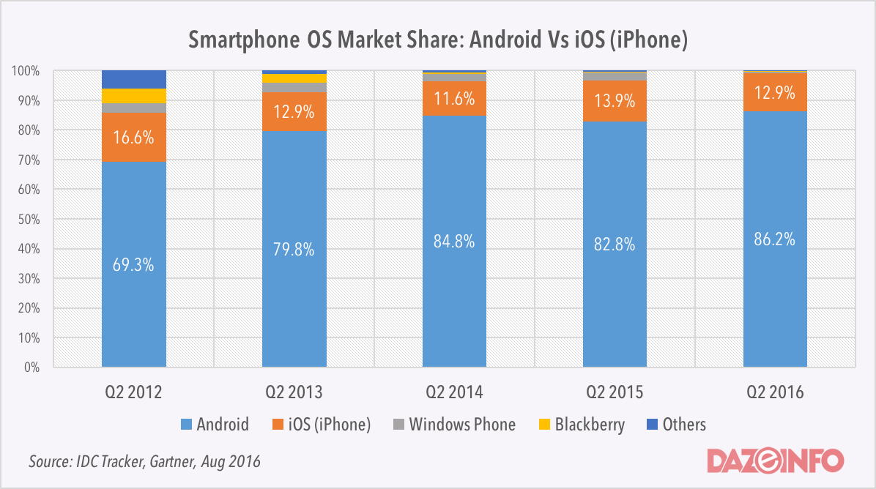

Figure 1: *Worldwide market share in OS*

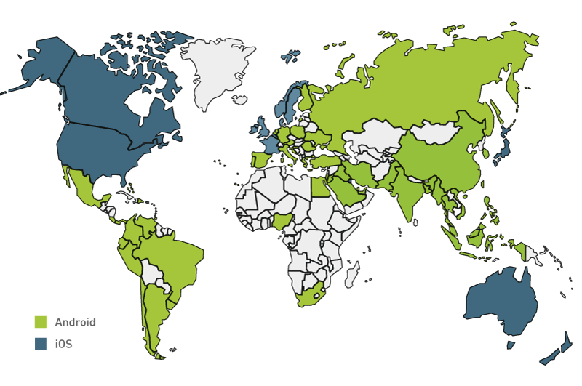

Figure 2*: Geography Distribution*

According to Figure 2 this geography chart, android mostly dominates more market shares on developing focus nation in Asia and Africa while IOS captures more shares in developed countries.

Here in the Philippines, A huge percentage of end user run’s the operating system android gaining 81% comparing to its competitor IOS that has a percentage of 21%. According to a blog of Gem Muzunes’s Infographic about *a profile of smartphone users in the Philippines*:

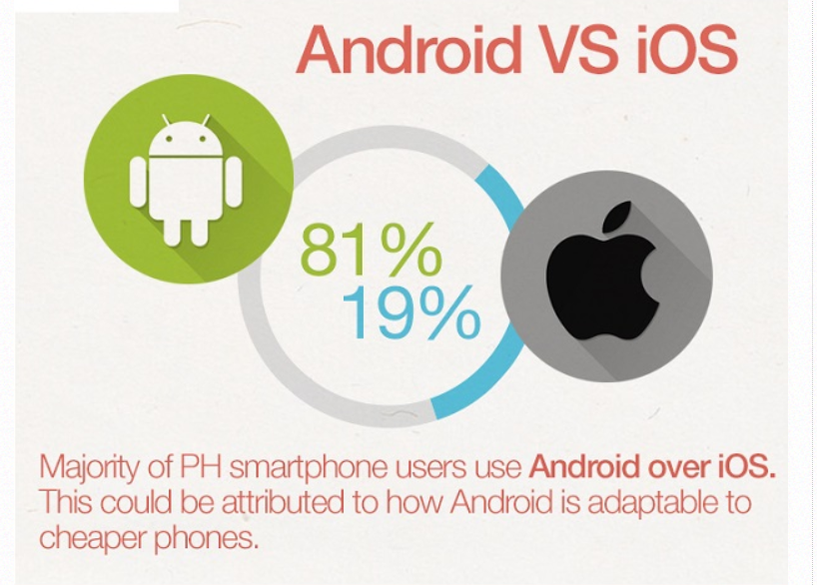

*Figure 3: a profile of smartphone users in the Philippines (2016)*

What is SSL Certificate? Is a certificate that is installed in the server, SSL Certified websites can be determined if the address bar shows a padlock icon or instead of having HTTP it shows HTTPs, “s” stands for *secure.* This means that any information that you give to that website is secure from attacks. SSL ensures data that is transmitted between the web browser and the web server is secure using encryption which makes use of SHA-256 encryption. This protects confidential user data like personal data, passwords, credit card details and other confidential data of the user to be kept away and prevent exposure from attackers most common attacks is a man-in the middle attacks. Google encourages the public to have a SSL Certification or HTTPS usage, therefore we choose Fastcomet for hosting, they provide a free SSL certificate included in the price this is LetsEncrypt Certification.

What if I don’t have sensitive data, should I still have a SSL Certification? In ensuring the security of your software, the answer to that is yes. Even if you don’t store sensitive data because according to the core security concept of software, having Integrity, this means we need to avoid the tampering of data within your website and especially inside the database.

Having an encryption on the app by using Advanced Encryption Standard or AES as an encryption type for encrypting sensitive data within our system. This to ensure that possible sensitive or confidential data that is stored in the database will not be shown to the public or prevent disclosure. This ciphers must not be hardcoded ensuring legibility of the cipher. Other protection that we need to implement to prevent such attacks are form validations this includes XSS protection, email validation this allows us to ensure that user is legitimate, and Captcha Implementation as it is recommended by PayPal prevent attacks that from a possible Botnet Attacks

Using PayPal’s adaptive payments, this allows a sender to pay multiple receivers in our case we will be using Figure 4:

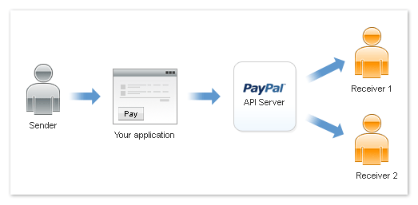

Figure 4: *Adaptive payment type “Parallel payment”*

A parallel type of payment as explained earlier allows a Sender (Customer) to pay through our application using the PayPal API in which there will be two or more receiver but base on the needs of the system we will be only using Figure 4. Our team as Receiver 1 and the service Provider as Receiver 2. Through this we can easily split the commission fee that we receive and the payment the of service provider easily.

What is the list of supported banks of PayPal here in the Philippines, as a known online payment service; PayPal has a lot of preferred banks in the Philippines therefore making it very accessible to Individuals that are registered to different banks. List of supported banks of PayPal here in the Philippines:

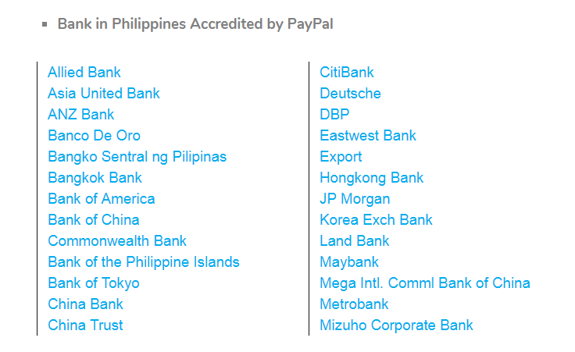

Figure 5: *Bank in the Philippines Accredited by PayPal*

APPENDIX 2: FastComet’s Cloud VPS provides:

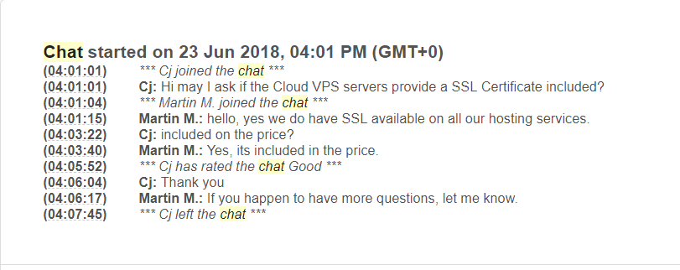

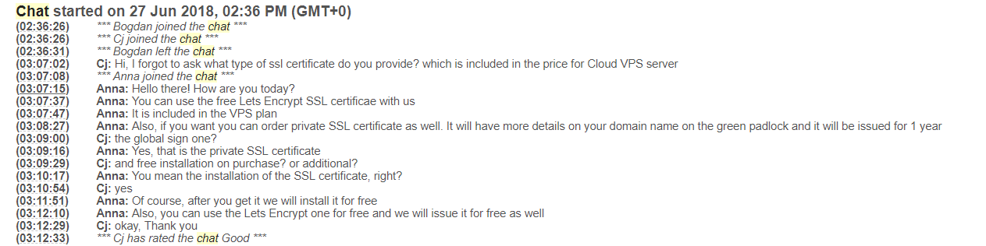

PayMaya is the first online payment app that enables users especially the financially undeserved to pay online without the use of any credit card. founded in the year 2007 by PayMaya Philippines Inc. which formerly known as Smart e-Money Inc. a subsidiary of Voyager Innovations, the digital innovations of PLDT and Smart.

What is PayMaya and how does it work? As of Septemeber 2015 Smart Communications Announced a new type of card that they called PayMaya. A hybrid version of beep card (A new type of card for people to use in paying train fee in LRT and MRT) that combines a e-wallet, a VISA debit Card and a beep stored-value card in one card.

Enable a user to start, it is recommended that you have the Physical Card itself which can be bought three Smart Jump Centers and selected train stations in metro manila but now can be also bought online through their website[5]. You must also have the app for IOS and Android that can be downloaded from either the app store or play store depending on platform you use. The app lets you to a register, Once that is done is immediately show you a virtual version of the card which you can deposit your money.

To load the your card you can to Cliqq Machine inside your nearest 7-11 store and other partner store stated from their website[6] some stores can be also seen stated from their frequently asked questions page[7] in which they have said they have 15,000 stores this includes 7-11,Palawan Pawnshop, Smart padala Centers, SM Stores Business Services, and Robinsons Department Stores Business Centers, for the CLIQQ or 7-11 stores just click paymaya button then type the amount then print the invoice in which you give in the cashier which it will be scanned and send a text message confirming you have receive the money.

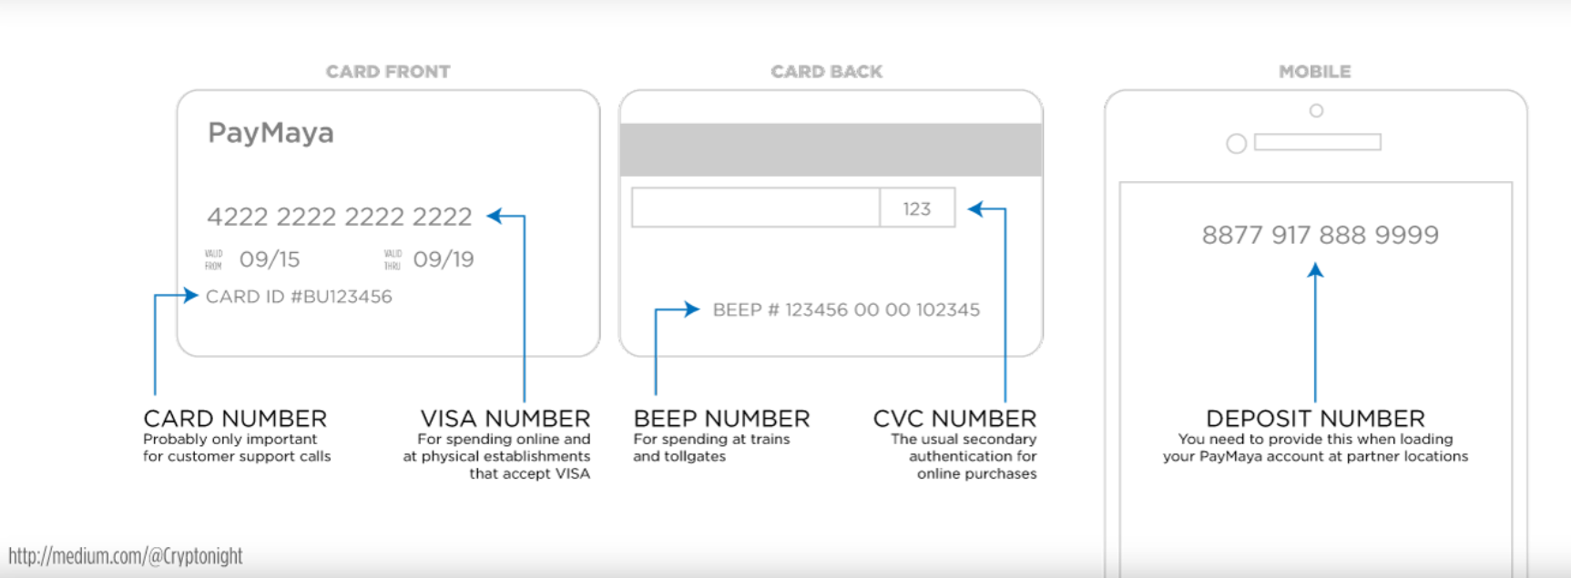

*Figure 1.0: The Anatomy of the PayMaya Card and Mobile App, as of November 2015*

Why chose to use PayMaya rather than a credit card or bank account, first and foremost is the convenience as we can tell based on articles surfacing the net is that 52.8 Filipinos don’t have bank accounts[8] the articles survey stated that “*Twenty-one percent of non-account holders say they don’t see the need for it, while 18% can’t produce the documents required to open an account; 10% say the cost of opening accounts is high; 9% don’t have knowledge about opening accounts; 8% are jobless; and 8% lack of awareness”;* based on their result. And Paymaya mainly targets peoples the underserved people[9]also it provides no account requirements required for registration unless you want to upgrade your account.[10]

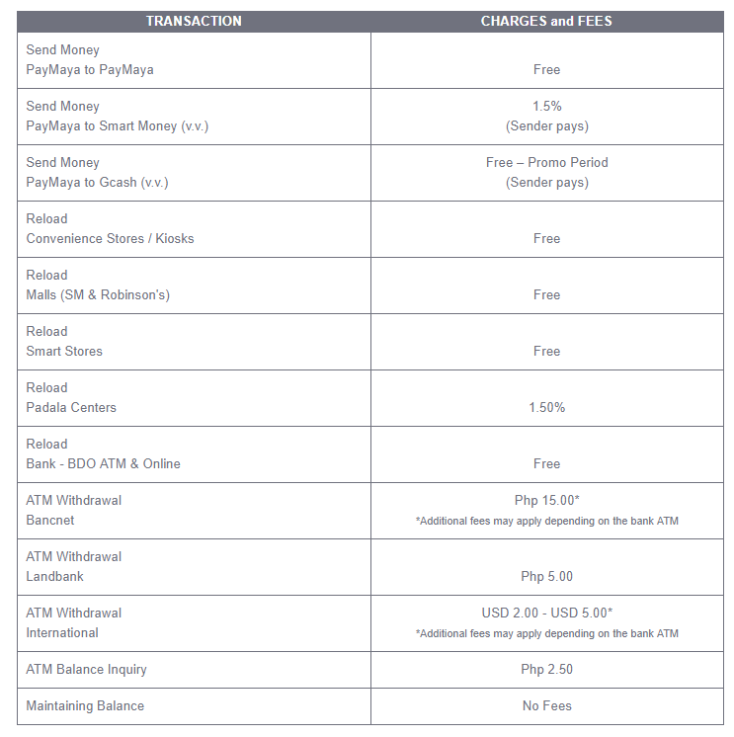

*Figure 1.1: Paymaya tables of fees and charges*

What is Firebase? Firebase is a mobile and web app development platform that provides vast amount of different services mainly focusing in Real-Time Database services, this was also a start-up of James Tamplin and Andrew Lee back in 2011, they called it as Envolve[11]. This API back then let’s developers integrate online chat into their website. However, in 2012 they realize they can separate the real-time architecture and chat after they saw that people also use the API to synchronize application data. This was later on acquired by Google in 2014 and as an exchange to Google Cloud Messaging (GCM)[12] which them lets the client development more simple while maintaining and inheriting the core infrastructure of GCM.

What does Firebase offers? As said earlier Firebase offer different kinds of services to name a few, they have Real-Time Database or a cloud hosted using NoSql which looks a lot like a big JSON file. They also have an authentication service which allows users to login through Google, Facebook, Twitter, Github and more. This feature can also be integrated in the real time database as your login feature. It also offers Firebase cloud Messaging (FCM) which allows for notification delivery reliable and efficient in Android, IOS, and Web without any cost. This is some of the services you get for using Firebase.

What is JSON, JSON was created by Douglas Crockford that means JavaScript Object Notation this is used for storing and delivering data. Common used of this type of language is for sending data from the server to a web application. In other words and to explain it simply this used as a middle man like a delivery and transporting data.

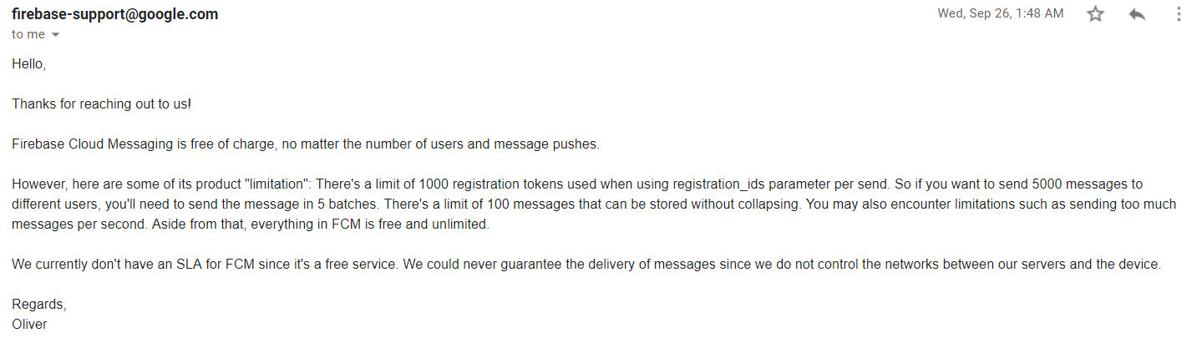

Review of related literature on security:

1. *OWASP.*

When we develop a system, for instance a web application, we often forgot to protect it leading to major threats on your system. These threats can exploit the confidentiality, integrity and availability of data which can cause a bunch of lawsuits against your company and major loss of money. This is the purpose of OWASP or Open Web Application Security Project.

The foundation was founded in December 1st, 2001, serving as an international organization and an open community that work together in conceiving, developing, acquiring, operating and maintaining application that can be trusted in the long run.

OWASP provides a list of vulnerabilities every year, this list is not just an ordinary list of vulnerabilities but also is a guide on what the attack does and how to protect your website from it.

1. What is SQL Injection? The possible damage of it and security measures need to be implemented against it.

One of the most dangerous attacks on a system according to OWASP top 10 and its still the top 1. This type of attack can directly bypass and access or targets the database server. This type of injection attack is SQL injection (SQLi) in which an attacker can execute unintended and malicious SQL commands on one’s site that can cause major damage to the website if it happens leading to a full system compromise.

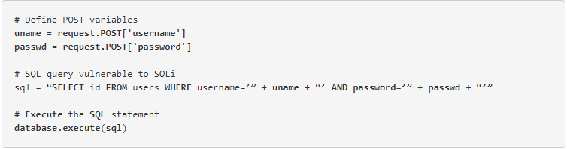

*Figure 1.0: SQLi sample vulnerability*

Security measures that need to be implemented to protect or prevent the system from such attacks is that must validate, or whitelist expected data and blacklist unexpected data which is will passed through inputs and URLs. We must also use the function of ‘*mysql_real_escape_string()’* function to prevent dangerous characters that can execute the commands nevertheless we must also make use data filtering for emails and other inputs that needs to have special characters. this protection can prevent the potential risk of the attack. We must also include prepared statements, parameterized queries and stored procedures, prevent the use of parameterized queries or concatenated queries such as figure 1.0’s sample.

1. *What is Cross-site scripting or XSS? Damages it may cause and security measures?*

From the OWASP top 10 we can also see another type of injection attack called XSS or cross-site scripting which will attack the client-side code injection attacks which make use of the scripting language JavaScript as a weapon of choice. In this attack, the attacker will pass a request containing a malicious script that can put the system on a potential risk of exposing the integrity, confidentiality, and availability of data.

There are 3 major types of XSS attacks, and these are the following:

* Reflected XSS
* Where the attacker will send a script that will become a part of the request and immediately executed by the web server or the browser as a response and reflect it back to the victim, hence the name of the attack “Reflected XSS”
* Stored XSS
* Similar as Reflected XSS attack but for this type of attack the payload script that will be passed on the HTTP request will be persisted inside the database in which will be executed when the page is opened by the victim.
* DOM-based XSS
* The DOM based XSS attack is where the attacker will insert a the payload directly into the DOM ignoring the script tag nonetheless will have the same outcome as the other XSS attacks.

Same as protecting the system from SQL injection we can also do it to this type of defense to prevent the attack. Security measures need to be implemented is to have “input validation” which will blacklist inappropriate inputs. We could also implement “input transformation” that will transform the script in in-executable code using HTML Escape Strings or escape characters that can disable the code from executing.

1. *What is broken authentication and possible damages of it what security measures needed to be implemented?*

We always have this feeling of paranoia against our privacy over the web in which someone and somebody will able to access our personal data and compromise integrity of it, no matter how protected the data even if the website use the latest protection and SSL security there’s always that one attack will be able to pass through, if a developer mishandle the creation of login and session management in the system. Broken authentication flaw, this is where the attacker will guess a user’s credential through a credential stuffing manually and through the use of an automation tool the attacker can also steal user sessions.

Protecting the data from this major flaw, the system must have password checking which will enable the use of password policy during registration this can protect one’s account from potential risk of credential stuffing a security a system can also implement is limiting the inputs. For session management we must have security measure for passing data; proper use of HTTP methods avoid exposing data in motion.

1. Minimum and maximum length and requirements of a password.

Having trouble making and choosing password? Which sometimes led to myname123 or any worst password you can think of. A memorized secret or a password to make more understandable, one of the most important part of a registration, allowing a user to access the account created later. What are needs of a password how to make it stronger is that user must be able to attain the requirements of a password while the system must have a security measure on password policy on the website.

What is the password policy or requirement, well, these are the following:

* A password length must have a minimum of 6 or 8 characters
* The password must have at least one Upper case, Lowercase, Numeric character and lastly Special character (some of this characters must be chosen properly and blacklisted)

1. What is PCI-DSS?

Over the years of protecting bank account data there is still vulnerabilities that arises which cause the compromise of Personally Identifiable Information and its integrity, leading to major loss of trust on a bank. This why the Payment Card Industry Data Security Standard (PCI-DSS) compliance was established, to make list of acceptable policies and protocols that will protect a security of payment transactions and an exposure of confidential data to the public.

1. What is a CAPTCHA?

CAPTCHA code or *completely automated Public turing test to tell Computers and Humans Apart* is a way of testing if the one who is inputting is whether or not a human or a machine. The major security measure of this basic implementation is to avoid the potential risk spamming on the system. Google has free service they called reCaptcha which is basically their own version of CAPTCHA called reCaptcha that can be implemented free of charge into your site.

Methodology

Waterfall Methodology, Pros and cons

Looking for the right software development methodology is difficult for an organization. Who is making the software? This guideline shows the advantages and disadvantages of using Waterfall methodology. It also contains the difference of Waterfall methodology (traditional method) and the Agile method.

Waterfall Methodology

The Waterfall Method, also known as the linear-sequential life cycle model, was proposed by Winston Royce in 1970. The proper use of Waterfall method is to complete each phase before moving forward to the next phase. There is no overlapping after each phase is completed. There are six phases to be followed in this method: the requirement analysis, System Design, Implementation, Testing, Deployment, and Maintenance.

The requirement analysis is the collection or gathering of requirements to be documented. The second phase is the design of the system where the study of the system design specifies the overall system structure. Implementation, the third phase, the designed system will be developed in this phase. The fourth phase is the testing, in this phase the developed system will be tested if any failures occur. Fifth phase is the release of the product to the customer also known as deployment phase. The last phase is called the maintenance phase, where some issues feed backed by the clients are fixed by releasing patches.

Pros and cons of the Waterfall Method:

Pros:

* There is a clear requirement to be followed
* There is specific time in each phase to be followed before the next phase is to be done
* Resources consumed is minimal
* There is a well document to be followed for each phase

Cons:

* If there are changes in the requirements, the requirements will not be change easily during the current implementation process.
* The final product is delivered until the last cycle, this will result to possible bugs.
* It only suitable in small projects

Conclusion:

Using Waterfall method can work best for small teams with small projects to be developed. Each phase can be understood easily. It has a well-documented project to be followed. Following each phase can lead to the success of the final product. The intended product is only finalized when the cycle reaches the final phase.

Each stakeholder doesn’t have the idea of the product until it reaches the final phase. Following the method can lead into a lot of problems. The problems can only be fixed until the maintenance phase. Giving updates to fix the problem can be costly.

**TESDA Validation**

Certificate of authentication and verification (CAV) for TESDA issued certificate of competency.

STEP 1: Go to the TESDA-issuing office of your NC/COC and apply for Certificate of Authentication and Verification (CAV).

STEP 2: Submit the following documentary requirements:

1. Two (2) photocopies of the NC/COC

2. Original NC/COC

STEP 3: Pay the authentication fee (P50.00) to the Cashier and get Official Receipt

STEP 4: Present Official Receipt to the TESDA Issuing Office for CAV.

STEP 5: Get the CAV document from the TESDA Office.

This is according to TESDA website certificate of authentication and verification (CAV) for TESDA issued competency (COC) https://www.tesda.gov.ph/About/TESDA/46

For us to verify submitted TESDA certificates we may do so in TESDA’s website which allows us to search the applicant’s certificate by simply searching their name, certificate no. and their qualification.

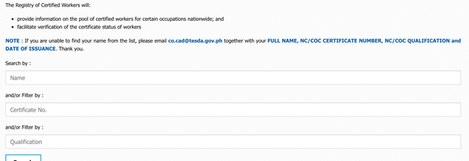  
*Figure 1: Steps on validating TESDA certificate number.*

Retrieved from: https://www.tesda.gov.ph/Rwac

We will be contacting the applicant’s references because it is a good way to validate their job portfolio for us to be sure that our applicants are credible and would provide outstanding service.

Al Palumbo(Career Expert) , Job Applications: When and How Does an Employer Check Your References?

Retrieved from: https://www.resume-now.com/templates/career-tips/job-applications-when-and-how-does-an-employer-check-your-references

For non-TESDA applicants, we will be accepting their applications given that they will be undergo a phone interview so that the applicant would not need to spend money to go to our main office. We will be placing them under-probation and give them a chance to show the skills they have written in their application form. We will be checking their customer feedbacks on their first 5 jobs, it will be a way for us to test and make it as a basis for us to fully accept the applicant.

Retrieved from: Susan Ricker(April 27,2014) How do employers test an applicant’s skills?

Retrieved from: https://www.careerbuilder.com/advice/how-do-employers-test-an-applicants-skills

# **APPENDICES**

Service Provider’s Demographic

Majority of the service providers are male with a total of 40 while the female are only 10. The age group with the highest male is from 36 – 41 and 42 – 47 years old while the highest number of female is from the age group of 30 – 35 and 36 – 41 years old.

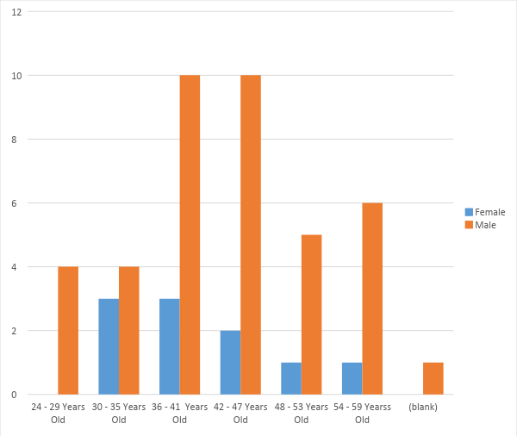

Service providers are mostly from Makati and Manila City, while the rest are from Quezon and Pasay.

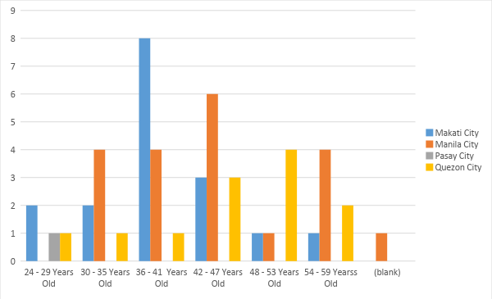

Most of the service providers are either married or single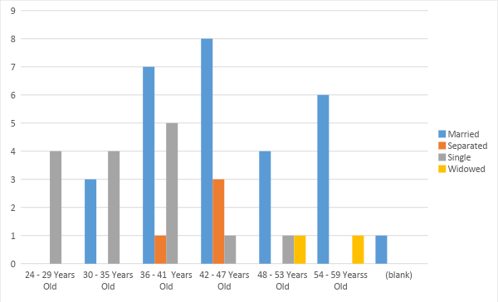

Most married service providers have at least one child and most single service provider has no child.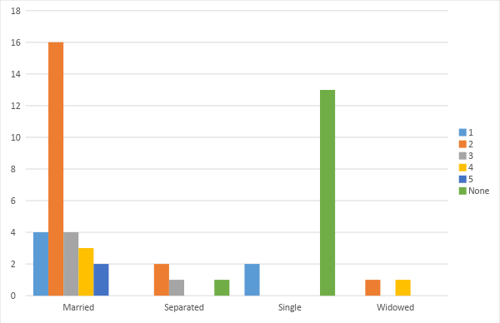

Nature of work per age group. For 24 – 29 years old, most job is airconditon cleaning, the rest are electrical and wiring, plumbing. For 30 – 35 years old most job is house cleaning, and the rest are airconditon cleaning, appliances repair, electrical and wiring, and plumbing. For 36 – 41 years old, house cleaning and carpentry are the top jobs, followed by appliances repair and aircondition cleaning, and lastly electrical and wiring. For 42 – 47 years old, carpentry is the most top job, followed by aircondition cleaning, followed by electrical and wiring and house cleaning lastly, plumbing. For 48 – 53 years old, carpentry is the top job, followed by aircondition cleaning, house cleaning, plumbing. And for the 54 – 59, electrical and wiring is the top job followed by carpentry, appliances repair, house cleaning, and plumbing.

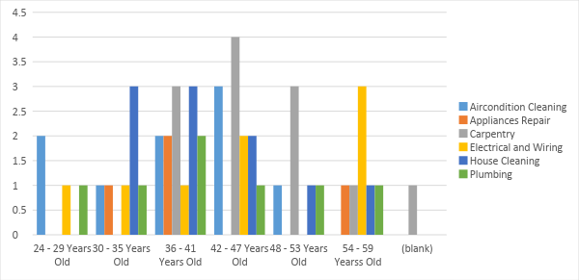

Most service providers learn their skill through experience. Some by being a helper, and by attending Tesda trainings.

Customer UI

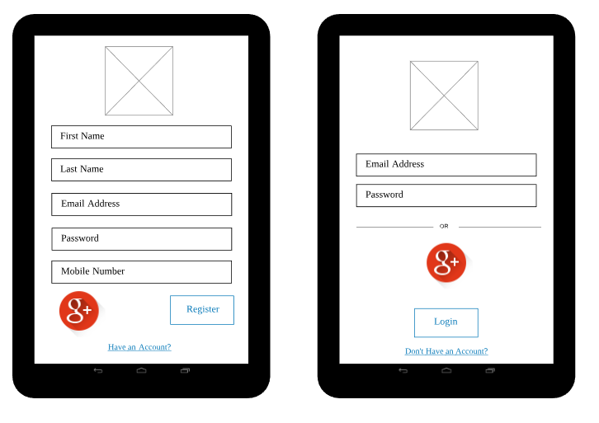

*Figure 1.0: Login and Registration*

Customers will be able to access the app through an account in which they can make in the registration page however if they have an account they have the ability to login

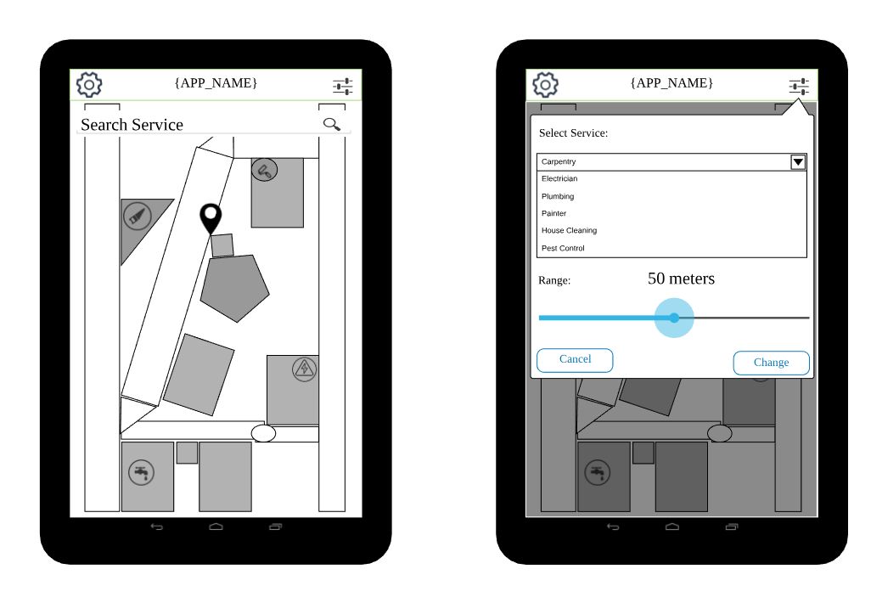

*Figure 1.1: Search service*

Here customers will be shown the nearby services within their vicinity. They can also have the option to change the preference of which services to show and the distance radius of services if they want to go further or nearer. They also have the option to search the service

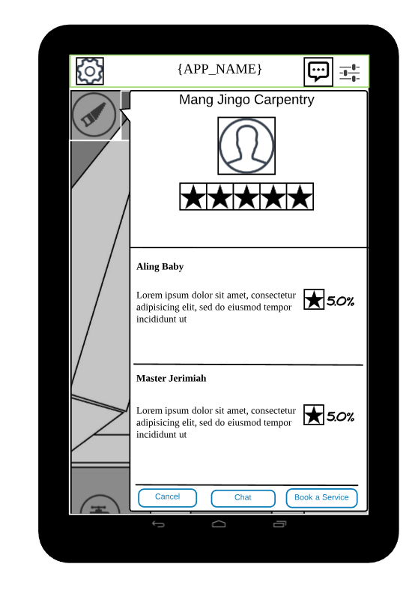

*Figure1.2a: Direct booking*

Customer can now book service when they have chosen the right service for them just by clicking the Book service; set an appointment, what is the problem? , and send photos of the problem.

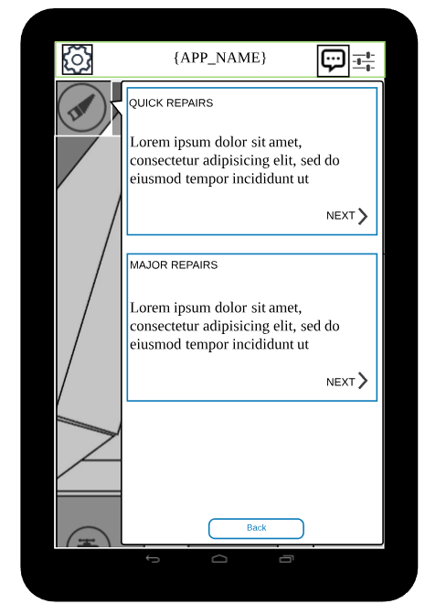

*Figure1.2b: Direct booking*

Set what type of repair we are tackling is it quick repair or a major this may differ on some other services

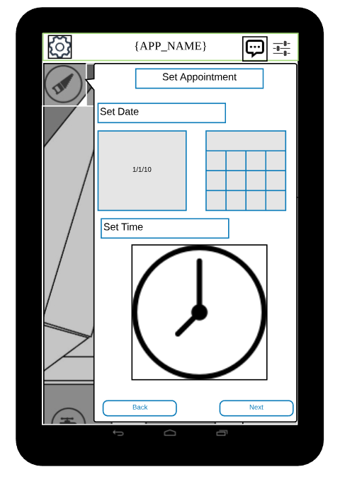

*Figure1.2c: Direct booking*

Here the customer must set the appointment of when you need the service; to explain it further, a customer must set the date then time of when you need it

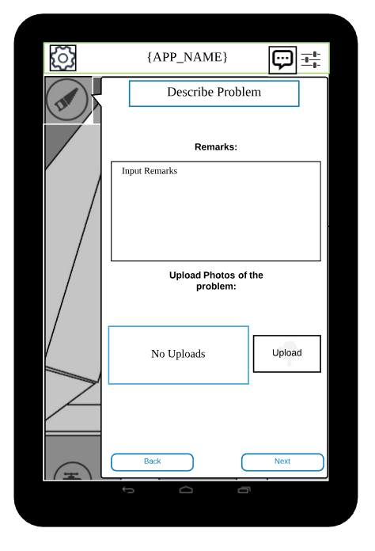

*Figure1.2d: Direct booking*

Here we can see that we allow the customer to provide some remarks about the problem then upload a picture of the problem.

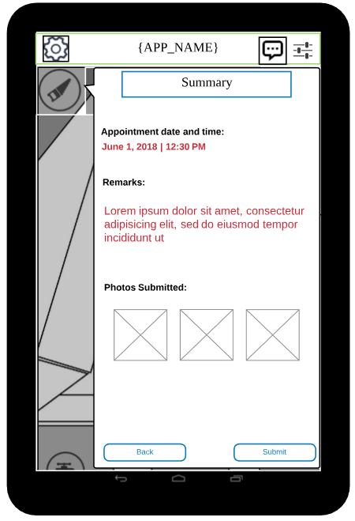

*Figure1.2e: Direct booking*

After the customer has done all the requirements for booking a summary is presented of the booking.

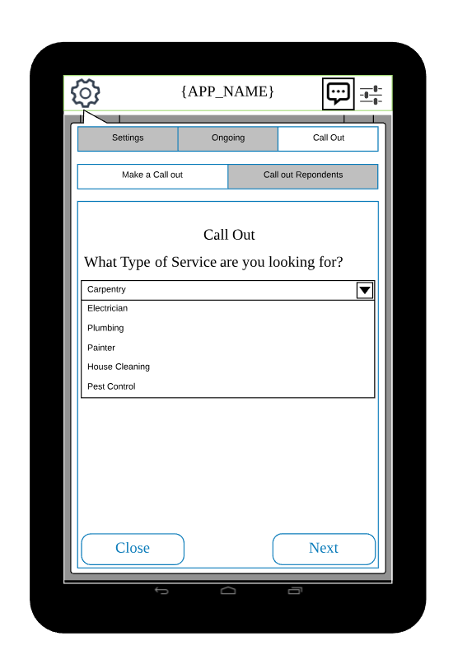

*Figure 1.3a: Broadcast or callout booking*

Same as a booking but this allows the booking to be broadcasted to numerous service provider which they can then respond and say their rates about the service

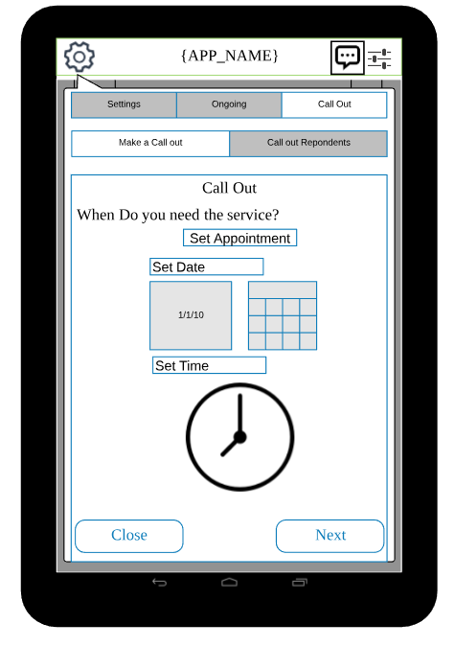

*Figure 1.3b: Broadcast or callout booking*

Same as direct booking we also have to set appointment date and time of the service, when the customer needs it.

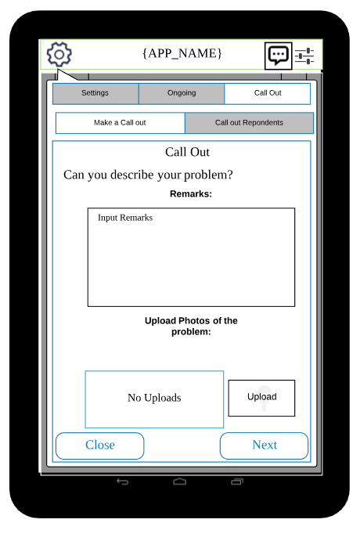

*Figure 1.3c: Broadcast or callout booking*

Also a remarks and send photos to let the service provider know what kind of problems they are dealing with. Simply assessment of the problem.

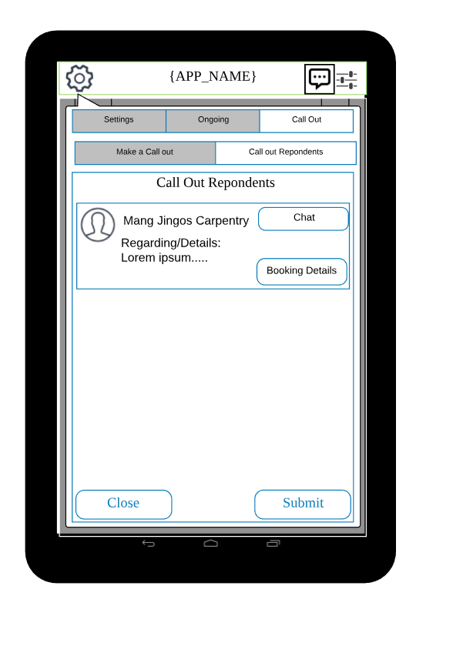

*Figure 1.4: Hire Service provider*

Here we can see all of the respondents from your broadcasted booking which customer can now choose who to hire.

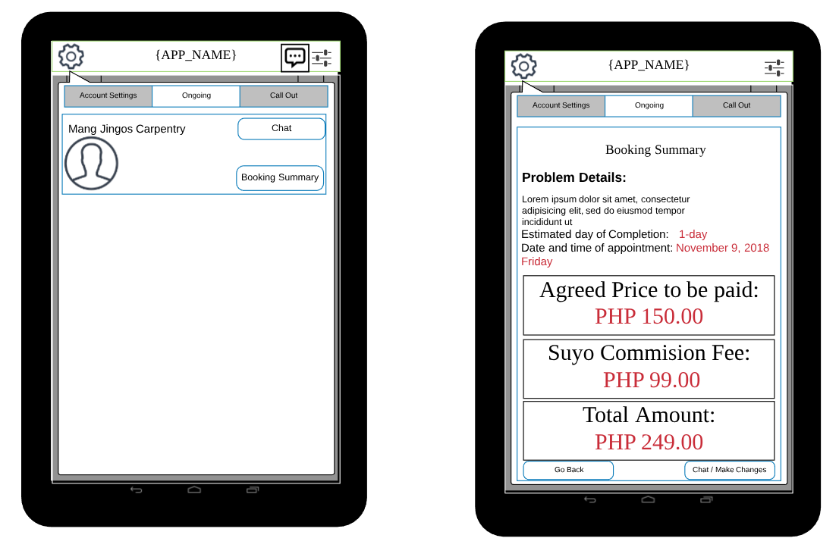

*Figure 1.5: Manage Booking*

In case of an emergency or an appointment date is compromise customer can change the booking of the service this will then notify the service provider about the changes which they can also respond.

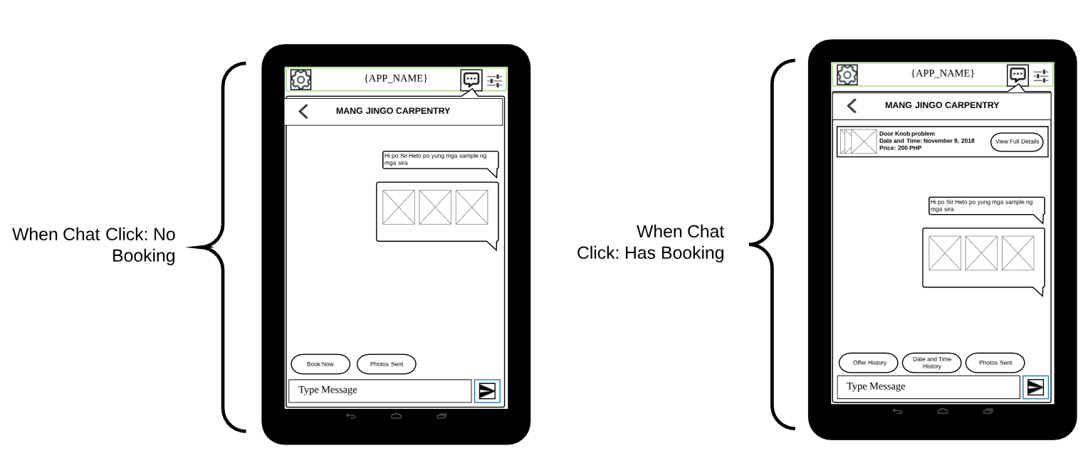

*Figure 1.6: Chat Feature*

For more thorough communication within the customer and the service provider a chat feature is implemented using firebase cloud messaging FCM

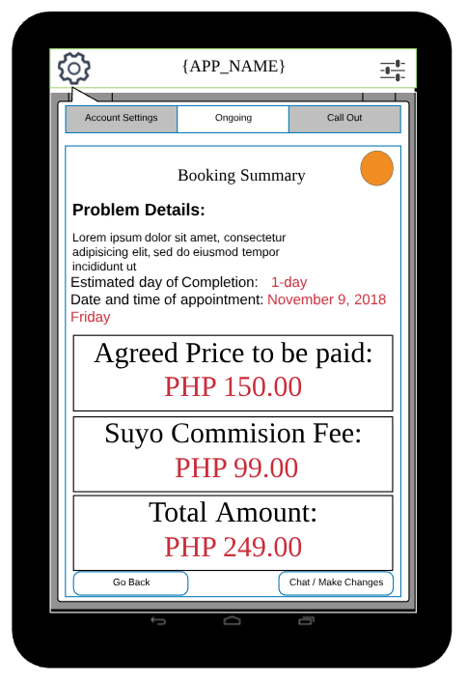

*Figure 1.7a: Manage booking customer side*

In this user interface shows the details of ongoing process in the customer side. The customer can manage the bookings or simply just go back.

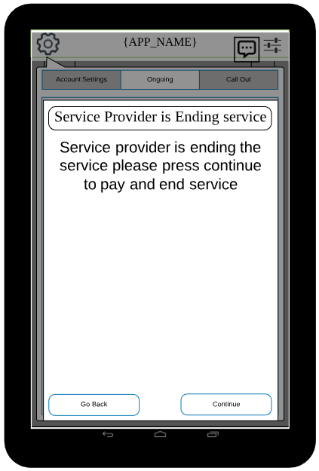

*Figure 1.7b: Ending of service alert*

The application notifies the customer or shows pop up alert in the application after the service provider ends the service. The customer has the will to go back and just ignore it or continue and will proceeds to the payment section.

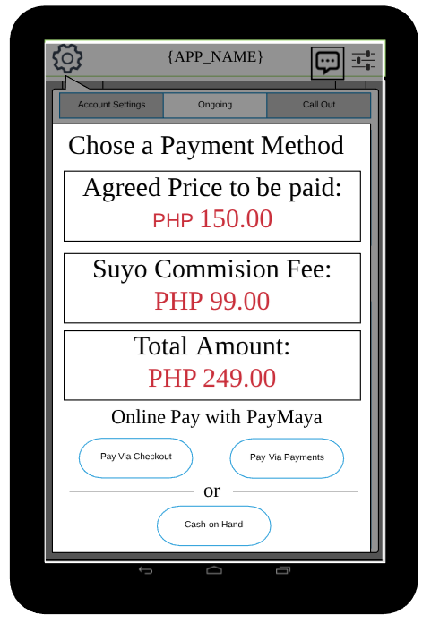

*Figure 1.7c: Process Payment*

After the customer pressed continue it will show the price agreed upon, Suyo commission fee, total amount to be paid, and buttons whether to pay in cash or using PayMaya.

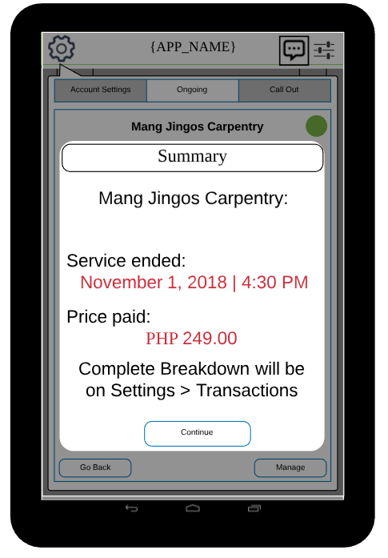

*Figure 1.7d: Transaction Summary*

A summary of the transaction is shown, after the customer successfully paid the service provider. The whole breakdown of the transaction is shown in the settings.

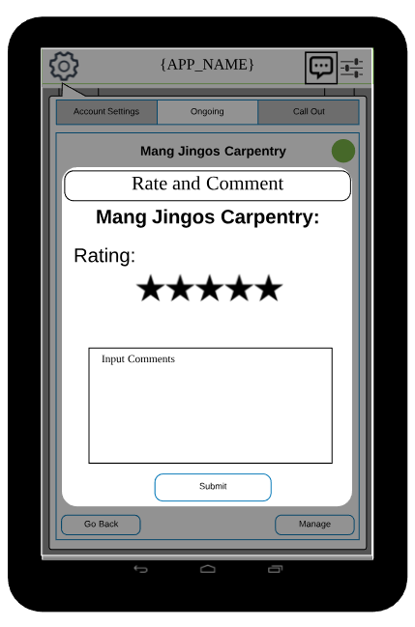

*Figure 1.8 Rating and Comment*

The application enables the customer to rate and give feedback after seeing the summary of the transaction

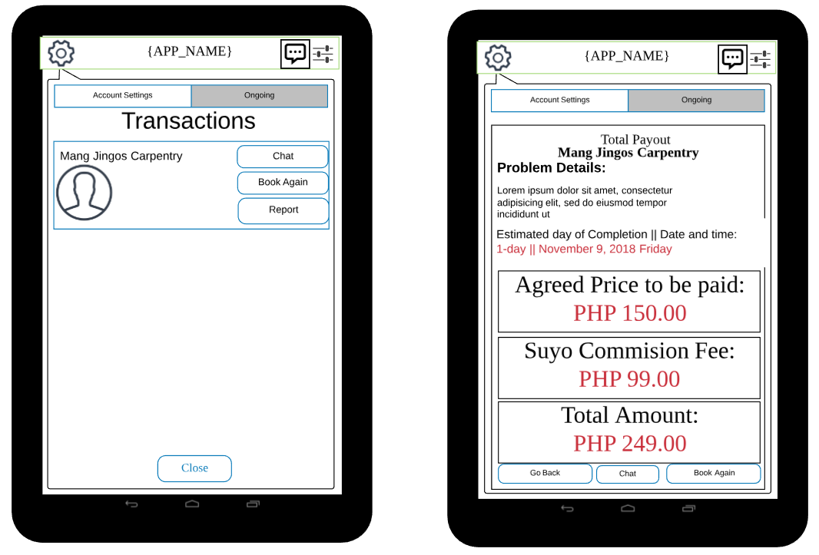

*Figure 1.9: Customer Transactions Feature*

After a service is done or have ended, it will go here for later viewing although we also email a copy of the receipt through email after a service has ended

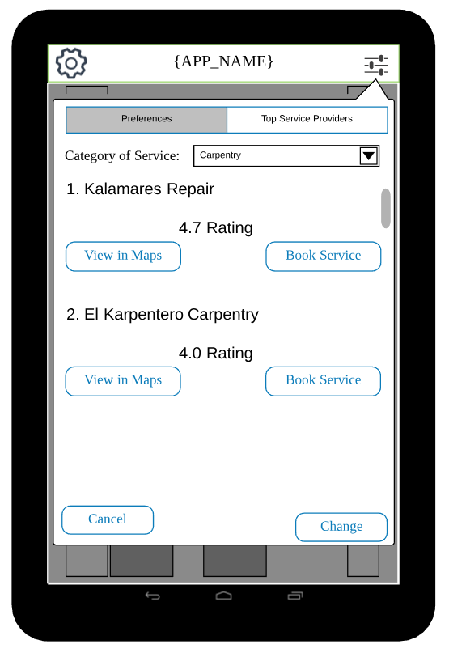

*Figure 1.10: Top Rated service providers*

Customer can view all of the top rated service providers in which they can also change the preferences depending on the skill or category. For example who is the top carpenter then show all of the top carpenter.

Service Provider UI:

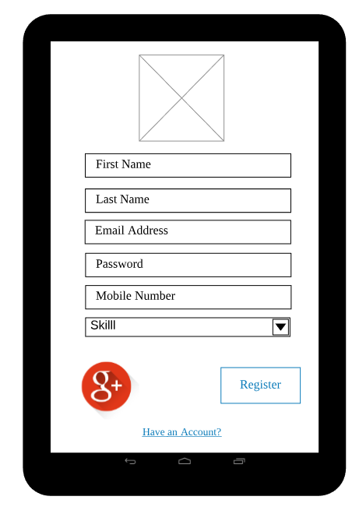

Figure 2.0: Service Provider Sign Up

Service Provider will be having this app to register or signup through the app and enable to make a Interview schedule enable for them to be hired.

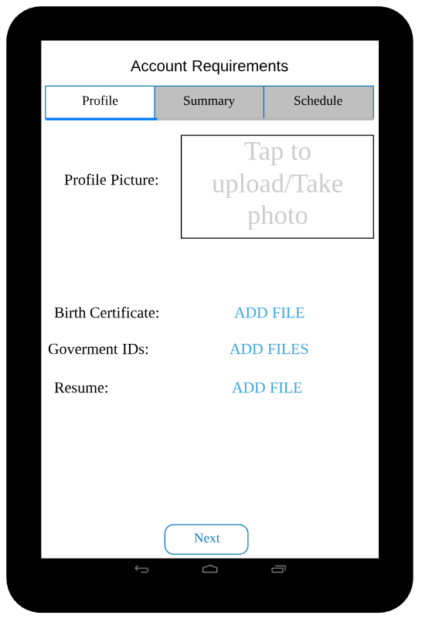

*Figure 2.1a: set Interview Schedule*

Service providers’ registers and set an appointment schedule for their interview of when are they available. Process of registration, first they upload their profile and other account requirements needed then when they click next they can see the summary.

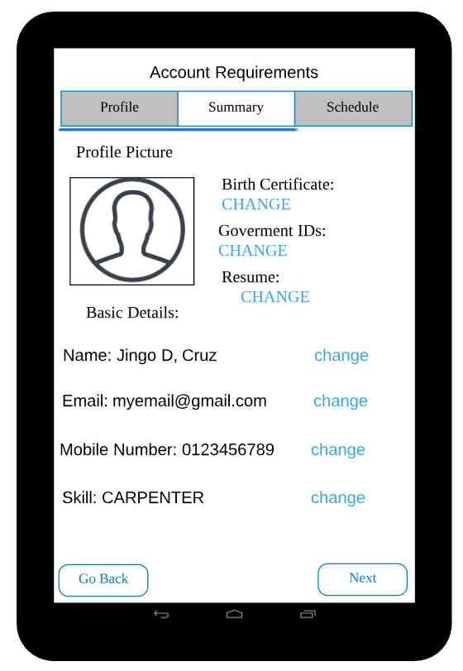

*Figure 2.1b: set Interview Schedule*

Here we can see the summary of the app which they can also edit in case of errors or typos and if they forgot to add a requirements. If all of that is done they can now set an appointment of when they are available for interview.

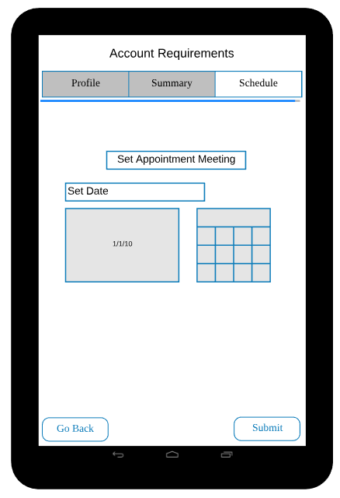

*Figure 2.1c: set Interview Schedule*

Here is where they set time date of when they want their interview to be processed..

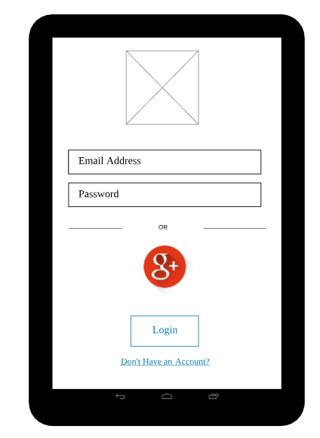

*Figure 2.2: Login for service providers*

Here we can see the login page for the service provider which they log on onto their account if the account is approved and active. If they forgot their password they can renew it by clicking they forgot password and renewing it through the email sent to them. In case they don’t have an account they click “Don’t have an account”

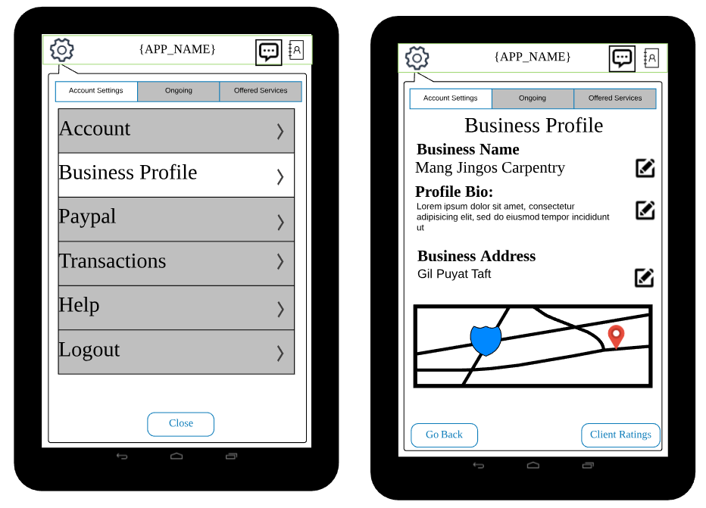

*Figure 2.3 Business profile*

This shows the settings with two categories and then under that has another multiple category. The service provider goes to the business profile, after tapping; the system shows the user interface of the Business profile. It provides the service provider to change business name, change their bio, and then change their business address. Under the business address, this shows the address of the service provider in Google maps.

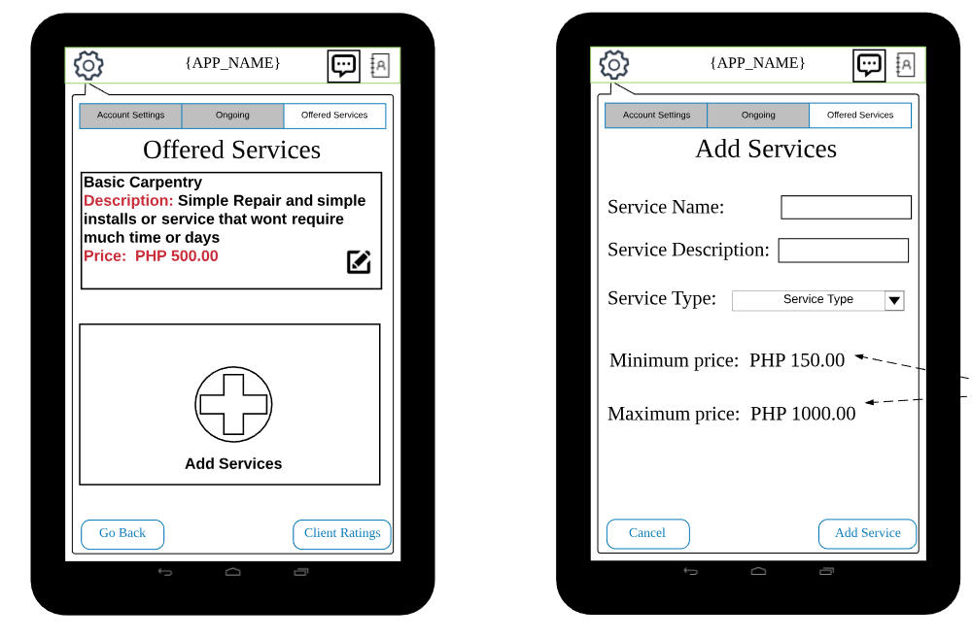

*Figure 2.3a Business profile, Add offered services*

Here we can see how service providers can add and edit services. They need to go to settings and tap on offered services, if there are no services they can add service or if there is one then they can edit it. important note on adding is that the minimum and maximum price will depend on the service type of the service, since the app aims for a fix price though the price can overridden on the concerns if and only if customer agree on the overriding the price.

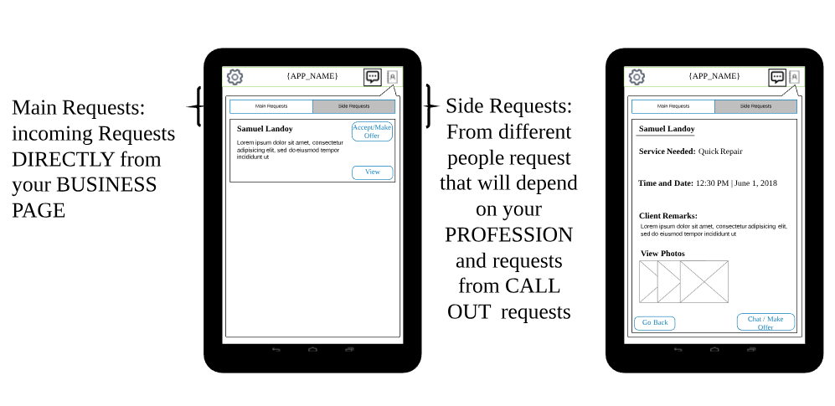

*Figure 2.4*

These shows the user interface for the service provider to view request. To access this part of the interface, the user must click the icon on the upper right corner. After clicking, the application will drop down a group box that looks like a message. The service provider will see the buttons: view request, and side request. The service provider can view request or just accept and make an offer. On the right side of the figure, the user clicked the view button and then the application shows the details of the booking. The design for both main request and side request are just the same.

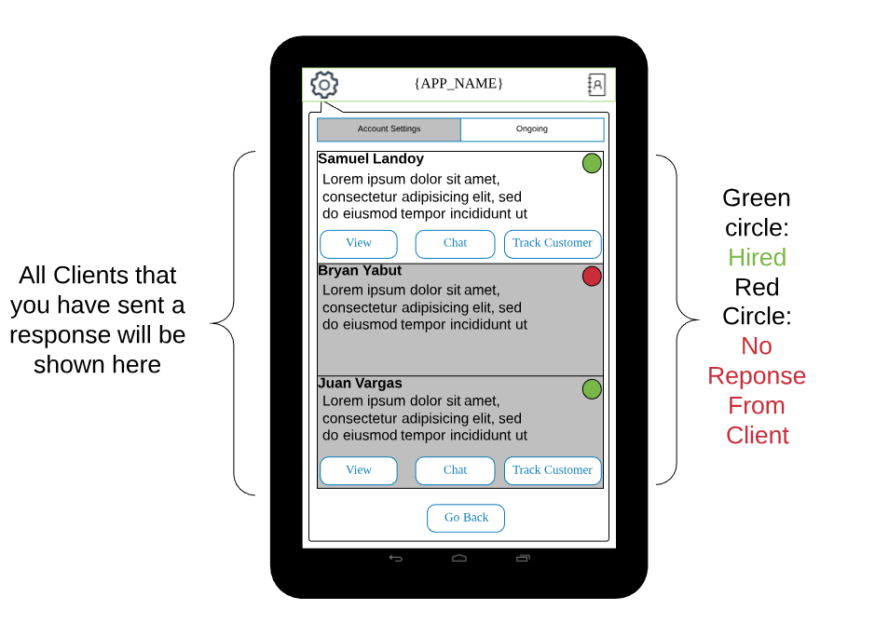

*Figure 2.5a: Ongoing*

The user interface shows the ongoing work or service. The service provider can see green, meaning this person hired him. The red indicates someone did not response to him.

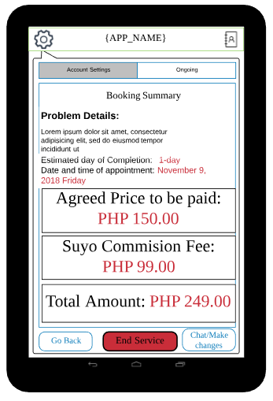

*Figure 2.5b: Ongoing*

The booking summary show the summary of the on-going work of the service provider or the details of the booking. The service provider can go back, end the service, and can chat the customer.

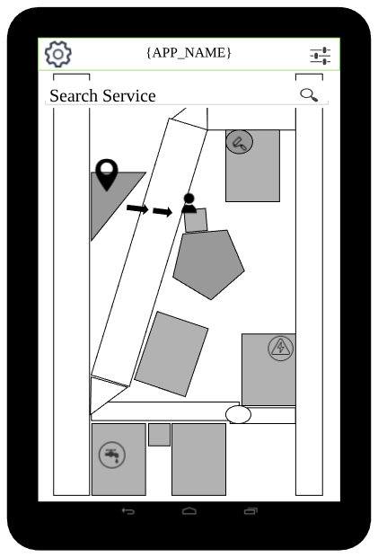

*Figure 2.5c Tracking*

The service provider can track the customer while using the included google maps in the application. It shows the location of the service provider and the customer’s address. The map enables the service provider an gps direction.

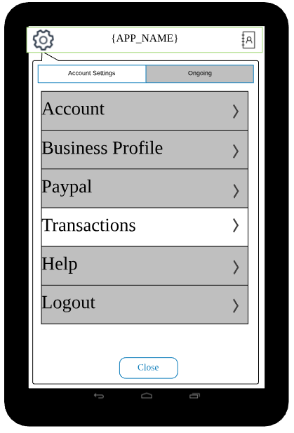

*Figure 2.6a Transaction*

The user taps the settings and it will show the setting menu: the account, business profile, paypal, transactions, help, and logout. Under those list this is close button.

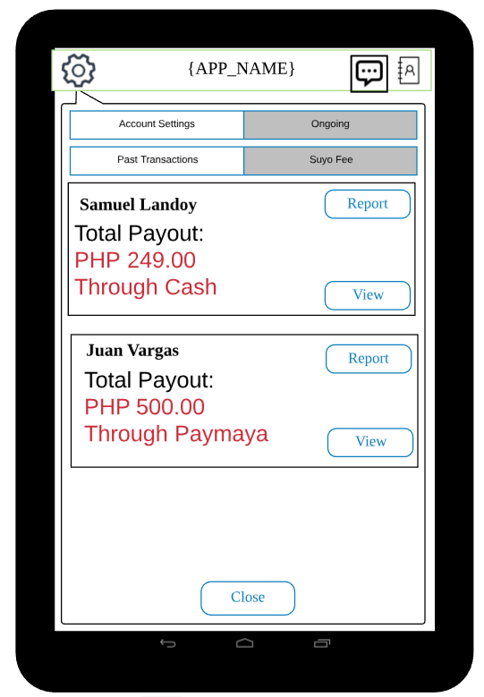

*Figure 2.6b: Transaction list*

After the service provider clicks the transactions the application shows the past transactions and a suyo fee button right beside it. The past transaction can be viewed or reported.

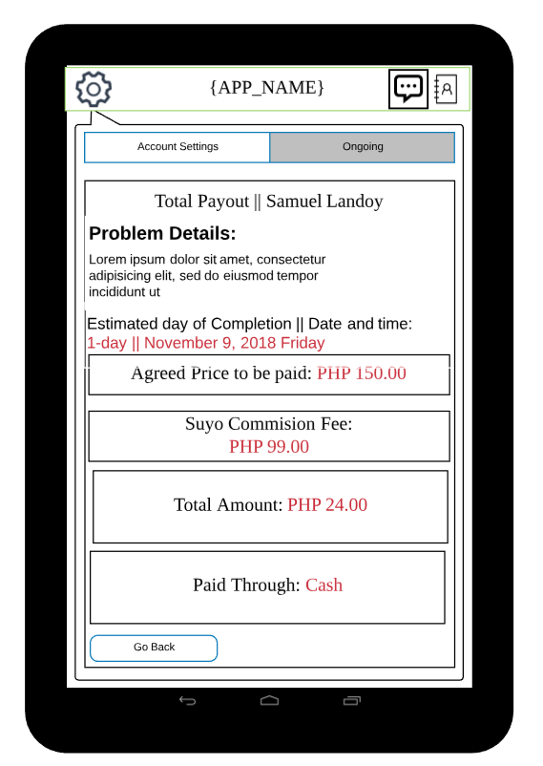

*Figure 2.6c: Transaction Details*

The service provider views one of the past transactions. It shows the details of the past bookings and transactions.

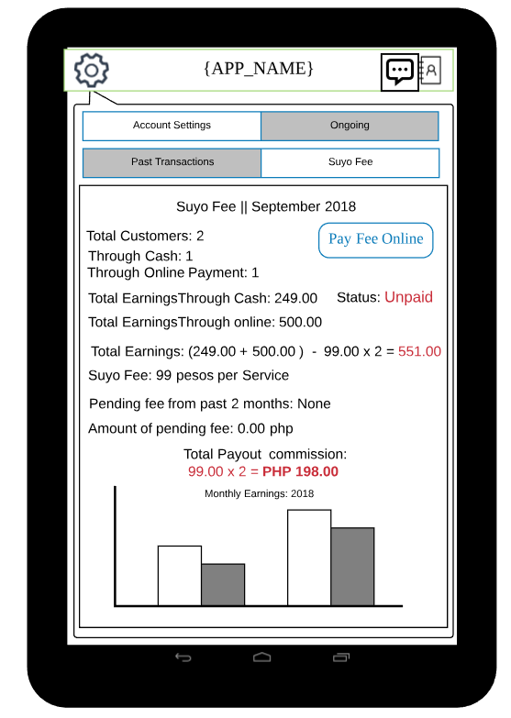  
*Figure 2.6d: Commision fee*

Inside the Suyo fee is the commission that the service provider must pay. It shows the details of the commission payment whether paid or unpaid, details of the earnings through cash and Paymaya, and the total earnings of the service provider.

Admin UI

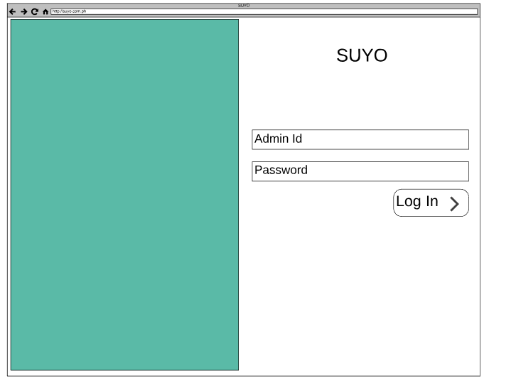

*Figure 3.1: Login*

Admin can access the admin website by logging in through their accounts

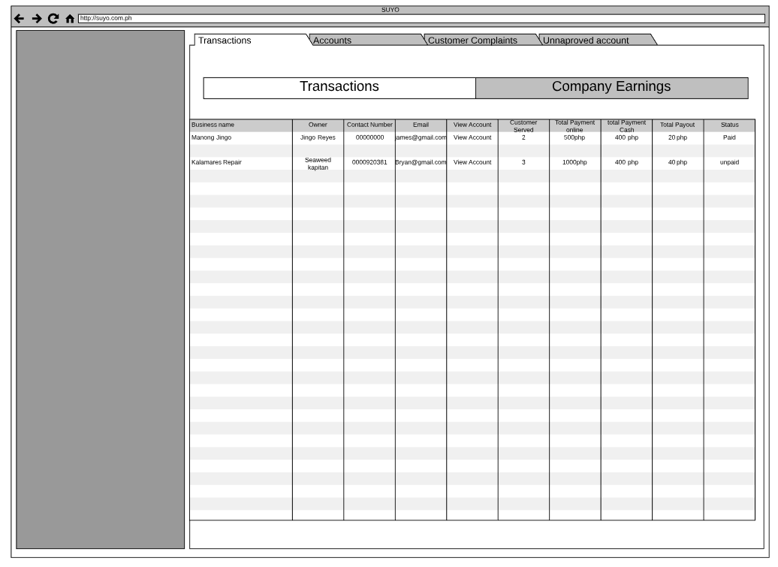

*Figure 3.2: Transactions*

Admins can see all of the transactions of all users customers and service providers

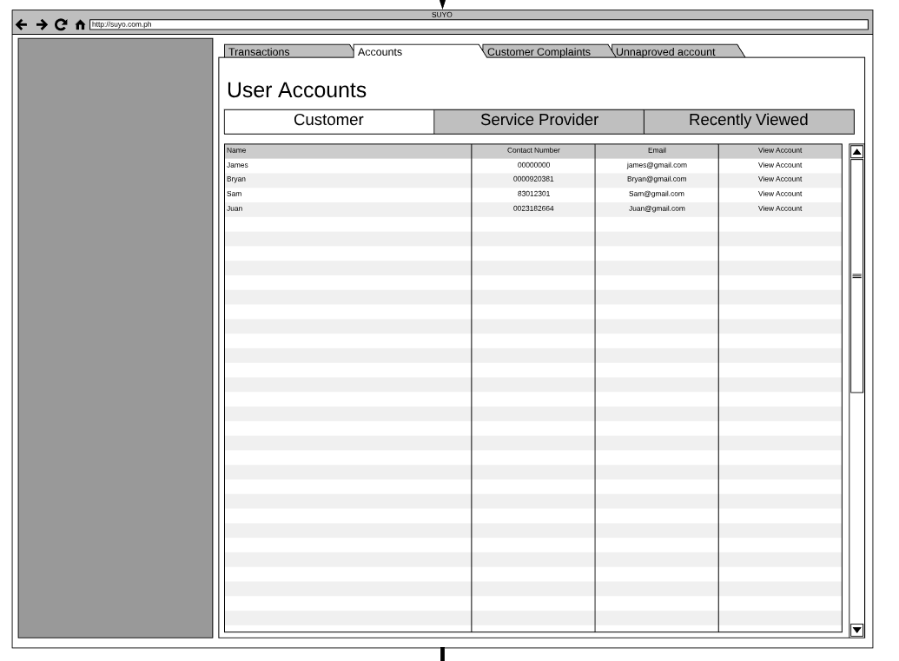

*Figure 3.3: User Accounts*

Admin can view all of the user accounts of customers and service providers to

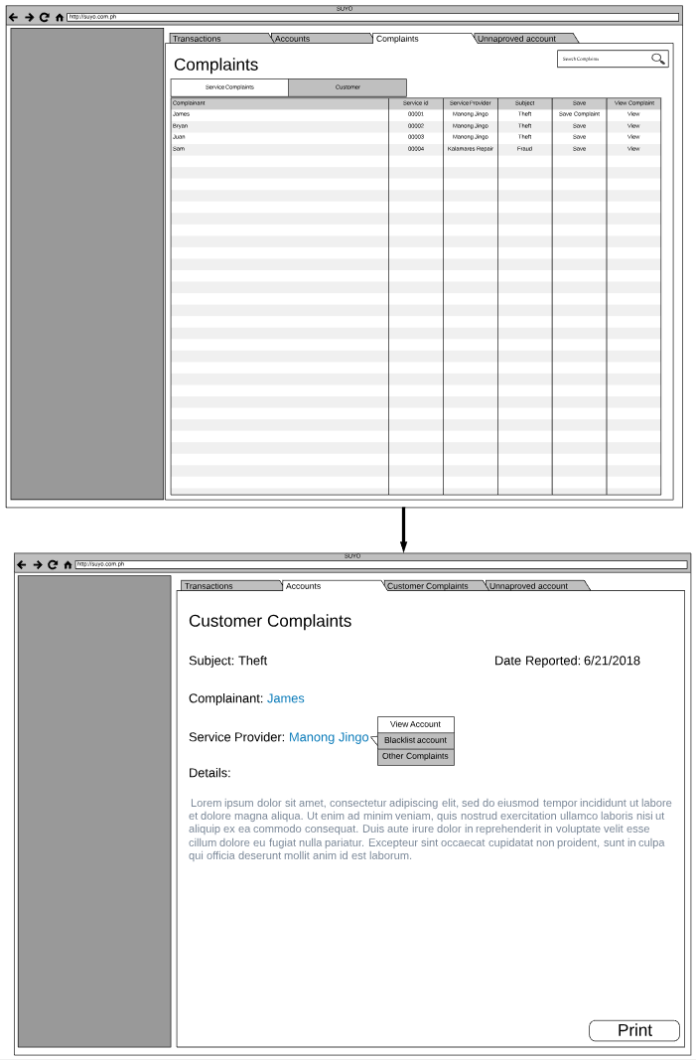

*Figure 3.4: Complaints*

Admins can also view all of the complaints of customer towards service provider and to be fair service provider towards customer

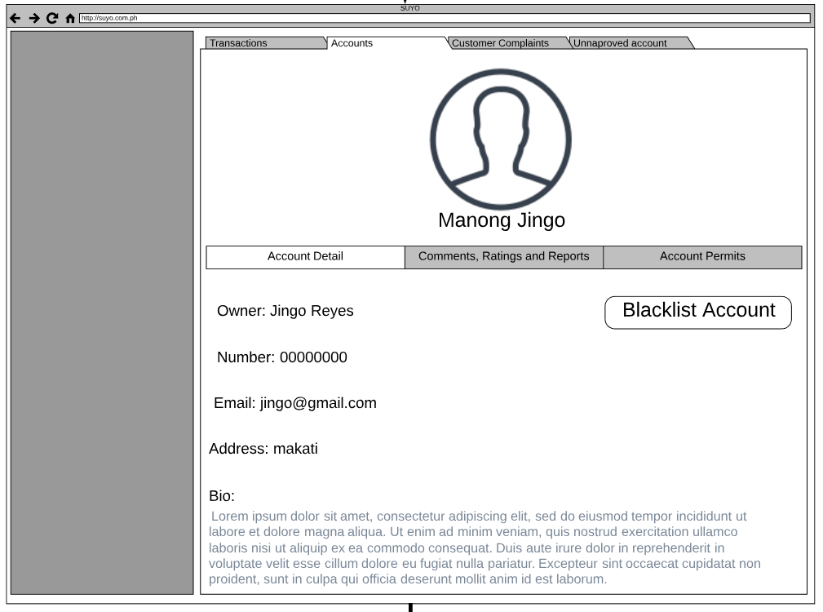

*Figure 3.5: Blacklist account*

Admin have the authority to blacklist an account depending on the level of the complaint

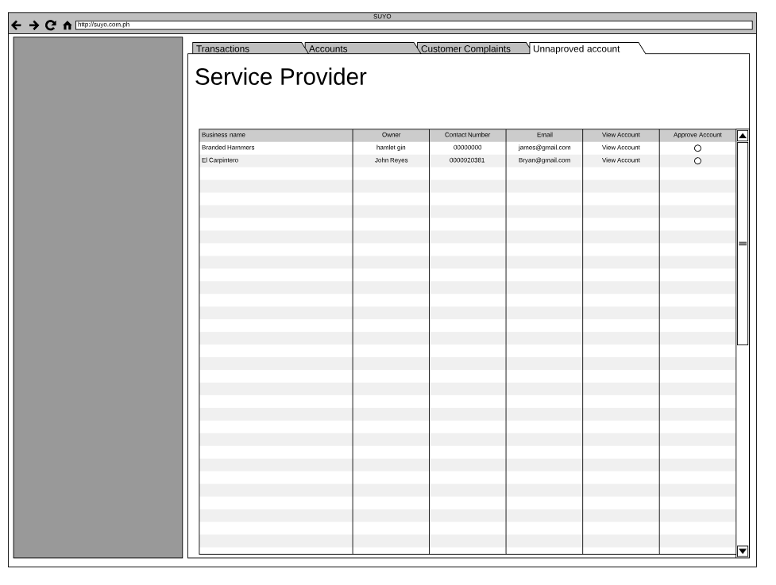

*Figure 3.6: Unapproved Accounts*

Admins can approve a service provider account if they have submitted all of the requirements and when the interview is successful.

Email Notifications

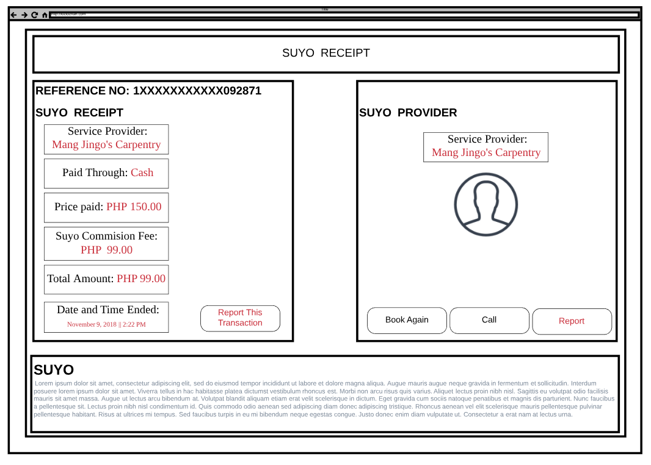

*Figure 4.1: Email for Customer*

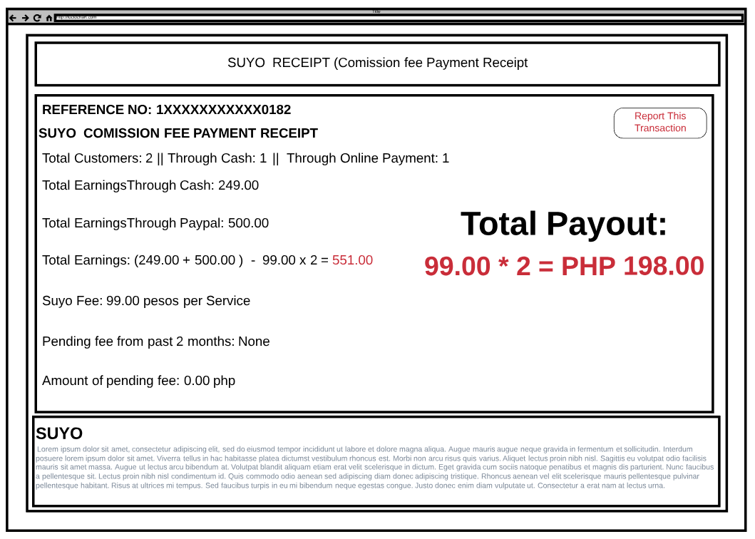

*Figure 4.1: Email for Service Provider*

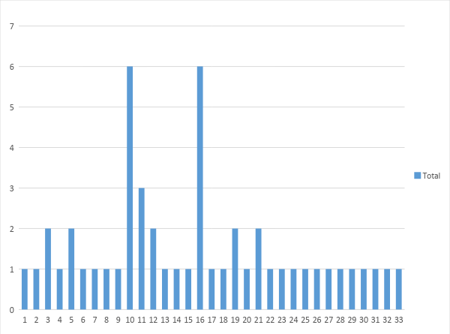

Most service provider have been working for more than 5 years now.

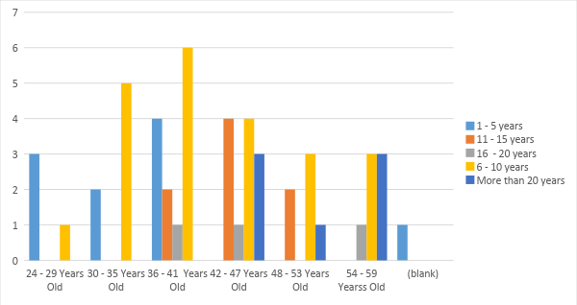

Each service providers has at least more than 5 customers per month.

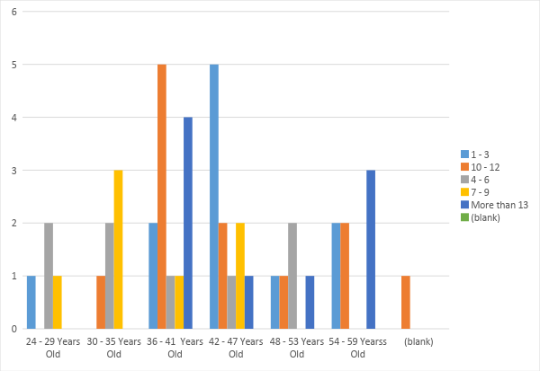

Service provider has the following as proof of skillset

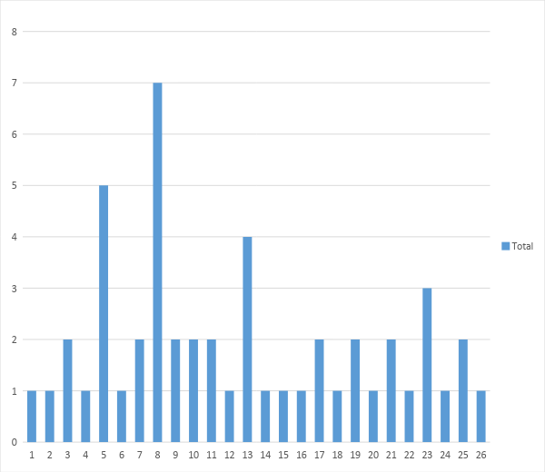

Most service provider charge at least 500 pesos per service..

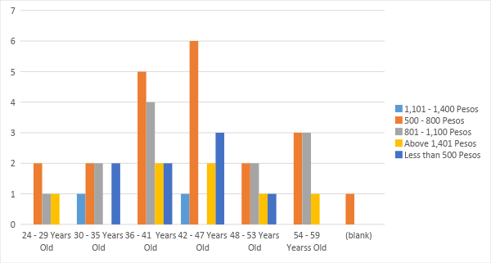

Personal Income of each service providers. Most service providers earns less than 10,000 per month while the rest ranges from 11,000 – 15,000 per month.

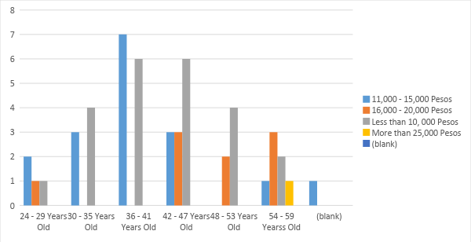

Their household income ranges from 10,000 – 15,000 pesos.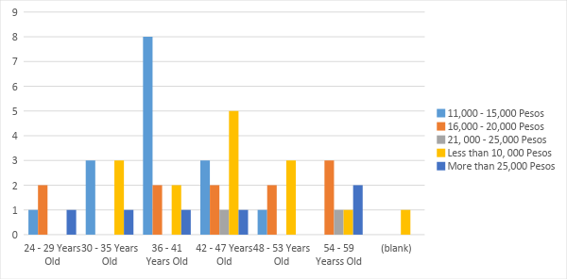

Most service provider uses an android os phone

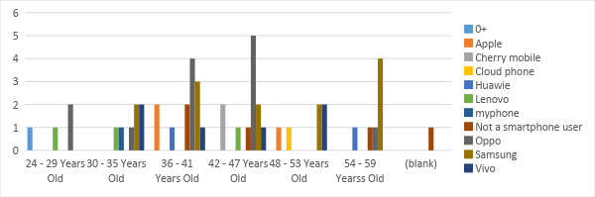

And answered they are willing to invest on smartphone if it would help them reach out to more customers.

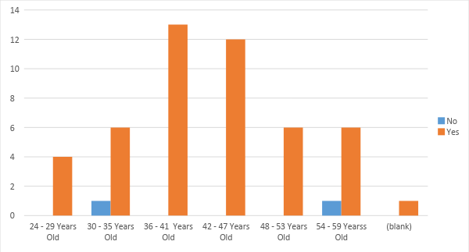

Each service providers are moderately familiar to very familiar in using their smartphones.

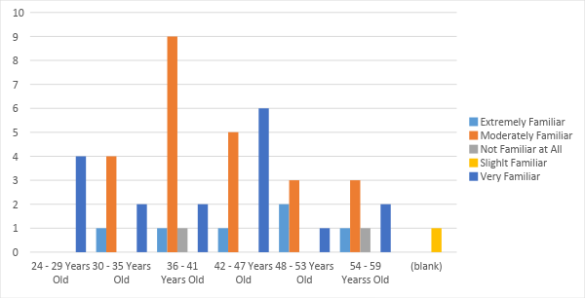

And spends at least 1 – 3 hours using their phone

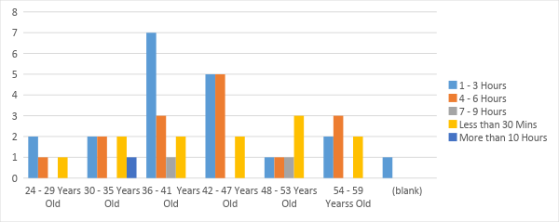

And most user uses Globe as their network

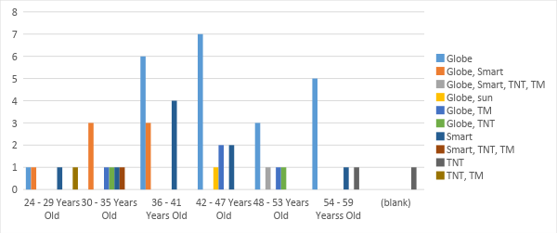

And spend at least 50 – 100 pesos on data network connection

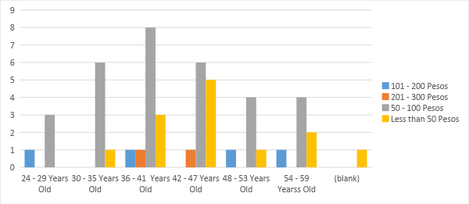

Service providers are willing to spend on data connection if it would help them connect to customers

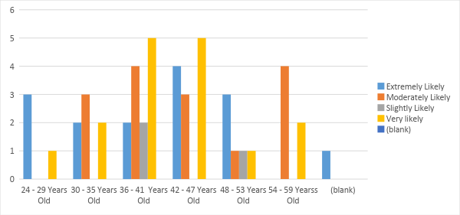

And they are willing to spend 50 – 100 pesos per week



Some service providers are not familiar with paymaya while some are slightly to moderately familiar with it

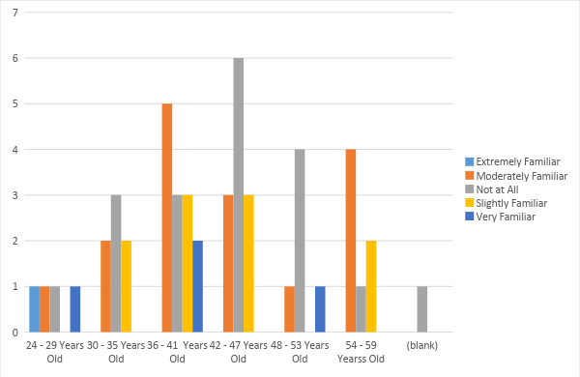

Majority of them didn’t used paymaya, while some used it at least 1 time

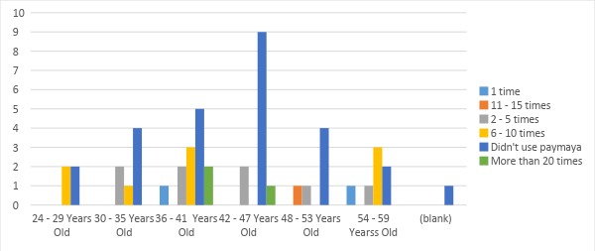

Service providers are slightly to moderately likely to use paymaya. 15 out 50 are moderately likely to use, 13 are likely to use, and 13 are not at all.

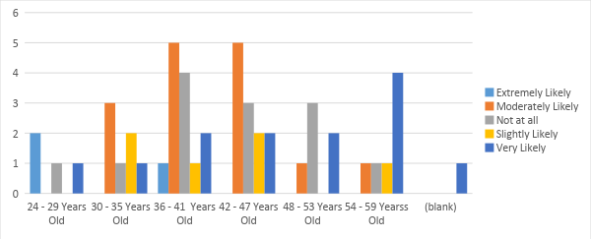

Service providers are willing to pay service charges. 13 are extremely willing, 14 are extremely willing, 10 are slightly willing, 12 are slightly willing, and only 1 is not willing in paying service charge.

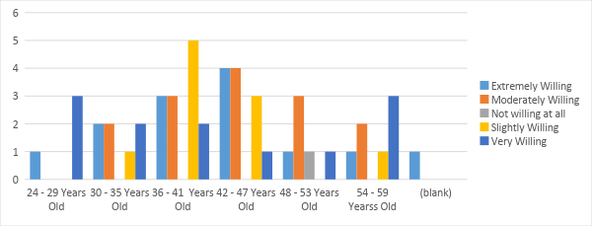

Service providers are willing to undergo orientation in using online platforms such as paymaya. 22 are exteremely willing, 12 are very willing, 10 moderately willing, 3 are slightly willing, and 3 not willing at all.

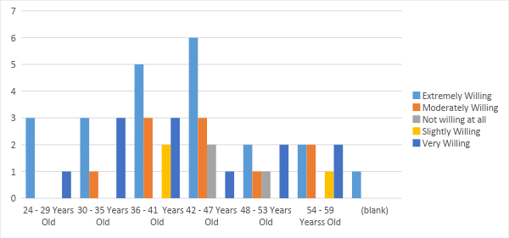

Service providers charges as low as 500 pesos and as high as 1,400 for electrical and wiring. For house cleaning, they charges as low as 500 pesos and as high as 800 pesos, for Plumbing they charge as low as 500 pesos, and as high as 1,400 pesos. For Carpentry, they charge as low as 500 pesos and as high as 1,400 pesos. For appliances repair, they charge as low as 500 pesos and as high as 1,100. For airconditon cleaning, they charge as low as 500 pesos, and as low as 1,400 pesos

1. <https://business.paymaya.com/security>
2. <http://www.bbc.co.uk/schools/gcsebitesize/ict/hardware/0inputandoutputdevicesrev3.shtml>
3. <https://pc.net/helpcenter/answers/meaning_of_internal_storage>
4. <https://www.regus.com.ph/office-space>
5. <https://store.paymaya.com/>
6. <https://paymaya.com/addmoney-channels/>
7. <https://paymaya.com/faq/>
8. <https://www.rappler.com/business/207091-number-filipino-adults-who-have-bank-accounts>
9. <https://paymaya.com/about/>
10. <https://paymaya.com/faq/>
11. <https://www.envolve.com/>
12. <https://developers.google.com/cloud-messaging/gcm>